A few pointers on World Building for the West Marches

“Exploratory adventures are likely to be the most exciting,
and their incorporation into the campaign is most desirable.”

– Gary Gygax, The Underworld & Wilderness Adventures, p16
To aid you in building your own Steven Lumpkin-esque West Marches setting, ready for exploration and adventure, I’ve selected several excellent, and often contradictory, resources and listed them below. Make no mistake, the West Marches is a sandbox hexcrawl campaign. A large percentage of the game’s structure involves the party picking a direction to travel (typically towards some location rumoured to contain either wealth or power), travelling across the wilderness, and discovering interesting (and often dangerous) stuff along the way.

No special equipment required.
In order to help determine what player characters might encounter as they explore, we’ll want to create a keyed hex-map that we can refer to during game sessions. The idea being that as the PCs enter a new hex on the map, we can just look up its number in the index and see what they might discover.
For creating hex-maps, personally I use Hexographer, (which seems to be the most widely used hex mapping-software,) but I’d recommend you use whatever you’re most familiar with; there’s nothing planned that requires any specific software. All we need is the ability to plot terrain types and features on a numbered hex-grid. And we’ll also need somewhere to keep an ordered list of notes, because we’ll be keying locations to those numbers.

A jumping off point.
Included within this document, is a map fragment containing the starting town of Viriskali and a few hexes surrounding it. As a first step, once you’ve fired up your software, (or, got your OSR hex-paper ready), you’ll want to to transfer this across to your own map. It isn’t essential though; if you’re making a smaller or larger map, just place Viriskali roughly in the centre of the page, and make a note of which hex you’ve centred it on (that way you can easily go back and key the map later).
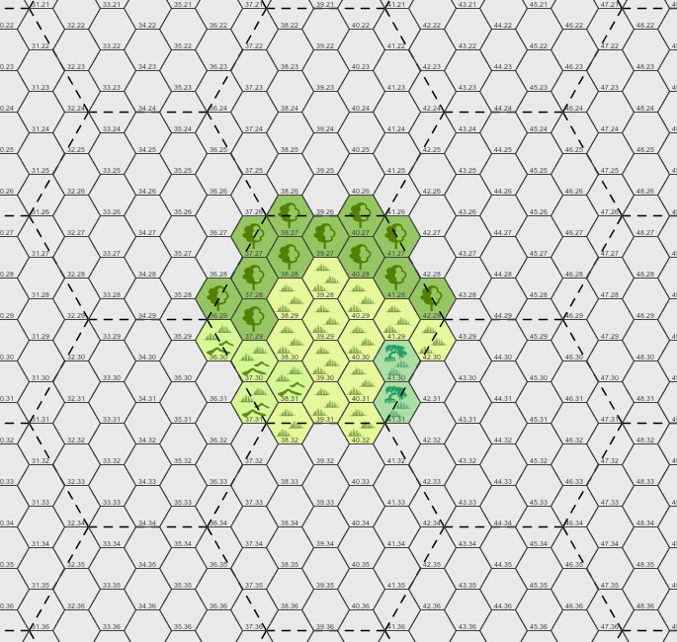  Diagram 1. Atlas Hexes & Viriskali Map Fragment | Atlas Hexes, & Scale.  So I don’t get lost using my own map, I’m a fan of using atlas hexes. Each of my atlas hexes, contains 19 whole hexes and 12 half hexes as shown by the dashed lines in Diagram 1, adjacent.  To speed up distance calculations, I’d suggest making each individual hex 6 miles high. If you don’t take my word for it, you can read a pretty convincing argument in praise of the 6-mile hex, over at The Hydra’s Grotto blog.  Each of my atlas hexes therefore, covers an area approximately 35 miles in diameter. So, if we plan on mapping the six atlas hexes around Viriskali, and the twelve atlas hexes that surround those, we’ll have a territory roughly the size of Belgium and that’s likely enough to start with.

(Un)Natural Geography.
With Viriskali and its surrounding atlas hex in place, probably the next most logical step, when building our map of the West Marches, is to mark out the area’s natural geography. Woods, swamps, barrows, cliffs, mountains, rivers and lakes are the most important to map out first as they pose the largest obstacle to the parties overland travel. Next you will want glades, plains and hills, as they are important for an authentic world but don't affect travel nearly as much. Try to make the regions flow into one another in interesting ways but don't do too much as that can be frustrating for players and hard to track for the GM. Terrain should be constant for about 2-3 hexes across although it may be more in some directions but not others (See the wood at the top of Diagram 1). Finally you should add anything that is truly strange. Floating hills, fire forests or anything that you feel would fit in your world that doesn't abide by the same rules as the rest of the terrain.

Finally KEY everything.
Number your hexes. Everything you write down that is somehow associated with a location on the map, write down the hex number(s). To start with it will be easy to remember where everything goes, but after a few session the amount of locations of importance and places the PCs have traveled or interacted with in some way, grows astronomically. There is no way you are going to remember where those pesky marauding goblins took the treasure they got from the keep the PCs cleared out on session 1, on session 10. In the West Marches keeping track of that stuff matter a whole lot more that with would normally in D&D. Keep a key of what each symbol on the map means in your world bible.

If PCs are traveling overland from one place to some other distant place, and I want to have something unexpected happen on the way there, the thing that happens should usually have something to do with the decisions the PCs made about how to get there.
– Zak S, Notes, Assumptions, and Conclusions About Travel In A Sandbox

Creating Factions.
Factions are social entities that inhabit the world of the WM. They organise and structure the people and beings that live in the WM for better or worse. Think of them as meta characters with their own goals and aspirations and flaws. What one faction wants, another my look to destroy.

Here are three important steps to creating a compelling faction.

- Goals - What does the faction want? How would the world be if they were in charge? Would they want peace at any cost or war with all that oppose them? Aim for the lofty goals, the ideals that churches and governments aim for.
- Means - What means does this faction have to achieve or work towards their goals? Can they accrue power by taking it by force or do they have to persuade the people that they are right? What can they do, and how would they do it? Try to keep it simple.
- Difficulty - What problem does this faction face in the accomplishment of its goal? will the people of neighbouring towns rise up against them or are they bound by the laws of the god they serve? Most factions have more than one problem in their way of their goals, aim for 2-3.
- Look - From the outside how does this faction appear? Do they wear ominous black robes and always hide their faces? Or do they exude an air of openness? Whether or not these things are true of the faction at heart, they influence the way people (including the PCs) react to them.

Often they come into conflict with the players, at these points create fronts (See front guide) to move the faction forward. Bare in mind that sometimes they may succeed and others times they won't make it a single step towards their goal. Try not to ruin your own game by making the factions goal something like world destruction, who knows they might succeed.

All factions are made up of people in one form or another, try to understand what the individuals want and what they all want together. This will make it much easier to understand the faction as a whole and make it a more believable entity.

Generally try be creative with these factions. Try everything from crazy cults to well meaning temples, from strict military leaders to mild mannered pacifist, from greedy guilds to good hearted gangs. Use different types of faction, like cult, congregation, sect, whole religion, to help diversify the appearance of the factions. The appearance can be as, if not more important than the faction itself. Just remember their motives, their means and the difficulty that have to face to get what they want.

