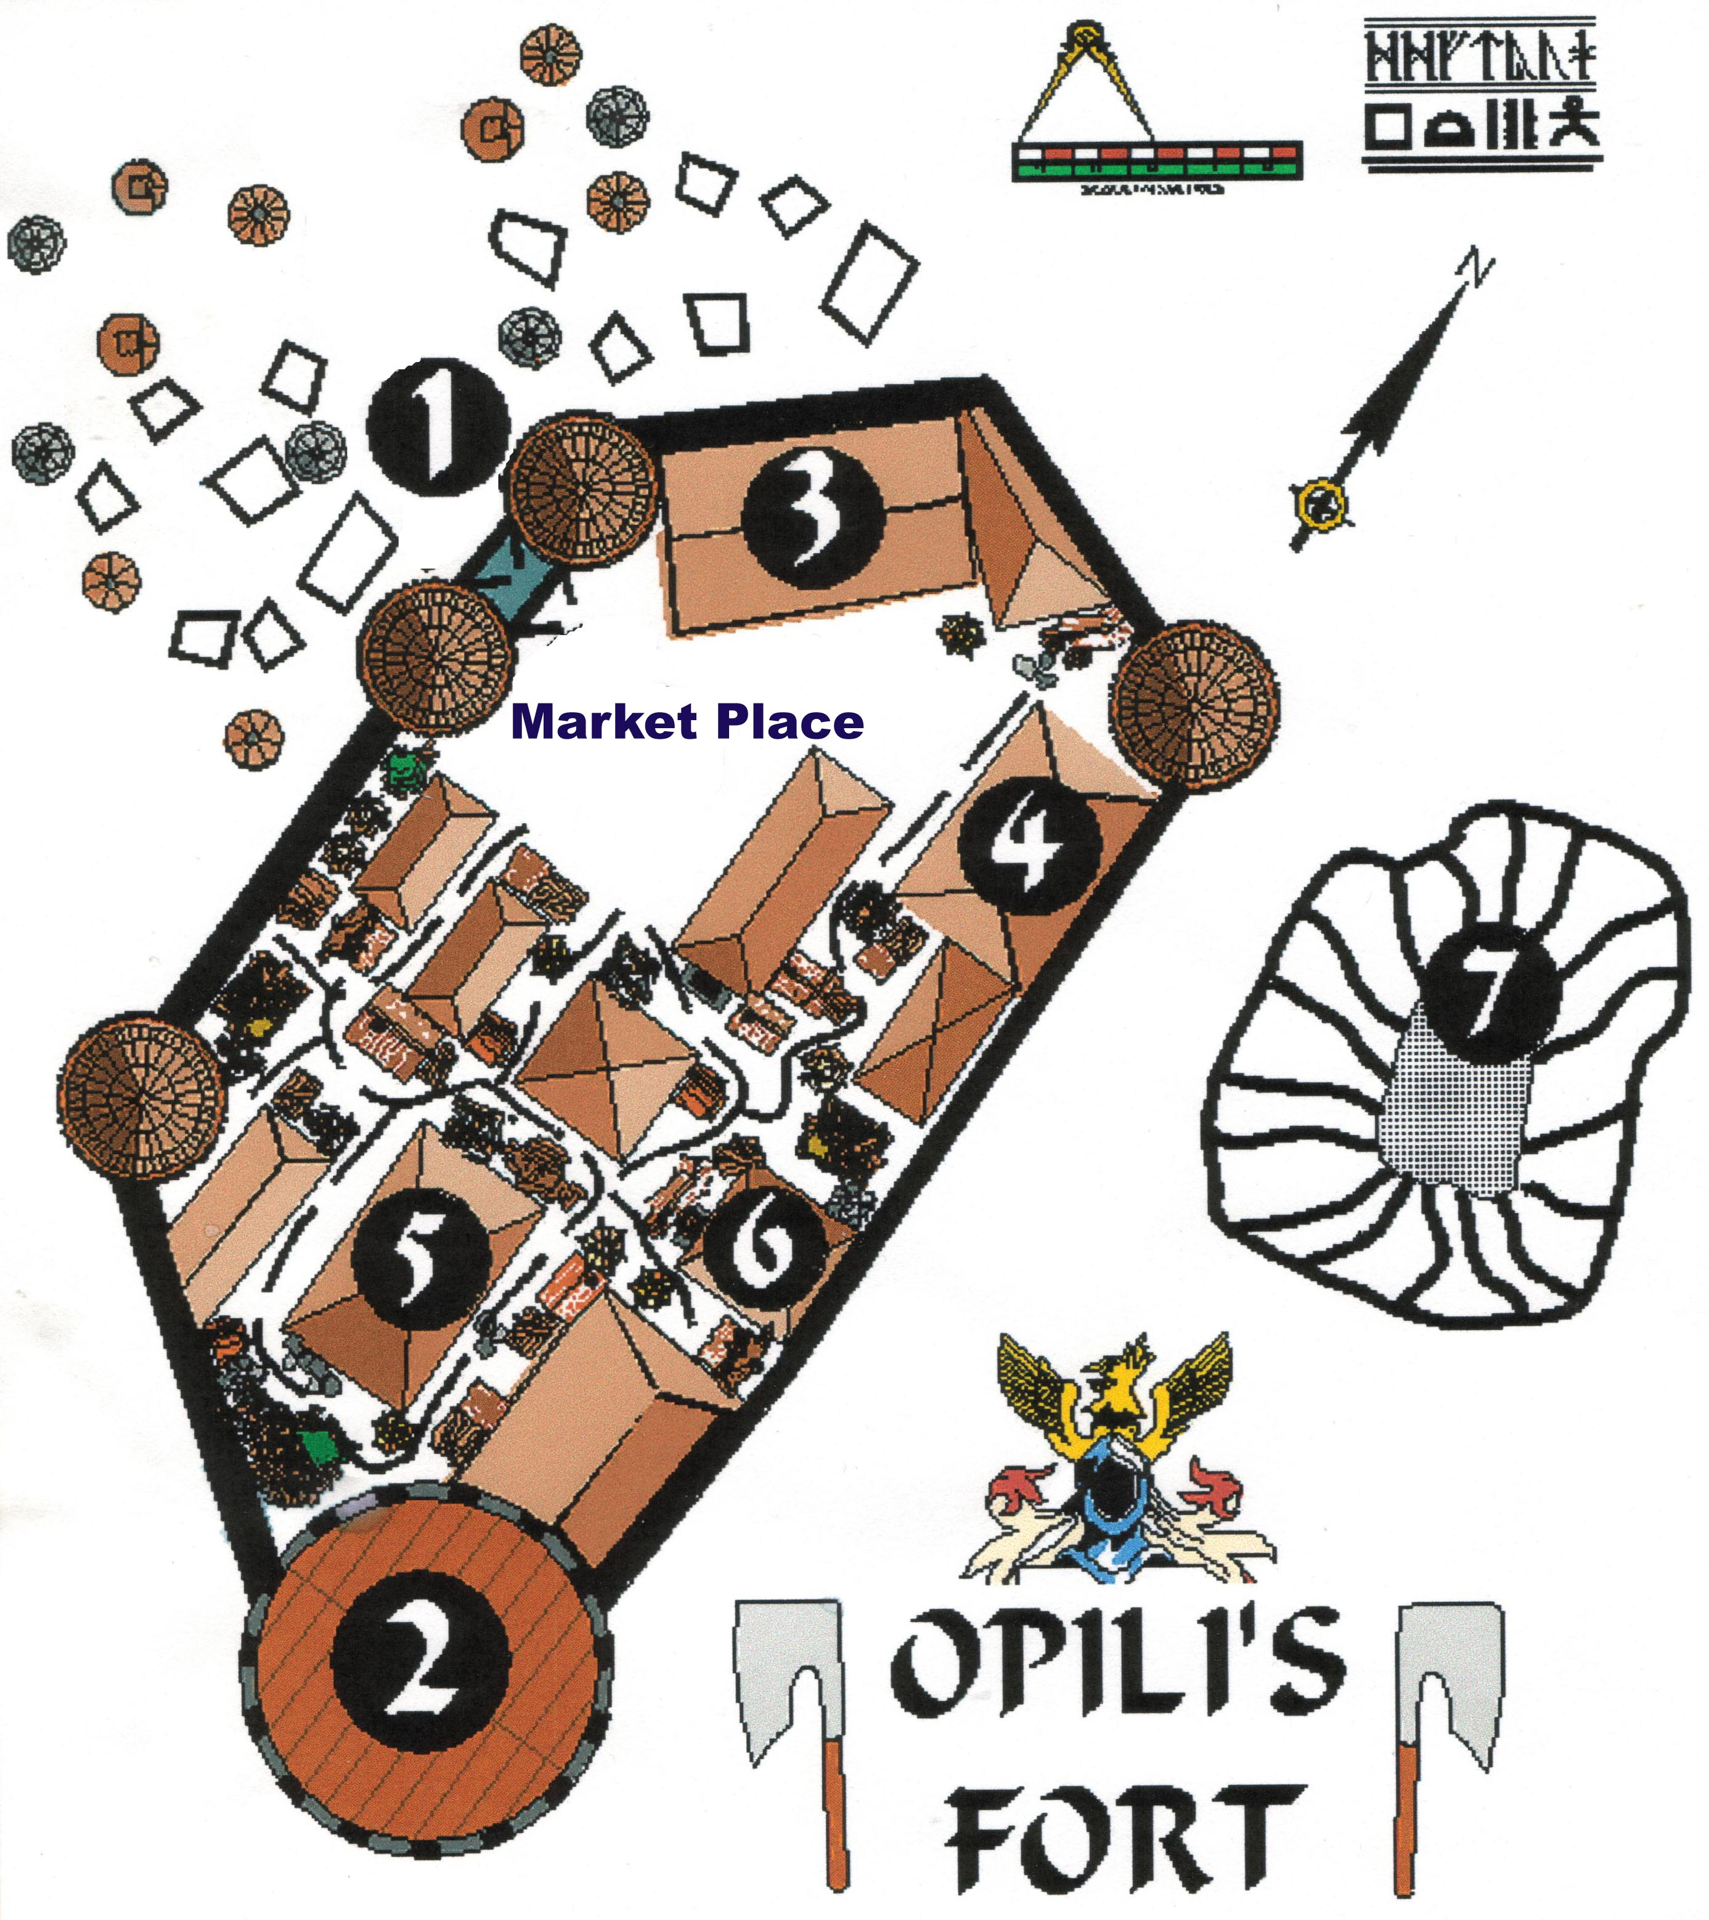

1 - The Gatehouse: Once the site of the famed 'Opili Gate', later rebuilt by trolls
2 - Queen Gerralyn's Residence: includes tower and connected structure
3 - Karrg's House: The Kaggrokka warriors and their best trollkin live here
4 - Gorakiki & Xiola Umbar building: wild fungi grows in caverns beneath (accessed from here), and the clan healer has rooms here.
5 - House of Vantalgaz: The troll trader priestess and her family live here, as do the clan's great trolls
6 - Gorakiki Temple: Tradamag Ghostkiller is priest here; his followers also access caverns from this building, and breed subterranean bees there, for their honey
7 - The Old Quarry: now used for gladiatorial entertainments

