Gangster    MR: 18.  Combat Dice: 2d6+9 |  | Vampire   MR: 90  Combat Dice: 10d6+45.  Special Abilities: Only harmed by organic matter and magic weapons |  | Robot    MR: 100  Combat Dice: 11d6+50  Special Abilities: Armor: 20
Werewolf  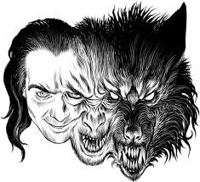  MR: 120  Combat Dice: 13d6+60. Special Abilities: Only harmed by silver and magic weapons. |  | Goons  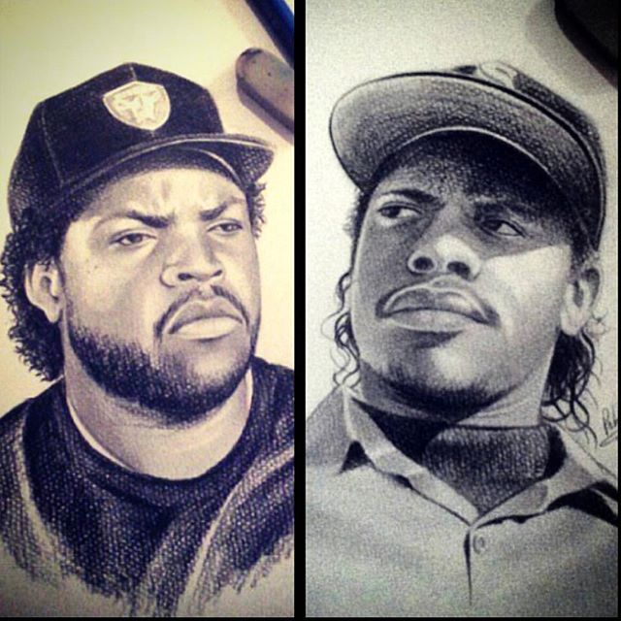 MR: 16.  Combat Dice: 2d6+8 |  | Bouncer/Bodyguard    MR: 22.  Combat Dice: 3d6+11
Thugs  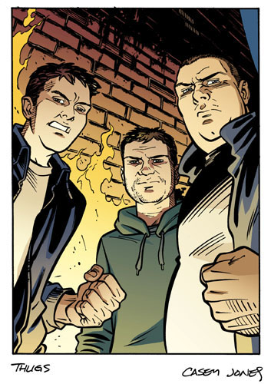  MR: 12.  Combat Dice: 2d6+6 |  | Mummy  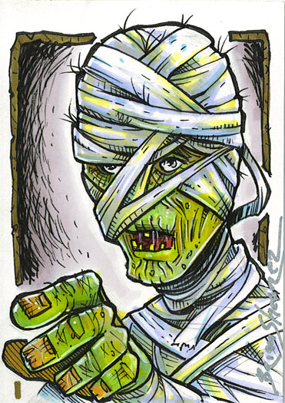 MR: 90  Combat Dice: 10d6+45.  Special Abilities: Only harmed by fire and magic weapons.  Texte |  | Ghoul  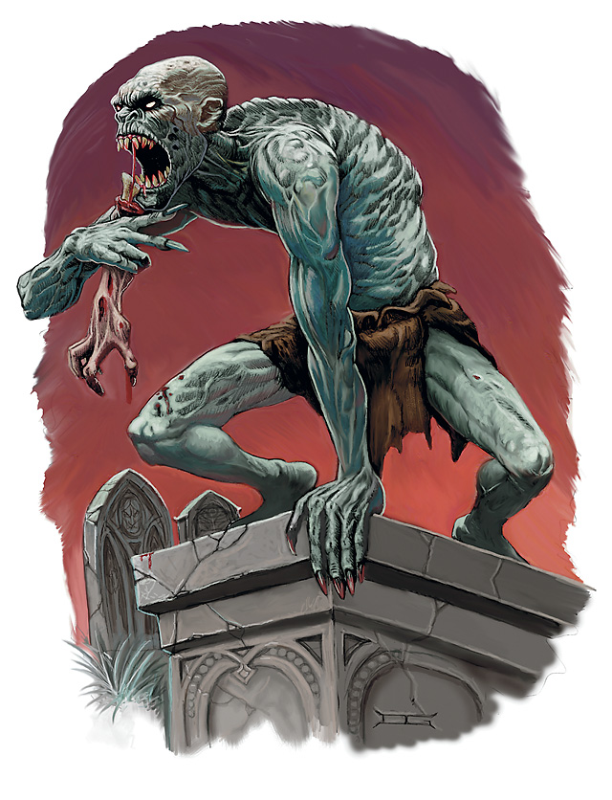 MR: 56  Combat Dice: 6d6+28  Special Abilities: Paralyzing cry 3/day (CON L3 Save)

