Geiger counter  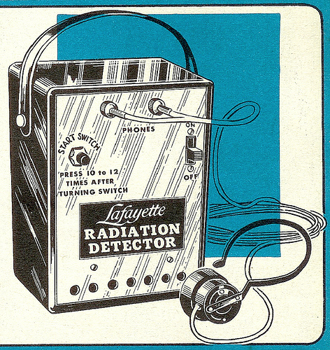  The Geiger counter is an instrument used for measuring ionizing radiation.  (-3 level saving roll) |  | Bandages  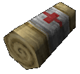  Bandages are available in a wide range of types, from generic cloth strips to specialized shaped bandages designed for a specific limb or part of the body.  (-1 level saving roll) |  | Lockpicks  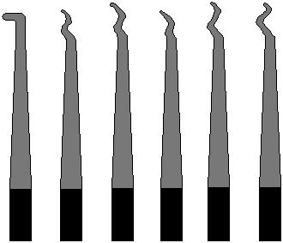  This versatile pick is included in nearly all kits and is mainly used for picking individual pins but can also be used for raking and for wafer and disk locks. (-1 level saving roll)
Superior Lockpics  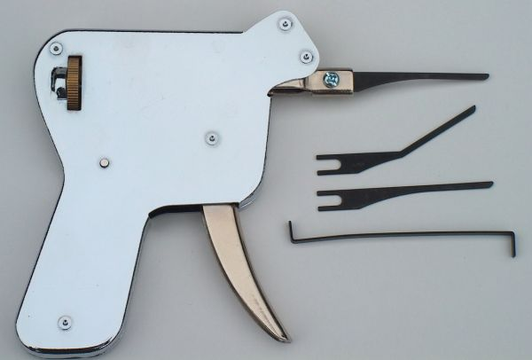  The manual pick gun usually has a trigger that creates a movement which allow the cylinder to turn freely for a brief moment.  (-2 level saving roll) |  | Flashlight  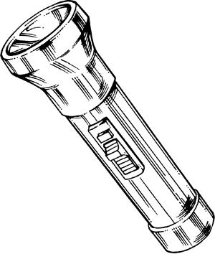  A flashlight (often called a torch outside North-America) is a portable hand-held electric light.  (-2 level saving roll) |  | Sedan  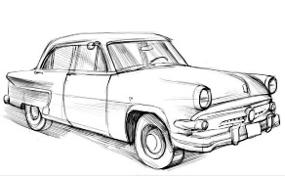The primary purpose of the sedan is to transport people and their baggage on ordinary roads  Class: 4 CON: 40  Damage Returned: 4d6
Sport car  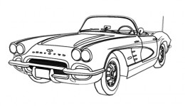A sports car is a small, usually two-seater, two door automobile designed for spirited performance and nimble handling.  Class:2 CON: 25  Damage Returned: 2d6 |  | Truck  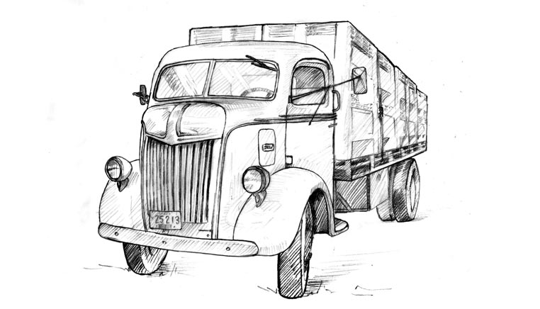A truck is a motor vehicle designed to transport cargo.  Class: 6 CON: 65  Damage Returned: 6d6 |  | Cruiser Motorcycle  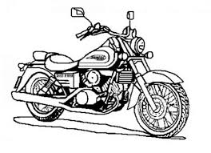A cruiser is a motorcycle in the style of American machines from the 1930s to the early 1960s.  Class:1 CON: 10  Damage Returned: 1d6

