BACKGROUND Until recently, only a few Bastilles had been built and even fewer had ever left their harbours of origin.
The Bastilles were the harbour defenses of Bretonnia, at least this was the duty Admiral Toureiffel had in mind when he ordered the first ship of it’s class to be built.
Bretonnian ships are some of the best when it comes to battles on high seas, but when they are attacked while beeing in a harbour, the confined space denies them to use their broadsides properly and they become sitting ducks for their enemies.
So the Admiral Class Bastilles were built, allthough no Admiral would have found it proper to set a foot on such a clumsy ship. (In fact they were much needed but also much disliked by a lot of Captains as they used up so much resources which, should better have been invested in more Galleons (under their command of course).
They acted as swimming harbourgates, as fortresses which would protect a harbourentrance, at least long enough for the corsairs and Galleons to prepare for a sally. Once the Galleons were amongst the enemy ships, wreaking havok with their broadsides, the Bastilles would confine themselves to sporadic supportfire with their catapults.
The change came when King Charlen used a Bastille as a demonstration of Bretonnias power. He had invited highranking officials and merchants from other countries for a luxurious banquet on board of a ship, specially prepared for the occasion.
They were rowed to the ship in small sloops which had even been slowed down by dragging nets beneath the surface. Thus the guests were forced to parade past those mighty bulwarks and gun batteries in boats which felt like fragile nutshells in comparison. The painfully slow pace gave them enough time to let the impression sink in.
On board the King served them the best food and wine Bretonnia could muster.
A huge Kitchen had been installed and a lower deck had been turned into a winecellar so that every wish could be fulfilled immediately.
Conversation was made about various themes, but the king broadly explained his idea of an errantrywar to clear the area called “the border princes” from orcs and that he was worried about the safety of his realm while so many knights were away and how he would even have to rely on clumsy brutes like the Bastilles to protect his kingdom…or to retaliate.
Then, after nightfall, King Charlen bade his guests to join him for special surprise, some kind of firework.
A huge fleet of older ships, mostly Buccaneers had been anchored around the ship and upon the king’s command they were shot at with cannons and catapults.
To make it more spectacular the Catapult towers had been equipped with furnaces so that they could prepare special glowing shot which could be seen arcing down on their target setting it on fire.
The “firekwork” was spectacular, but ended very quickly.
The old ships had been secretly prepared with powder kegs and pitch to set them ablaze and sink them at the slightest touch of fire and the glowing shot saw to that pretty well.
And in light of the burning wrecks the King bade his guests farewell and had them rowed ashore.
A few days later rumours came up about a new siege ship, a new bretonnian warship, capable of destroying a whole fleet on it’s own.
For the next months no bretonian ship or city was harassed by anyone, not even pirates and King Charlen could start his errantrywar without hesitation.
When the war was over though, the fear about the Bastilles had nearly vanished and it was time for the bretonnian fleet to leave it’s harbours once more.
The tilean pirates based on Sartosa had captured a ship which carried a diplomat from Araby and the remains of a Grail Knight who had been found dead in the desert.
This time a Bastille went with the fleet, not to guard the achoring ships but to live up to it’s rumoured abilities as a siegeship.
It did not even fire a shot. The moment the it came into view, the ship, diplomat and knight were set free.
Thus the Bastilles were accepted as fighting ships and the One Admiral even made one his flagship.
It was Admiral Bouccuse and he had been waiting for the opportunity for quite some time as he chose the specially prepared one, including the kitchen, called the “haute quisine” as it was sited on the top deck, and the wincellar which had not been emptied after the demonstration.
As the furnaces allready had been installed while the errantrywar lasted, now every Admiral wanted such luxuy too and so every Bastille chosen as flagship was equipped that way until it allmost became standard.

CLASSIFICATION
The Bastille is an Admiral Class ship and follows the appropriate rules.
(Actually, I don’t know if there are proper written rules)
Allthough that Bastilles carry so much gadgets allready I think that they should get one Man O’War card.
In campaigns Bastilles may start without kitchen, furnaces or winecellar to reduce points. They may earn them back by aquiring Man O’War cards treating every location as one card (Furnaces count as one location though). Until those three “cards” have been earned the locations are treated as having no special effect.
Only the fourth card will be an actual card.

FLEET RESTRICTIONS
There is only ever one Admiral class ship in the fleet, which is always the flagship.

MOVEMENT
The Bastille may move under sail only.
Sail: 6”(6”)
(No mundane tinkering or scrapping may make it move faster than 6”, only magic may change it’s speed)
STEERING
The Bastille is a cumbersome ship at best.
Some captains state that it has been designed with the huge Black Arcs of the Dark Elves in mind but the shipwrights ended up with a floating rock and not with a fortress ship.
Allthough it has not such a great depth as their devilish counterparts they can only turn properly with the support of a huge rudder and two spritsails.
This is represented by rudderpoints.
RUDDER POINTS
A Bastille has 4 rudderpoints which can be reduced due to damage. The Bretonnia player may only use the turning template on a dieroll below or equal it’s current number of ruderpoints.
If it fails it’s dieroll it has to move straight ahead 2” instead.
The ship may end up without rudderpoints which will mean that it will leave the table in a straight line unless they have any boni from Man O’War cards.
Man O’War cards and rudder points
Some Man O’War cards may cause an increase of movement which is not possible for the bulk of the Bastille. Instead the shipwrights and crewmen will take great pains to increase the maneuverability of the their ship. On the other hand a strengthening of the hull might decrease the allready low steeringability.
- “Inspired Seamanship” Succeed automatically with
one steeringroll, regardless of
points, instead of moving
twice. Play and discard.
- “streamlined hull” +1 rudder point instead of
movement increase of 2”
- “Reinforced Bulkheads” -1 rudder point in addition to
the card effect
- “Armourplating” -1 rudder point in addition to
the card effect
- “Massive Hull” Loose one rudder point if
using and discarding the
card.
COMBAT
The Bastille has two forms of attack.
Two batteries of three catapults on each tower and it’s broadsides.
CATAPULTS
The catapults fire like the ones on the buccaneers, but as there are three catapults, it will be a three dice attack.
All three catapults will fire on one target, as all the warmachines sit on one platform, rotated by the same oxen driven gear, hidden in the tower.
The towers are very high, so that other ships don’t block LOS. The catapults still cannot fire on targets in short range.
Every tower has a 180° Firearc.
BROADSIDES
Against ships, seamonsters and other normal targets, an undamaged Bastille has a Broadsidevalue of 8.
Due to the size of the ship it can only bring half of it’s guns to bear on boarders. One location is marked appropriately.
Cannons from that location may not be used to repell boarders.
FURNACES
Every tower comes with a furnace.
As long as this location is not destroyed, the catapults will start blazes on enemy locations, instead of destroying them.
Vice versa, if the location is destroyed, it will cause a blaze too.
The player has always the option not to heat the furnaces.
He has to do this when the ship is deployed and he may not change his mind afterwards.
The funaces will then be without any special effects for the whole game.
THE “HAUTE CUISINE”
The kitchen itself has no effect only on the admiral’s stomach. Once it is destroyed, two things might happen:
1) A lot of people become unemployed and free to join the crew (unless they got killed).
- Roll two dice, for every roll of 4+ add one crewcounter.
2) If all cooks and waiters got killed, all the luxurious food is left unprotected. The sailors stop working to fill up their pockets with roasted meat and other delicious food, a sailor usually won’t taste in his whole life.
- The ship is not able to fire any weapon this turn.
THE WINE CELLAR
To the bretonnian crew the wine cellar is a place of sacred mystery. Bottles of age old wines are rumoured to be stored there, magically protected they had time to develop a flavour only a king should taste, or even the Lady of the Lake herself. Once it is destroyed, two things might happen :
1) The whole wine had been cheap stuff, possibly even coming from Tilea, or worse, the Empire.
Surely it is a great deed to destroy all the remnants which have survived the attack.
But still, it is wine, and it would be a sacrileg to simply empty the botles in the sea…
- The sailors get drunk and every crewcounter is in danger to fall into the sea on a roll of 6.
2) If no crew counter got destroyed it is a sure sign that a horrible discovery had been made. One crewman holds up a broken bottle and shouts
“Oh my god they killed a Bottle of 1743 KNY-parc-du-Sud. You bastards!”
which makes the rest crying in shame and anger for letting such a relic be destroyed.
Now the crew is out for revenge.
- In a boarding action the Bretonnia Player may reroll his die but has to abide by the second result, even if it is worse than before.
- Each character onboard now adds an additional +1 in a boarding action.

POINT COST
First guess 250 points
14 Battlehonours
DESIGNER NOTES
Nothing new here: I still don’t know how many points would be appropriate. My first bet still would be 250 points, and still I haven’t tested it in battle.
I changed the wording in some areas and removed some typos (well, and maybe added new ones).
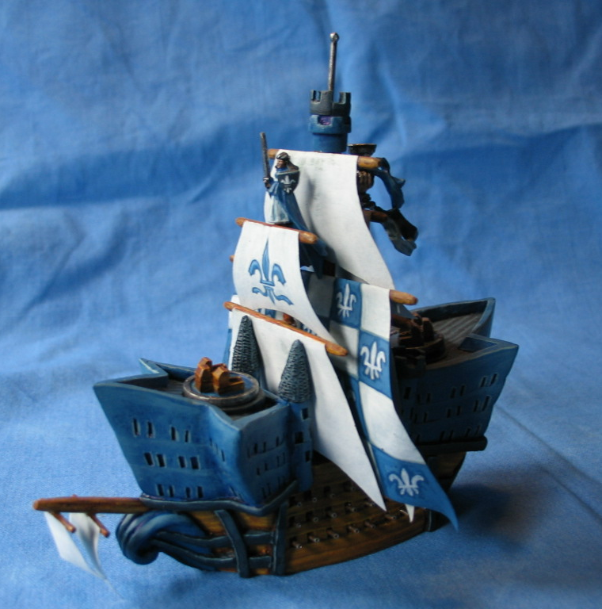
There is abetter picture in the competition folder but there it lacks the second spritsail.

