More Animals

**Apes**

NOTE: These stats have been edited to conform to the [rules revisions](https://drive.google.com/file/d/0B-T2-uWej8Y3VExaeVNSOGtRUnc/view?usp=sharing) posted on 9/8/15.  
    
After Animal Herd, the next two "normal animals" listed in the Rules Cyclopedia Monsters chapter are "*Ape, Snow*" and "*Ape, White*."  Neither of them is a real world animal, but some of the game information listed for them can nonetheless be translated into stats for bonobos, chimps, gorillas, orangutans, and gibbons.  
  
Of course, each of the ape species are very different from one another.  Gorillas have a fierce reputation, but are usually quite peaceful and docile.  Chimpanzees, on the other hand, are almost the reverse; non-apes generally view chimps as playful and cute, but of all the apes, they are the most violent and warlike, especially in large groups.  Orangutans are loners except during mating periods, and nearly always prefer flight over fight.  Gibbons are often mistaken for large monkeys, and most non-apes don't even call them to mind when the word "ape" is mentioned.  Finally, bonobos are a source of great confusion to non-apes; they are almost identical to chimpanzees in every physical respect, but their society is vastly different (and, it should be noted, much randier).   
  
To reflect these differences, the Featured Creature entry for apes begins with a stat block of traits common to all apes.  From there, it delineates how each individual species differs from that norm.  
  
Ape characters are likely to be the closest that players in a *Great & Small* campaign get to playing true longpaws.  They have so much in common with humans (and, in some settings, dwarfs, elves, and halflings) that other animals often view them as "junior members" of the human species.  Indeed, many apes themselves aspire to this status, and more than one ape adventurer has been motivated by the desire to crack the secrets to humankind's success.  
  
**Ape**  
Apes are, to a fault, inquisitive and probingly curious, keen to investigate any new creature or object in their environment.  Their great manual dexterity makes them the best tool-users of any animal type save the longpaws themselves, and in some settings, they are the smartest of the non-human animals, as well.  Of course, they are often keen to remind others of this fact, which does not endear them to other species.  In many worlds, there is a fierce rivalry between apes and dogs, each seeing themselves as closest to man in their legacies and abilities.  
  
The following game rules reflect the traits common to all types of ape.  Variations on these themes can be found under individual species headings.  
  
**AC**: 6  
**AT (Dam)**: 2 fists (1d3 [1d4]), 1 bite (1d2)[1d3]  
**Beginning HP**: 5 [6]

**Habitat**: Any, typically tropical or sub-tropical

**MV**: 6

**SZ**: Small  
  
**Species Traits**:

* **Brachiation**
* **Hands**: Unlike most other species, apes have true hands, very similar to those of longpaws.  They a get +2 bonus on all Scout and Trickster lore checks to manipulate fine tools, spring traps, perform "sleight of paw" tricks, and other activities that mimic the use of human hands.
* **Growth Spurt**:  Most apes increase to Medium size at 3rd Total Levels.
* **Low-Light Vision**
* **Poor Swimmers**:  Apes automatically fail all lore checks that involve swimming, unless they have been specifically trained in the skill by a member of another species.  Even then, they suffer a -4 on all lore checks involving swimming.
* **Scent**
* +2 bonus on all lore checks that involve feats of strength such as breaking, bending, lifting, or otherwise manipulating heavy objects with their hands.
* +4 bonus on all lore checks that involve climbing; this bonus is +6  in their native habitat.
* **Suitable Niches**: [Guardian](http://greatandsmallrpg.blogspot.com/2015/04/new-niche-guardian.html), Healer, Herbalist, Runner, Scout, Seer, Trickster, Warrior

**Bonobo**

This randy species of matriarchal apes is physically nearly identical to chimpanzees, but socially, they couldn't be any different.  Status among bonobos is measured by association with the eldest females in the group, and it is young females, rather than young males, who normally leave a bonobo troop in search of adventure or opportunity among other troops.

[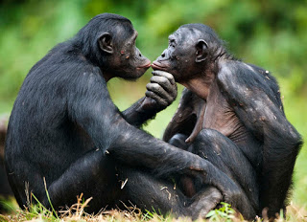](http://2.bp.blogspot.com/-yZWOTf4tQ78/VXpJ-LnatYI/AAAAAAAAALo/qEvVcK1zGr4/s1600/bonobos.jpg)

**Species Traits:**

Bonobos have all the standard ape traits, except as noted below.

* **Mimic Chimp**:  With sufficient study (and a successful Trickster lore check), bonobos can successfully pass themselves off as chimpanzees.  They get a +2 bonus on all Trickster lore checks to pull off this ruse, but true chimps can see through it more easily than other characters (gaining a +2 bonus on all Seer lore checks to penetrate the disguise).
* **Seduction**:  Bonobos of both sexes are masters of obtaining affection from others, and thus making them easier to manipulate.  They get a +2 bonus on all Storyteller checks to influence the Attitude of others in a positive direction.
* +6 bonus on all lore checks involving climbing; this bonus is +8 in their natural habitat.

**Chimpanzee**

[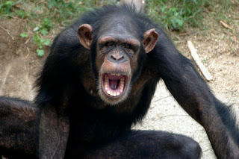](http://4.bp.blogspot.com/-kRovywpqZY0/VXpKGEfVxSI/AAAAAAAAAL0/-LPL9wMDyhw/s1600/chimp+yawn.jpg)Chimps are among the most beloved of ape species by longpaws, which is all the more ironic because of their violent nature.  While often playful, chimps are also known as savage killers and raiders of surrounding troops, sometimes even hunting and eating other fellow apes.  But, they are also among the smartest species in the world, and thus capable of great guile.  This is not to say that individual chimps are bestial -- they have various dispositions and personalities -- just that it is wise to avoid angering them.

**Species Traits:**

Chimpanzees have all the standard ape traits, except as noted below.

* +6 bonus on all lore checks involving climbing; this bonus is +8 in their natural habitat.

**Gibbon**

[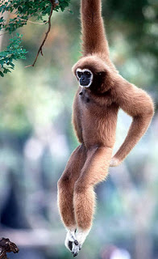](http://3.bp.blogspot.com/-FpwhzEKBiiE/VXpKG8G4tGI/AAAAAAAAAMM/xzpA5KmjD1M/s1600/white_handed_gibbon.jpg)Sometimes called the "lesser apes," gibbons are smaller and more monkey-like than their cousins, but like all true apes are tailless.  They are unrivaled masters of the branches, being the fastest and most agile of all tree-dwelling, non-flying mammals. Unlike the "great apes," gibbons mate for life, and display far less sexual dimorphism, leading to greater social equality between the sexes in their society.  Gibbons get along well with bonobos for this reason, but remain wary of other apes.  
  
**Species Traits:**  
Gibbons possess all the standard ape traits, except as noted below.

* **Master Brachiator**: While swinging from branches, gibbons can add their Total Level to lore checks when attempting to push their movement limits, even if they have not taken Runner as their niche.  Note that this bonus applies only to swinging from branches, and not to other uses of brachiation.
* **SZ**: Small.  Gibbons do not gain a Growth Spurt at 3rd Total Levels.
* **Swinging Leap**:  With a successful Runner lore check, gibbons can leap distances of up to 34 feet while swinging from branches.

**Gorilla**  
[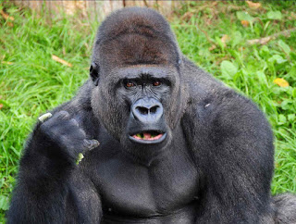](http://3.bp.blogspot.com/-ygK-CnPnDZI/VXpKGaD4MCI/AAAAAAAAAMI/zdZu9rmjBUg/s1600/gorilla.jpg)The most feared of the great apes by other animals, gorillas are ironically among their gentlest of their kind.  Normally, it is only when defending their territory or their kin that gorillas truly need to be feared, for while they rarely intend to kill, their great strength often leads them to inflict greater damage than they wanted.  Gorillas are nonetheless respected for their wisdom, and many non-apes will seek the counsel of an aged gorilla over the leaders of their own kind.  
  
**Species Traits:**  
Gorillas possess all the standard ape traits, except as noted below.

* +4 bonus on all lore checks that involve feats of strength such as breaking, bending, lifting, or otherwise manipulating heavy objects with their hands.
* +2 bonus on Warrior lore checks to intimidate opponents.

**Orangutan**  
[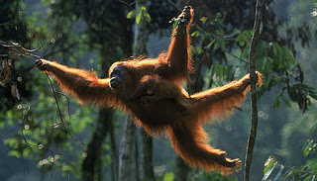](http://2.bp.blogspot.com/-UP6OH-CIE1c/VXpKGO4fSAI/AAAAAAAAAME/ZcxweBViEOk/s1600/orangutan.jpg)Of all the apes, orangutans are the least social, normally leading lives of solo exploration and wandering until mating season.  They are adept climbers, and even gentler than gorillas, usually preferring to avoid conflict altogether rather than get into a fight.  This has given them an unfair reputation as a race of cowards, but as the orangutans see it, they just have better things to do than fight over food or territory.  Their jungle homes are so bountiful, they rarely see the point in such disputes.  
  
**Species Traits**:  
Orangutans possess all the standard ape traits, except as noted below.

* +6 bonus on all lore checks involving climbing; this bonus is +8 in their natural habitat.

**Bats!**

NOTE: These stats have been edited to conform to the [rules revisions](https://drive.google.com/file/d/0B-T2-uWej8Y3VExaeVNSOGtRUnc/view?usp=sharing) posted on 9/8/15.  
    
Millions of years ago, bats were banished into the night, either by the gods or the other  animals, for some long-forgotten crime, real or perceived.  Since that day, they have embraced the darkness and spread to every corner of the world, quietly serving as pest controllers and pollinators for their friends, the trees and flowers. Next to rodents, they are the most widespread group of mammals in the world.  
  
They are especially appropriate in a Creepy Crawlies campaign, where they can adopt the Familiar niche.  In classic fantasy settings like the Trucewood Vale, they can also be Magic-Users.   
  
There are two main types of bats: megabats and microbats.  Each shares certain characteristics, while also maintaining unique traits.  
  
All bat characters have the following Species Traits:

* **Confuse Foes:**  Bats can flitter about the heads of land-borne opponents, confusing their senses.  For every 5 (megabat) or 10 (microbat) bats co-operating on a confusion attack (minimum of 1 bat),  one Medium-sized terrestrial opponent can be affected; each such target suffers a -2 penalty on all attack and saving throw rolls for the duration of the attack.  Spell-casters or other foes with abilities that require concentration or precision must make a Paralysis save (at the above -2 penalty) or be unable to concentrate  well-enough to carry out such tasks.  Thus, their spell-casting is ruined.
* **Flight Ability:** Bats are the only species of mammal capable of true natural flight.
* **Flyby Attack**
* **Low-Light Vision**
* **Scent**
* **Swoop Maneuver**

**Megabat**  
Most megabat species are frugivores or nectarivores, and have an intimate knowledge of plants.   
  
**AC:** 6  
**AT (Dam):**1 bite (1d3)  
**Beginning HP:** 3 [4]  
**Habitat:** Any  
**MV:** 1; 8 flying  
**SZ:** Tiny  
  
**Species Traits:**  In addition to the common bat traits above, megabats have the following abilities.

* **Growth Spurt:** Megabats become Small in SZ at 2nd Total Levels.  The largest megabats have wingspans of 5 feet.
* **Plant Lore:** Megabats get a +2 bonus on all lore checks involving knowledge of plants.  In fantasy settings, they automatically know the languages of treants and other plant creatures.
* [**Ultravision**](http://greatandsmallrpg.blogspot.com/2015/02/on-beyond-purple-taking-back-ultravision.html)
* -4 penalty on all lore checks involving feats of strength
* **Suitable Niches:** Herbalist, Runner, Scout, Seer, Trickster, Warrior

**Microbat**

Microbat species are almost all insectivorous, though the (in)famous vampire bat feeds on the blood of large mammals.  
  
**AC:** 5  
**AT (Dam):** 1 bite (1d3 [1d4])  
**Beginning HP:** 2 [3]  
**Habitat:** Any  
**MV:** 1; 8 flying  
**SZ:** Diminutive  
  
**Species Traits:** In addition to the common bat traits above, microbats have the following abilities.

* **Blindsense**
* **Echosight**:  Though not truly blind, microbats rely more heavily on their hearing than on their sense of sight or smell.  Thus, they suffer no penalties when making Scout lore checks  if using their hearing, but a -2 penalty when using sight or smell. They can ignore the effects of attacks or effects that blind their targets, provided such attacks do not also deafen them.
* **Growth Spurt:** Microbat characters have the option of becoming Tiny at 2nd Total Level, but are never required to do so.
* -5 penalty on all lore checks involving feats of strength
* **Suitable Niches:** Healer, Runner, Scout, Seer, Storyteller, Trickster

**Bears**

NOTE: These stats have been edited to conform to the [rules revisions](https://drive.google.com/file/d/0B-T2-uWej8Y3VExaeVNSOGtRUnc/view?usp=sharing) posted on 9/8/15.

[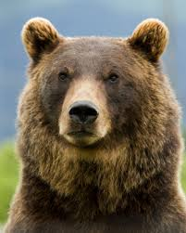](http://2.bp.blogspot.com/-te-T7SiYOnM/VclH35VsChI/AAAAAAAAAO0/6Fq7GOdiO90/s1600/index.jpg)

Bears are among the most physically powerful land animals in the world, with a great capacity for menace.  Yet, they are often highly-regarded as symbols of healing and nobility, thanks to their generally humble personalities.  A bear is often the top hunter in its domain, though black bears often compete with cougars or wolves (grizzlies fear no one, of course).  On the other hand, all bears are omnivorous, giving them many more options for food than strict carnivores like the big cats.  This may help explain their gentle disposition: they rarely see any point in fighting other predators for food, when they could just go eat some berries, honey, or longpaw leftovers.  
  
In some settings, bears are also associated with magic and mysticism, thanks to their long hibernation periods.  These are seen as times when the bear journeys the spirit world and interacts with gods, ancestors, and other spirit creatures.  The bears themselves, however, remain humble about these claims, as they are about most other things.  
  
**AC:** 6   
**AT (Dam):** 1 bite (1d5 [1d6]), 2 claws (1d3)   
**Beginning HP:**7 [8]   
**Habitat:** Temperate forest and mountains  
**MV:** 8  
**SZ:** Small   
  
**Species Traits:**

[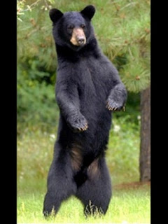](http://1.bp.blogspot.com/-XdTx62POmMk/VclH4SckoeI/AAAAAAAAAO4/KE4sIE_HCa4/s1600/wallpaper_20110520103051_9992808672.jpg)

* **Bear Hug:** With a successful bite attack against a foe of the same SZ or smaller, bears can attempt a free Wrestle maneuver with their claws.  This grants them additional damage dice to roll on their attacks, as noted in the individual species descriptions.
* **Dream Time:** Bears hibernate for weeks on end, during which time they are subject to lucid dreams and visions.  This grants them a +2 bonus on all Seer checks for the rest of the year, even if they do not have Seer as their niche.  They are also subject to recalling these dream time visions during their waking days, if the BM deems such visions relevant to the character's current situation.  However, these visions are involuntary, and the bear has no innate control over them. She can, however, make a Seer lore check to try and affect either the intensity or the duration of the vision. In campaign settings where magic and the spirit world are real, this ability also means that bears spend time traveling in the ethereal plane during hibernation, though they are usually invisible to others there and unable to affect what they witness.
* **Growth Spurts:** All bears begin play at Small size.  Black bears reach Medium size at 2nd Total Levels, while grizzlies reach Medium at 4th and Large at 8th.  Polar bears become Medium at 3rd level, and Large at 6th.
* **Low-Light Vision**
* **Scent**
* +2 bonus on all lore checks that involve climbing.  This bonus becomes +4 if they are climbing rocks or trees.
* **Suitable Niches:**  [Guardian](http://greatandsmallrpg.blogspot.com/2015/04/new-niche-guardian.html), Healer, Herbalist, Runner, Scout, Seer, Warrior.

**Black Bears**  
Black bears have all the standard bear traits, except as noted below.  
  
**Species Traits:**

* **Bear Hug:**  On a successful Wrestle attack, black bears do an additional 2d3 [2d4] hp of damage.

[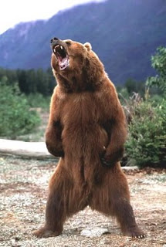](http://4.bp.blogspot.com/-3n3uhuKU6NU/VclH3ziDATI/AAAAAAAAAOs/L6DqTqslZmw/s1600/bear+roar.jpg)**Grizzly Bears**  
Grizzlies have all the standard bear traits, except as noted below.  
  
**AC: 8**  
**AT (Dam):** 1 bite (1d10), 2 claws (1d7 [1d8])   
**Beginning HP:** 9 [10]  
**Species Traits:**

* **Bear Hug:**  On a successful Wrestle attack, grizzly bears inflict an additional 2d7 [2d8] hp of damage.

**Polar Bears**  
Polar bears have all the standard bear traits, except as noted below.  
  
**AT (Dam):** 1 bite (1d10), 2 claws (1d5 [1d6])  
**Beginning HP:** 9 [10]  
**Habitat:** Temperate, arctic, sub-arctic forests, mountains, seashore.  
**MV:** 8; 6 swimming

[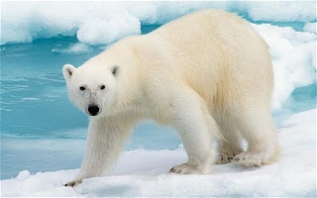](http://4.bp.blogspot.com/-wfY8mqeAnP0/VclH3-9dzrI/AAAAAAAAAPA/Ga7wUKU85w4/s1600/BBX8JM_1964794c.jpg)

**Species Traits:**

* **Bear Hug:** On a successful Wrestle attack, polar bears inflict an additional 2d5 [2d6] hp of damage.
* **Camouflage:** In heavy snow or ice environments, polar bears get a +2 bonus on Trickster checks to hide.
* **Snow Walkers:**  Polar bears' wide feet allow them to walk on snow packs without sinking.

**Panda**

Pandas are to their fellow [bears](http://greatandsmallrpg.blogspot.com/2015/08/featured-creature-bears.html) as [cheetahs](http://greatandsmallrpg.blogspot.com/2015/12/featured-creature-cheetah.html) are to other cats: technically a relative, but "weird" enough compared to them that they stand apart. Unlike other bears, they do not hibernate for the winter, and almost never eat meat. They also have strange "thumbs" that have become legendary among those who study the history of life.  
  
Pandas are serene and ponderous (other bears say, "lazy"), and have an even greater association with meditative and spiritual practices than their cousins in other lands. Almost purely vegetarian, they are peace-loving and playful to a fault, but still capable of handling themselves in a fight if necessary.  
  
**AC:** 6   
**AT (Dam):** 1 bite (1d5 [1d6]), 2 claws (1d3)   
**Beginning HP:**7 [8]   
**Habitat:** Temperate forest and mountains  
**MV:** 6  
**SZ:** Medium  
  
**Species Traits**:

* **Calming Presence**: Pandas inspire stillness in others.  Simply being in their presence grants other animals a +2 bonus on Seer checks or other lore checks that involve concentration, and a +1 bonus on Fear saves and other rolls to resist a forced shift in Attitude.
* **Low-Light Vision**
* **Panda's Thumb**: Pandas have a "mutant" radial sesamoid bone that functions almost like a thumb, and makes them better at grasping small objects than other bears.  They get a +1 bonus on all lore checks that involve tool use or manipulation of objects (but not trap-springing, sleight of paw, or other uses that mimic the use of true hands).
* **Scent**
* **Still Mind**: It's difficult to get a panda riled up.  Storyteller lore checks attempting to shift their Attitude in a more hostile direction suffer a -2 penalty.  Pandas also get a +2 bonus on Fear saves.
* **Unique Diet**: Pandas are the only bears naturally capable of eating bamboo, their favorite and almost only food.  They get a +2 bonus on all Herbalist lore checks involving the use of bamboo, and with a successful Challenging Healer lore check, can boost their natural healing capability by 50% per day by eating a dose of bamboo.
* +2 bonus on all lore checks that involve climbing.  This becomes +4 if climbing rocks or trees.
* **Suitable Niches**: Guardian, Healer, Herbalist, Seer

**Boar**

This is the first Featured Creature entry using a format compatible with the [rules revisions](https://drive.google.com/file/d/0B-T2-uWej8Y3VExaeVNSOGtRUnc/view?usp=sharing) I posted last night.  The previous Featured Creatures and other creatures on the blog will be updated to be compatible soon.

[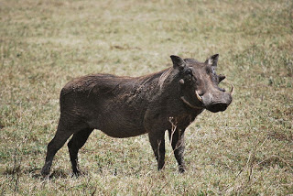](http://4.bp.blogspot.com/-ssYRMor13hE/VfDOK4DSXBI/AAAAAAAAAVE/bQZl44N243E/s1600/warthog8.jpg)

Boars are among the most aggressive mammals in the wild, remarkable especially since they are not typically predators.  They rarely back down from a fight, and have a reputation for fearlessness that borders on insane disregard for their own safety, though it is possible that many of them are over-compensating.  For this reason, boars (especially males of the species) are revered as warrior totems by many longpaw cultures... and also hunted by them, for it is believed that eating a boar imbues one with the animal's ferocity in battle.  
  
Most wild boars live in matriarchal societies composed of related adult females and their young (of both sexes).  Adult males are typically solitary during the mating season, but rejoin a herd led by their female kin for the rest of the year.  
  
The stats presented here can represent any type of wild boar species (including razorbacks and warthogs), but are not suitable for domesticated pigs.   
  
      **AC**: 7  
      **Att. (Dam.)**: tusks (1d7+1) [2d4]  
      **Beginning HP**: 7 [8]  
      **Habitat**: Any, but prefer temperate forests  
      **MV**: 6  
      **SZ**: Small  
  
**Species Traits**:

|  |
| --- |
| [http://1.bp.blogspot.com/-SnyD3cNBU_A/VfDOLOn_KKI/AAAAAAAAAVA/jld6C8yg9lk/s320/pumbaa_tf__request__by_braverunner-d8ve4u7.png](http://1.bp.blogspot.com/-SnyD3cNBU_A/VfDOLOn_KKI/AAAAAAAAAVA/jld6C8yg9lk/s1600/pumbaa_tf__request__by_braverunner-d8ve4u7.png) |
| Pumbaa from *The Lion King* |

* **Growth Spurt**:  Boars reach full maturity at 3rd Total Level, becoming Medium in SZ.
* **Low-Light Vision**
* **Scent**
* **Tenacity**: Boars are not easily intimidated, and can fight longer than many other species.  In non-lethal conflict, they can choose the better of two Threat checks they are forced to roll.  In combat, they do not have to make a Trauma save to avoid dying until they reach -5 hp.
* **Venom Resistance**:  +4 on all Poison saves to resist the effects of snake venom (and other poisonous bites).
* +1 bonus on lore checks to push, pull, drag, break, or otherwise use their raw muscle power on heavy objects.
* +2 bonus on lore checks to hide and move silently in forest underbrush.
* **Special Maneuvers**: Charge, Gore.
* **Suitable Niches**: Herbalist, Runner, Scout, Trickster, Warrior.

**Camel**

Back on track with the alphabetical animal listings from the *Rules Cyclopedia*.  
  
**Camel**

[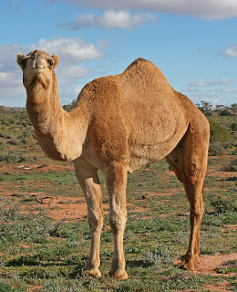](http://2.bp.blogspot.com/-Y7Q1nxVt40Y/VlaVcB8qJVI/AAAAAAAAAZM/LLe_YvCoe_s/s1600/07._Camel_Profile%2C_near_Silverton%2C_NSW%2C_07.07.2007.jpg)

There are two extant species of camel in most worlds: one-humped (dromedaries) and two-humped (bactrian), both of which are exceptionally well-adapted to life in arid climes.  Like horses, they have a long association with longpaws as service animals, companions, and even war mounts.  But unlike horses, they never seem to have gotten over their foul disposition towards longpaws; they are notorious for their bad tempers and moody behaviors.  Nonetheless, they are sturdy beasts and faithful companions, able to weather environments that end lesser animals quickly.  
  
     **AC**: 7  
     **AT (Dam)**: Bite (1 HP), hoof (1d3 [1d4])  
     **Beginning HP**: 7 [8]  
     **Habitat**: Arid lands (Bactrian), desert (dromedary)  
     **MV**: 10  
     **SZ**: Medium  
  
**Species Traits:**

* **Arid Adapted**: Camels need less water than other animals, and can function longer in hot, dry climates, as well.  A well-watered camel can travel for two weeks without needing to drink water.  After this, she needs only to make a Trauma save vs. dehydration every 36 hours, instead of the normal 24 hours.
* **Growth Spurt**: Camels become Large at 2 Total Levels/Hit Dice
* **Low-Light Vision**
* **Scent**
* **Spit Attack**: Camels are prone to spitting at targets who aggravate them.  While this inflicts no actual damage, it does require an attack roll to successfully spit upon a target.  The subject of a spit attack must make a successful Blast save or be partially blinded until she cleans out her eyes.  This inflicts a -2 penalty on all attack rolls and lore checks until the camel's phlegm is removed from her eyes.
* +4 bonus on all endurance-based lore checks
* +2 bonus on lore checks to detect noise and spot hidden attempts.
* **Suitable Niches**: Any

**Cats, Big**  
The name "big cat" covers a range of feline predators in various climates and habitats who are larger than domestic cats but smaller than the great lions and tigers.  This includes bobcats, cougars, jaguars, leopards, lynxes, mountain lions, ocelots, and panthers.

[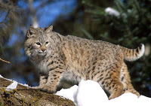](http://1.bp.blogspot.com/-GfxS7wPXA-Q/Vmi0Jb4JDtI/AAAAAAAAAZo/t7-1dHOXjmk/s1600/bobcat3.jpg)

[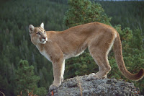](http://2.bp.blogspot.com/-LJJaW7-cXRA/Vmi0Knm_ASI/AAAAAAAAAaI/9kWBup6CIyw/s1600/o-COUGAR-facebook.jpg)

[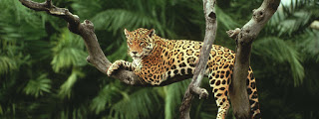](http://3.bp.blogspot.com/--6YW3wUgbaQ/Vmi1sJmbfII/AAAAAAAAAag/srk_3mzZsDQ/s1600/jaguar.jpg)

[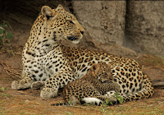](http://1.bp.blogspot.com/-iVbohoNlpJw/Vmi0KTaAlJI/AAAAAAAAAZ4/NdtL0QHkPNs/s1600/leopard-lessons-615.jpg)

[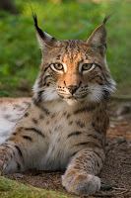](http://3.bp.blogspot.com/-KYM1QJtfVus/Vmi0JZ5iZYI/AAAAAAAAAZk/x0WkuJ5XzIY/s1600/Lynx_lynx_poing.jpg)

[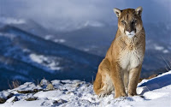](http://2.bp.blogspot.com/-pFt9GKsbYDk/Vmi0JVcQOEI/AAAAAAAAAZg/dsmA4GZPkUw/s1600/Mountain_Lion-animal_desktop_wallpaper_medium.jpg)

[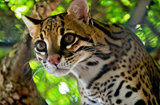](http://2.bp.blogspot.com/-fyTij4VjOys/Vmi0bsr-jCI/AAAAAAAAAaQ/h_A0S7f1Rbs/s1600/ocelot2-Dan-Bodenstein1.jpg)

[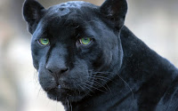](http://3.bp.blogspot.com/-fTpYVJ4iRjo/Vmi1F6m4F5I/AAAAAAAAAaY/-b_NRIF5Y3A/s1600/panther-06.jpg)

    
Like their kin at either end of the feline size range, big cats tend to be curious, patient, solo hunters adept at stealth and ambush tactics.  They are good climbers with reputations for both ferocity and wisdom in equal measure, and love a good prank at the expense of their kin or even potential prey.  
  
     **AC**: 4  
     **AT (Dam)**: 1 bite (1d7 [1d8]), 2 claws (1d3 [1d4])  
     **Beginning HP**: 7 [8]  
     **Habitat**: Any, varies by species  
     **MV**: 10  
     **SZ**: Small  
  
**Species Traits:**

* **Growth Spurt**: Except for bobcats and lynxes, big cats become Medium at 2nd Total Levels/Hit Dice
* **Low-Light Vision**
* **Nine Lives**: Cats can re-roll nine critical failures over the course of their career.  Often, this will mean the difference between life and death; hence, the name *nine lives*.  Once these “lives” are used up, they cannot be restored.
* **Scent**
* **Special Maneuvers**: Claw/claw, bite/claw/claw, pounce, rake, wrestle
* [**Ultravision**](http://greatandsmallrpg.blogspot.com/2015/02/on-beyond-purple-taking-back-ultravision.html)
* +2 bonus on all lore checks to climb, hide in shadows, and move silently. The bonus is +4 in tall grass or other thick foliage.
* **Suitable Niches**: Any

**Cheetah**

Cheetahs are about as un-cat-like as an animal can get and still be considered a cat; indeed, some big cats and great cats consider them freaks of nature, while cheetahs themselves take pride in the features that set them apart from other felines.  Cheetah evolution diverged from that of big cats and great cats some five million years ago, and has continued distinguishing them ever since.

[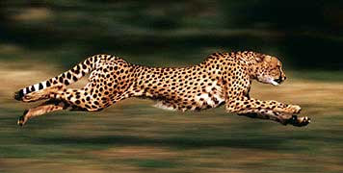](http://1.bp.blogspot.com/-Pnosm_e41mY/Vmi-b4_finI/AAAAAAAAAa0/1hwTCRbq7Ng/s1600/Running-cheetah.jpg)

Unlike other cats, cheetahs primarily rely on great speed to capture their prey, and they make poor warriors against other animals of their size.  If a fight cannot be won right away, cheetahs will flee the conflict at top speed.  Though this gives them a reputation for cowardice among other cats, cheetahs like to point out how much their speed is envied by them, too.  Cheetahs are the fastest land animals in existence, and they don't let anyone forget it.  
  
     **AC**: 6  
    **AT (Dam)**: 1 bite (1d5 [1d6]), 2 claws (1d3 [1d4])  
     **Beginning HP**:  7 [8]  
     **Habitat**: Savannah  
     **MV**: 12  
     **SZ**: Small  
  
**Species Traits**:

* **Epic Sprint**:  When taking a charge or run maneuver, cheetahs can travel up to 10 times their base MV in a single round.  They can do this a number of times per day equal to their Total Level; if they exceed this amount, cheetahs have to make a Trauma save or suffer the effects of fatigue (-2 on all lore checks involving feats of strength or endurance) until they obtain a full 8 hours of rest.
* **Growth Spurt**: Cheetahs increase to Medium SZ at 3rd Total Level/Hit Dice.
* **Low-Light Vision**
* **Scent**
* **Special Maneuvers**: Charge, Claw/Claw, Pounce, Rake, Wrestle
* [**Ultravision**](http://greatandsmallrpg.blogspot.com/2015/02/on-beyond-purple-taking-back-ultravision.html)
* +4 bonus on all lore checks to make quick turns, sudden stops, or other fast movements during a combat round.
* +1 bonus on all lore checks to climb, hide in shadows, or move silently.  The bonus is +3 in tall grass or other thick foliage.
* **Suitable Niches**: Runner, Scout, Seer, Trickster.

**Cat, Great**  
Among the most adored, feared, loved, and respected animals in the natural world, great cats are living symbols of power, nobility, and savagery.

[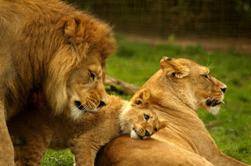](http://1.bp.blogspot.com/-m_q7odae-wA/Vbro0olLSqI/AAAAAAAAANU/GxmuwGqg7fM/s1600/Lion_Family__by_TheSilverLotus.jpg)

One of them, the lion, is widely known as the "king of the beasts," and typically acts like it in the worst possible way.  Despite their reputation among longpaws, most male lions are lazy bullies who spend their day lounging about their prides' lair while the females do most of the hunting.  Male lions are polygamists with a tendency to murder the children of their wives' previous mates, but some stray from this behavior and strive to live up to their species' noble reputation.  Female lions, as noted, do most of the hunting and child-rearing among their kind, and are thus far more gregarious towards outsiders, often of necessity.  Indeed, lions are unique among cats in being group hunters.  
  
Tigers, like lions, are polygamous, though far less social.  They possess such fearsome reputations that many longpaw communities actually worship them as minor deities and offer them sacrifices in the hopes of avoiding the tigers' wrath.  Sometimes, this works.  But other times, it feeds the tiger's ego and leads her to expect more from her subjects, which only makes them more terrified.

[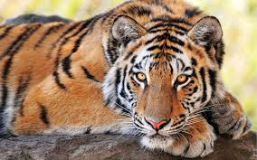](http://3.bp.blogspot.com/-n_ly2p2xyj8/VbrpCurDgAI/AAAAAAAAANc/_UG5eFFtyQk/s1600/images.jpg)

In spite of these fearsome traits, however, great cats, like their smaller kin, are highly curious and playful.  They will often track or follow a group of other animals just to see what they are up to, and this sometimes creates a sense of responsibility for these animals in the cat's mind.  They are also quite stealthy and shy, and when not hunting for food, great cats prefer to avoid confrontation even with obviously weaker foes.  If startled or attacked, they will just as often flee the area as stand and fight, particularly when they are alone.  
  
Great cats possess amplified versions of the game traits of [small cats](http://greatandsmallrpg.blogspot.com/2015/02/featured-creature-small-cat.html), as noted below.  
  
**AC:**6  
**AT (Dam):** 1 bite (1d7 [1d8]), 2 claws (1d5 [1d6])   
**Beginning HP**: 9 [10]  
**Habitat**: Tropical to temperate forest, grasslands, savannah.

**MV:** 10

**SZ**: Small

**Species Traits**:

* **Growth Spurt:** Lions go up a Size category to Medium at 3rd Total Level, and then to Large at 5th Total Level.  Tigers go up to Medium at 3rd Total Level, as well, but do not achieve Large Size until 6th Total Levels.
* **Low-Light Vision**
* **Nine Lives:**Cats can re-roll nine critical failures over the course of their career.  Often, this will mean the difference between life and death; hence, the name *nine lives*.  Once these “lives” are used up, they cannot be restored.
* **Scent**
* **Special Maneuvers**: Claw/Claw, Bite/Claw/Claw, Grapple, Pounce, Rake
* [**Ultravision**](http://greatandsmallrpg.blogspot.com/2015/02/on-beyond-purple-taking-back-ultravision.html)
* +2 bonus on all lore checks to climb, hide in shadows, and move silently. The bonus is +4 in tall grass or other thick foliage.
* +3 on all Warrior lore checks involving feats of strength.
* **Suitable Niches**: [Guardian](http://greatandsmallrpg.blogspot.com/2015/04/new-niche-guardian.html), Runner, Scout, Trickster, Warrior

**Small Cat**

NOTE: These stats have been edited to conform to the [rules revisions](https://drive.google.com/file/d/0B-T2-uWej8Y3VExaeVNSOGtRUnc/view?usp=sharing) posted on 9/8/15.  
    
Two things utterly fascinate cats: chases, and secrets. This simple fact explains their close association with longpaws – gullible targets who cling to the unspoken and hidden things in their lives more preciously than to their shiny trinkets. Cats are often considered pampered slaves of humans by other animals, but this is all part of their ruse. The cats know who’s really in charge.

|  |
| --- |
| <http://4.bp.blogspot.com/-5fS8ZPcvCnM/VN0PQLWbpOI/AAAAAAAAAF8/IfML_-AFuN0/s1600/10568836_10154475193940352_2368921500269120725_n.jpg> |
| **"I can haz advenjur?"** |

**AC:** 6  
**AT (Dam):** 1 bite (1d3 [1d4]), 2 claws (1d2 [1d3])  
**Beginning HP**: 3 [4]

**Habitat**: Any

**MV:** 12

**SZ**: Tiny

**Species Traits**:

* **Low-Light Vision**
* **Nine Lives:**Cats can re-roll nine critical failures over the course of their career.  Often, this will mean the difference between life and death; hence, the name *nine lives*.  Once these “lives” are used up, they cannot be restored.
* **Scent**
* **Special Maneuvers**: Claw/Claw, Bite/Claw/Claw, Grapple, Pounce, Rake
* [**Ultravision**](http://greatandsmallrpg.blogspot.com/2015/02/on-beyond-purple-taking-back-ultravision.html)
* +2 bonus on all lore checks to climb, hide in shadows, and move silently. The bonus is +4 in tall grass or other thick foliage.
* +1 on all lore checks to interpret human behavior, or deduce the function of human-crafted devices
* **Suitable Niches**: Runner, Scout, Trickster, Warrior

**Chameleon**

A few weeks back, a reader inquired if I planned to stat out chameleons, geckos, and other lizards.  I thought I might create a stock "Lizard" entry with sub-headings for different species, the way I've done with apes, cats, and monkeys.  It's quite a challenge, though, because lizards are an amazingly diverse clade; aside from being squamate reptiles, there is little that all lizards have in common.  So, I've decided to go with individual species entries instead.  First up is chameleons.

[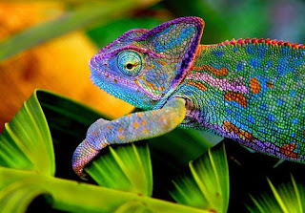](http://4.bp.blogspot.com/-o43LQdhtlXQ/Vg9SvXdkj6I/AAAAAAAAAXA/X1JlYRroZh8/s1600/chameleon-4.jpg)

**Chameleon**  
Like many of their kin, chameleons are deliberative -- indeed, seemingly inactive -- taking their time to reach any decision.  But once decided on a course of action, they act swiftly.  This is especially true where acquiring food is concerned.  
  
Though they are fully capable of terrestrial movement, chameleons prefer spending as much of their time as possible hidden among the flowers and leaves of their canopy home.  When long journeys are called for, they demand to be carried by larger, stronger, faster beings at every opportunity, and thus have a reputation for laziness.  
  
     **AC**: 6  
     **AT**: Bite (1d2)  
     **Beginning HP**: 3 [4]  
     **Habitat**: Tropical forest  
     **MV**: 4  
     **SZ**: Tiny  
  
**Species Traits:**

* **Adaptive Camouflage**
* **Independently Focusing Eyes**: Chameleons have amazing eyesight.  Because they can focus each eye independently, they have 360 degree vision, and can only be surprised while asleep.  Further, they are immune to sneak attacks, unless both of their eyes are engaged in paying attention to the same target. In addition, chameleons get a +2 bonus on all lore checks that involve detecting things by sight.
* **Low-Light Vision**
* **Prehensile Tail**
* +4 bonus on all lore checks involving climbing.
* +2 bonus on all attack rolls against targets smaller than themselves.
* -4 penalty on all lore checks involving feats of strength
* **Suitable Niches**: Any

**Crocodilian**  
Other than the great cats, crocodilians are perhaps the most feared predators on land, for they will eat anything or anyone they can catch in their powerful jaws.  They specialize in striking suddenly from a well-hidden position; so suddenly, in fact, that potential allies have little time to notice them, let alone establish parley, and so often become victims.  Despite their prowess, though, crocodilians rarely leave their habitat, and thus have limited knowledge of the world beyond their swamps and wetlands.  Like lizards and snakes, they are deliberative and ponderous, but swift and deadly when finally taking action.

[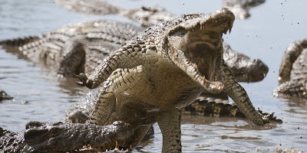](http://2.bp.blogspot.com/-3IVgln2kB3c/VkUHjgKfvhI/AAAAAAAAAY4/iYqCTW02Gzs/s1600/o-CROCODILE-facebook.jpg)

There are three main kinds of crocodilians: alligators (which includes caimans), crocodiles, and gharials.  In a reality-lite setting, they will occupy separate continents but have very similar habits, while in a fantasy setting, they can mingle more or less freely.  The listed game stats cover all three types.  
  
     **AC**: 5  
     **AT (Dam)**: Bite 1d7 [1d8], Tail slap 1d5 [1d6]  
     **Beginning HP**: 7 [8]  
     **Habitat**: Semitropical, tropical swamps & wetlands  
     **MV**: 5, swim 6  
     **SZ**: Small  
  
**Species Traits**:

* **Death Roll**
* **Fast Swimmer**:  Crocodilians can use the run action while swimming, provided they only move in a straight line.
* **Growth Spurt**: Crocodilians become Medium at 2nd Total Level
* **Hold Breath**: Crocodilians can hold their breath for 10 minutes + 1 minute per Total Level/Hit Dice.
* **Low-Light Vision**
* **Surprise Attack**:  If successfully hidden at the beginning of a combat round, crocodilians surprise their foes on a roll of 1-3.
* +4 bonus on all lore checks that involve swimming.
* +2 bonus on checks to hide or move silently in the water.  This bonus becomes +5  if the character lies under the water with only her eyes and nostrils above the surface.
* **Suitable Niches**: Any

**Death Bringer, King Crocodile, Darklord of Ravenloft's Wildlands**  
This great monster began life as a typical crocodile in a distant land that closely resembled sub-Saharan Africa.  When longpaws first arrived in this land, the other animals lived in fear of their weapons and mastery of fire, finding themselves driven further and further from their original home habitats.  It was then that Death Bringer seized his opportunity.  He visited all the other animals of his land, and made a pact with them: in exchange for a bit of their power, he would slay all the longpaws.  The other animals quickly agreed to this pact, for none of them had been able to defeat the longpaws on their own.  
  
With each ritual infusion of other animals' power, Death Bringer grew larger in size and more versatile in his capabilities.  After the last longpaw was slain, he declared himself King Crocodile, and refused to return any of the other animals' power to them.  Instead, he began to prey upon his fellows, and became a horrible tyrant.  It was then that the Mists claimed him, and created the Wildlands as his domain.  
  
The following stats use the Rules Cyclopedia entry for a giant crocodile as their base, with spandrels added on from each of the other species in the Wildlands, representing the powers Death Bringer claimed from them.  
  
Death Bringer possesses all the standard crocodilian traits, except as noted below.  
  
**Death Bringer, 15th-level giant crocodile (Warrior)**  
     **AC**: 1  
     **AT (Dam)**: Bite 3d7 [3d8], tail slap 3d5 [3d6]  
     **HP**: 98  
     **SZ**: Huge  
  
**Spandrels**:  In addition to the standard crocodilian traits, Death Bringer possess the following traits claimed from other species of animals through dark pacts born of fear and vengeance.

* **Brachiation**(claimed from the apes)
* **Prehensile Tail**(claimed from the monkeys)
* **MV 8 on land** (claimed from the elephants)
* **Nine Lives** (claimed from the lions)
* **Scent**(claimed from the herdbeasts)
* **Venom Resistance** (claimed from the boars)

**Dog**

NOTE: These stats have been edited to conform to the [rules revisions](https://drive.google.com/file/d/0B-T2-uWej8Y3VExaeVNSOGtRUnc/view?usp=sharing) posted on 9/8/15.  
    
Dogs are the cleverest and most versatile of the animals, at least to hear them tell it.  They tamed humans and have shepherded civilization for thousands of years, all while fooling the longpaws (their name for humans) into thinking it was their idea the whole time.  As the species with the most intimate experience with human ways, and the greatest exposure to human knowledge, dogs are indeed highly flexible beasts.

[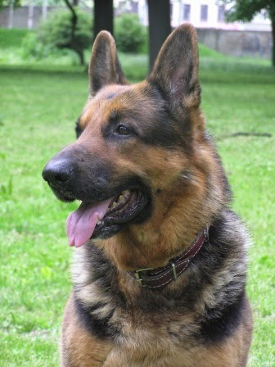](http://3.bp.blogspot.com/-wZm_solMkeQ/VN0VVjm4IbI/AAAAAAAAAGM/LiA3GhnVGMY/s1600/dog_4.jpg)

**AC:** 7  
**AT (Dam):**Bite 1d3 [1d4]  
**Beginning HP**: 7 [8]  
**Habitat**: Any  
**MV**: 12   
**SZ**: Tiny  
  
**Species Traits:**

* **Growth Spurt**: Many dogs remain Tiny, but some breeds can grow to be Small or even Medium. Dogs have the option of gaining a Size Category at 2 Total Levels and again at 5 Total Levels, but are never required to do so (depending on the breed the player  chooses).
* **Low-Light Vision**
* **Scent**
* [**Ultravision**](http://greatandsmallrpg.blogspot.com/2015/02/on-beyond-purple-taking-back-ultravision.html)
* **Versatility**: Thanks to their close association with longpaws, dogs are quite flexible in their abilities. They have a permanent +2 bonus to all checks with a single lore of their choice outside their niche, chosen at 0-level and remaining the same throughout their life.
* +2 on all lore checks to interpret human behavior, or deduce the function of human-crafted devices.
* +2 on all lore checks when tracking by sense of smell
* **Suitable Niches**: Any

**Dolphin**

Dolphins have a reputation among longpaws as playful, benevolent sea creatures with great affection for land-dwellers.  But at best, they only half-deserve this reputation.  
  
[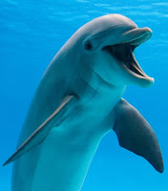](http://2.bp.blogspot.com/-xoV5gplFDJg/VmtoRsSbkPI/AAAAAAAAAbI/Asu0T9IEXs0/s1600/Bottlenose_dolphin_1603341a.jpg)Much of it comes from the dolphins' ancient feud against shark-kind; whenever a dolphin or group of dolphins protects a swimming longpaw from sharks, it is mostly to deny the shark a meal and not because they have any special affection for humanoids.  
  
Dolphins are also predators, so from the point of view of many fish species, they are fearsome monsters.  Even among themselves, dolphins are prone to violent rivalries and even sexual assault, with losers of conflicts often finding themselves in lonely exile for the rest of their lives.  
  
Nonetheless, dolphins are highly intelligent and social creatures, usually forming strong bonds of friendship within their pods.  In classic fantasy-style campaigns, they can even become [Magic-Users](http://greatandsmallrpg.blogspot.com/2015/08/the-magic-user-niche.html), and often form alliances with longpaw races like merfolk and sea elves.  
  
     **AC**: 5  
     **AT (Dam)**: 1 head butt (1d7+1 [2d4])  
    **Beginning HP**: 9 [10]   
     **Habitat**: Oceans  
     **MV**: 12 swimming only  
     **SZ**: Medium  
  
**Species Traits:**

* **Air Breathers**:  Unlike most sea creatures, dolphins cannot breathe water.  They must surface every 15 minutes to take in fresh air.  They can extend this time between breaths by 1 minute per Total Level, after which they must begin making Trauma saving throws.  Failure on this save means they have begun drowning, and must be aided to the surface by companions or they will die.
* ***Detect Magic***: In high fantasy campaigns, dolphins can *detect magic* to a range of 360 feet underwater.
* **Echosight**: Dolphins can "see" by means of a natural form of sonar that has a range of 120 feet, enabling them to detect objects or creatures within this range.  If blinded, they can even rely on this echosight to continue acting normally with a successful Scout lore check each round (or other relevant unit of time). This ability is negated by spells or other effects that create areas of unnatural silence.
* **Far Speech**: Dolphins can communicate with each other over a range of 50 miles underwater, using their language of clicks and whistles (related to whale speech).
* **Growth Spurt**:  Dolphins become Large in SZ at 3rd Total Level/Hit Dice.
* **Legless**:  Dolphins have no natural means of moving about on dry land.   Without the aid of magic or super-science, they are confined entirely to aquatic environments.
* **Low-Light Vision**
* +2 bonus on all Warrior lore checks to formulate plans against sharks and their allies.
* +1 bonus on all attacks vs. sharks and their allies.
* +2 bonus on all lore checks to detect hidden objects or hear noise while underwater.
* **Suitable Niches**: Healer, Runner, Scout, Seer, Trickster, Warrior.

**Eagle**  
Among the noblest and most majestic of raptor birds, eagles range most of the world and prey on all manner of species.  They have even been known to attack prey larger than themselves, and are in fact one of the physically strongest flying birds in all the animal kingdom.  
  
In fantasy realms, eagles often ally with elves and other fey creatures, especially in times of war against goblins, orcs, and the twisted worg wolves who serve them.  
  
To small terrestrial species, eagles are a nightmare from the sky, but they are also respected for their courage.  Potential prey approaching an eagle would do well to shower the bird with flattery, as eagles are quite susceptible to their own self-image as the kings of the birds.  
  
     **AC**: 7  
     **AT (Dam)**: 2 claws, 1 bite (1d2/1d2/1d4)  
     **Beginning HP**: 5 [6]  
     **Habitat**: Sub-arctic to sub-tropical  
     **MV**: 2; flying 12  
     **SZ**: Small  
  
**Species Traits:**

* **Excellent Vision:** Eagles can see three times better than a longpaw under normal conditions, granting them a +4 bonus on all lore checks to spot hidden objects or track moving targets on the ground from great heights.
* **Flyby Attack**
* **Great Strength**: Eagles are among the strongest flying birds in existence; some have been known to lift targets three times their own body weight into the air.  They get a +2 bonus on all lore checks involving airborne feats of strength made against targets on the ground.
* **Low-Light Vision**
* **Spatial Awareness**: Like other flying birds and most sea creatures, eagles can easily think and fight in three dimensions. They suffer no penalties in "aerial" combat against land-dwelling creatures who enter their habitat.
* **Swoop**: Eagles can mount a flying charge attack against creatures at a lower altitude.  This gives them a +2 to hit and lets them inflict double damage on their target.  However, it imposes a 2-point penalty on their Armor Class.
* [**Ultravision**](http://greatandsmallrpg.blogspot.com/2015/02/on-beyond-purple-taking-back-ultravision.html)
* +6 bonus on all move silently checks while airborne
* **Suitable Niches**: Herbalist, Runner, Scout, Warrior

**Elephant**

[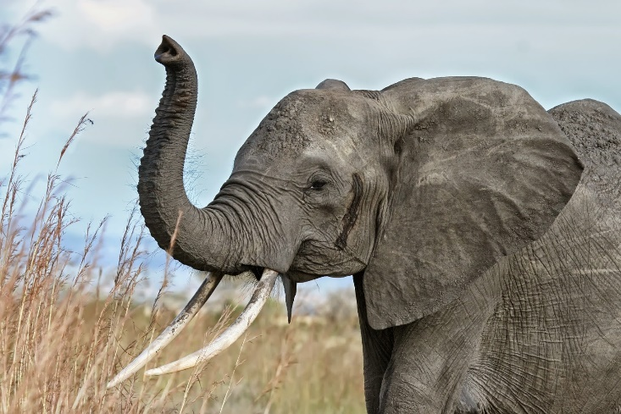](http://3.bp.blogspot.com/-5DqhywBY17U/VPJUn1Qsp_I/AAAAAAAAAHw/pQBC-7pEhDk/s1600/African_elephant_warning_raised_trunk.jpg)

NOTE: These stats have been edited to conform to the [rules revisions](https://drive.google.com/file/d/0B-T2-uWej8Y3VExaeVNSOGtRUnc/view?usp=sharing) posted on 9/8/15.  
    
Said to have the longest memories of any land animal, elephants are the archetypal repositories  of ancient wisdom; some of their Seers can tap a well of racial memories that stretches back to a time before longpaws walked on two feet.  Though feared and respected for their great strength, elephants have a gentle disposition and a great capacity for empathy.  Many of them, however, look with scorn upon the longpaws, who often hunt them for the ivory in their tusks.  And despite the gentle natures, an enraged or rogue elephant is one of the most powerful and nearly-unstoppable forces in the animal kingdom.  
  
**AC:** 5  
**AT (Dam.):**Stomp x2 (1d7+1 [1d8])  
**Beginning HP:** 10   
**Habitat:** Temperate or Tropical (jungle, plains, woodlands)  
**MV:** 8  
**SZ:** Medium  
  
**Species Traits:**

* **Growth Spurt:** Elephants become Large at 5th Total Level, and Huge at 10th.
* **Natural Insight:** Elephants get a +1 bonus on all Seer lore checks
* **Prehensile Trunk:** Elephants' long noses can be used almost like a hand.  They can grasp objects, manipulate tools, and even swing weapons.  Elephants can use their trunks to perform Scout lore and Trickster lore checks related to these activities, but suffer a -4 penalty to any attempt to wield weapons with their trunks.
* **Special Maneuvers:** Charge, Gore, Trample
* Elephants automatically fail lore checks that involve jumping.
* +4 bonus on Warrior lore checks to push, pull, drag, break, or otherwise use their raw muscle power on heavy objects.
* **Suitable Niches:** Healer, Runner, Scout, Seer, Storyteller, Warrior

**Fey Pony**

"*Ponies are a race whose time has come and left. According to their legend and lore, they once oversaw nature, guiding and protecting it much like contemporary druids: controlling the weather,overseeing animal migrations, and protecting the lands they called home. They have surrendered much of these tasks over time, but their spirit is not yet faded. Most ponykind live in isolated communities, far from civilization, but growing numbers have migrated to join multiracial cities, where they trade, craft, and make their livings.*"  
-- ***Ponyfinder Campaign Setting***, p. 8.

[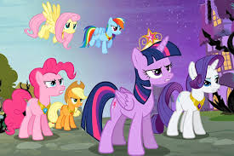](http://3.bp.blogspot.com/-2jkoM3XX7dQ/Vhc5USFsm_I/AAAAAAAAAXw/begiId1mnkc/s1600/images.jpg)

     **AC**: 7  
     **AT**: Bite 1d3 [1d4], two hooves 1d5 [1d6]   
     **Beginning HP**: 7 [8]  
     **Habitat**: Any  
     **MV**: 8 (4 bipedal)  
     **SZ**: Medium  
  
**Species Traits:**

* **Feyborn**:  Ponies and their kin are natives of the faerie realms.  As such, they are considered fey for the purpose of herbal, magical, or other effects that effect or can be used by fey beings.
* **Feyspeech**:  Ponies automatically know and can speak the language of faeries.
* **Low-Light Vision**
* +2 bonus on all Poison saves
* +2 bonus on all saves vs. magic, regardless of save category
* +1 bonus on all Runner lore checks
* +1 bonus all lore checks to push, pull, drag, break, or otherwise use their raw muscle power on heavy objects.
* **Suitable Niches**: Any

**Herd Animal**  
There is great strength in numbers, as any herd beast can tell you.  But this does not mean that individual members of the herd are weak.  Indeed, many herd animals -- such as bison, or male cattle -- are symbols of strength and virulence among other species, and such individuals make for powerful foes on their own terms.  Nonetheless, even such great warriors would not deny that the true strength of the Hoofed Lords (as they like to call their species) lies in their vast herds: a veritable forest of sharp horns and muscled bulk waiting to gore and trample any enemy foolish enough to attack them.  For this reason, most predators prefer herd animal stragglers -- the sick, dying, or those too foolish to stay with the rest of the herd.

[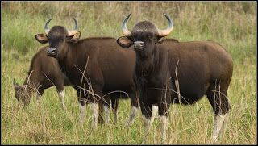](http://2.bp.blogspot.com/-LLs_ErVCvp0/VV5OE19TwEI/AAAAAAAAALA/wM0123SaZPc/s1600/wild+cattle.jpg)

These stats can be used to represent characters from the species of bison, buffalo, cattle, oxen, or other Large grazing ungulates.

**AC:** 7  
**AT (Dam.):**Head butt (1d5 [1d6])  
**Beginning HP**: 7 [8]

**Habitat**: Any, plains  
**MV**: 16  
**SZ**: Medium

**Species Traits**:

* **Gore Bonus**: male herd animals get a +1 bonus to attack rolls when making a Gore attack with their horns.
* **Growth Spurt**: Herd animals gain a Size category at 3rd Total Levels, going from Medium to Large Size.
* **Low-Light Vision**
* **Rouse The Herd:** At 9th Total Level, a herd animal can release a call that sparks her entire herd into action against a single target, be it an individual or a group. This takes the form of a mass Trample attack.
* **Scent**
* +1 bonus on all Scout lore checks to hear noise or detect hidden objects
* +2 bonus on Warrior lore checks to push, pull, drag, break, or otherwise use their raw muscle power on heavy objects.
* **Special Maneuvers**: Gore, Trample
* **Suitable Niches**: Healer, Runner, Scout, Seer, Warrior.

**Horse**

NOTE: These stats have been edited to conform to the [rules revisions](https://drive.google.com/file/d/0B-T2-uWej8Y3VExaeVNSOGtRUnc/view?usp=sharing) posted on 9/8/15.

[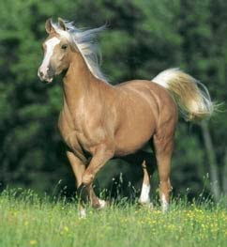](http://2.bp.blogspot.com/-htBFBOg74yI/VNO-RkC1i1I/AAAAAAAAAEw/MI-KSxlvrLE/s1600/Palomino_Horse.jpg)

Horses, like dogs, have a long association with humans, and are nearly as tightly bound to the longpaws as dogs, too.  Many horses pride themselves and their ancestors on their willingness to accompany their human friends into the gravest of dangers.  Some have even become legends in their own right.  Nonetheless, there remain many wild horses in the world, far many more than wild dogs, and such noble steeds are wary of man.

**AC:** 7  
**AT (Dam.):** Bite (1d3), 2 hooves (1d5 [1d6])  
**Beginning HP:** 7[8]  
**Habitat:** Temperate (plains)  
**MV:** 10  
**SZ:** Large  
  
**Species Traits:**

* **Combat Restriction:** Horses who do not take Warrior as their niche must choose bite as their favored attack form.
* **Low Light Vision**
* **Scent**
* +1 bonus on all Runner lore checks.
* +1 bonus on all Warrior lore checks to push, pull, drag, break, or otherwise use their raw muscle power on heavy objects.
* +1 on all lore checks to interpret human behavior, or deduce the function of human-crafted devices
* **Special Maneuvers:** Charge, Kick Back, Trample
* **Suitable Niches:** Runner, Scout, Warrior.

**Bonus Featured Creature!  Half-unicorn**   
In some fantasy worlds, the fey ungulates called unicorns are a randy species, capable of breeding with any equid (horse, pony, zebra) and producing viable off-spring.   Such children are known by many names, depending on the realm, but are here described under the general heading of half-unicorn.    
  
Half-unicorns look mostly like a normal member of their equid species, but careful observers can distinguish their magical heritage with a successful Seer lore check.  Such observers will notice a bony plate on the half-unicorn’s forehead (possibly covered over by the mane), their blue eyes, and (on males) a short, goat-like beard.  Half-unicorns are usually light-colored or have patches of white on their coats, though zebra hybrids can be hard to tell apart in this fashion.   
  
Like their supernatural parent, half-unicorns are renowned for their swiftness and magical abilities, but sometimes live on the fringes of their herds, feeling like they do not belong to either world.

**AC:**4  
**AT (Dam.):**Head-butt (1d5 [1d6]), 2 hooves (1d5 [1d6] each)  
**Beginning HP:** 7 [8]

**Habitat:** Temperate or Tropical (plains)

**MV:** 12

**SZ:** Large

**Species Traits:**

* **Healing Powers:** Once per day, a half-unicorn can heal 1d3 hp of damage on another animal, in a manner similar to Healers.  She must do this by touching her head-plate to the subject.  She gains an additional use of this ability at 4th Total  Level, and again at 8th.
* **Low Light Vision**
* **Scent**
* **Teleportation**: At 5th Total Level, a half-unicorn can teleport herself (and any rider she may be carrying) to any unoccupied space with 60 ft of her current position, once per day.  The range increases to 120 ft. at 10th level.
* +2 bonus on all Runner lore checks.
* +1 bonus on all Warrior lore checks to push, pull, drag, break, or otherwise use their raw muscle power on heavy objects.
* +1 bonus on all Healer lore checks
* +2 bonus on all Charm saves
* **Special Maneuvers:** Charge, Kick Back, Trample
* **Suitable Niches:** Healer, Runner, Scout, Seer, Warrior.

**Manta Ray**  
One of the most fearsome-looking animals in the sea is also one of the most docile.  Manta rays, sometimes called "devil fish" by land-dwellers because of their "horns," are gentle filter-feeders with little interest in or talent for violence.  Often, they are as playful as dolphins or whales, and are known to breach the ocean's surface like those animals, too.  Mantas give birth to live young, who are left to their own devices once emerging from the mother's oviduct.  
  
Manta rays are also one of the smartest sea species in the world, and are renowned among fishes as keepers and teachers of knowledge ancient and new.  Their reputation among fish is similar to that of whales among sea-dwelling mammals: wise, gentle, and honorable to a fault.  
  
     **AC:** 6  
     **AT (Dam)**:  1 slam (1d3 [1d4])  
     **Beginning HP**: 7 [8]  
     **Habitat**: Temperate, tropical, or sub-tropical oceans  
     **MV**: 8  
     **SZ**:  Small  
  
**Species Traits:**

* **Brain Power**: Manta rays have the largest brain-to-body mass ratio of any fish species, making them among the most intelligent animals in the sea.  They get a +2 bonus on all lore checks involving complex problem-solving or tactical thinking.
* **Cold Resistance**:  Mantas possess a mammal-like network of blood vessels in their brain called the retia mirabilia, which helps keep them warm.  This grants them a +1 bonus on all saving throws to resist magical or natural cold.
* **Growth Spurt**: Mantas become Medium in SZ at 4 Total Levels
* **Pressure Tolerance**: Mantas can dive to depths of up to 2000 m (roughly 6500 ft) without suffering any MV penalties due to increased water pressure.
* **Scent**
* **Spatial Awareness**: Like birds and most sea creatures, manta rays think and fight in 3 dimensions.  They suffer no penalties in "aerial" combat against land-dwelling creatures who enter their natural habitat.
* **Suitable Niches**: Any.

**Mole**

NOTE: These stats have been edited to conform to the [rules revisions](https://drive.google.com/file/d/0B-T2-uWej8Y3VExaeVNSOGtRUnc/view?usp=sharing) posted on 9/8/15.  
    
The featured antagonists in the Quick Start adventure, "Secret Of The Spooky Old Warren."  
------------------------------  
[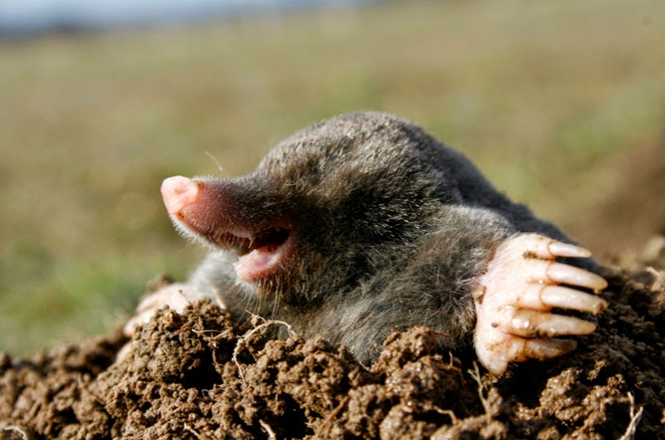](http://3.bp.blogspot.com/-M0OtmwYp2vE/VUFADT7BU7I/AAAAAAAAAKc/UH-hAOX_We4/s1600/HowtoGetRidofMolesinYard.jpg)Moles are masters of stealth and the unseen.  Their society, existing as it does almost entirely underground, is largely invisible to other animals.  As a result, moles are insular and often introverted when not among their own kind.  The isolation of mole society makes them subject to many xenophobic philosophies, with schisms and factional wars common among the larger mole populations.  Nonetheless, moles make good friends, and can be valuable contributors to a mixed-species group.

**AC:** 6  
**AT (Dam.):** bite (1d3)  
**Beginning HP**: 1 [2]

**Habitat**: Any, underground

**MV**: 3 (burrowing)

**SZ**: Diminutive

**Species Traits**:

* **Blindsense**
* **Low-Light Vision**
* **Mole Toxin**: Mole saliva contains a paralytic toxin that is normally only effective against earthworms, their preferred prey.  But with a successful Tough Healer lore check, moles can boost the potency of this toxin for a number of rounds equal to their levels in Healer lore, to a minimum of 1 round.  Any target bitten by the mole during this time must make an Average Poison save, or become paralyzed for 1d3 rounds.  Success on the save means all of the target's actions are suffer a -2 penalty for the next 1d3 rounds.  These effects are in addition to any damage inflicted by the mole's bite.  This attack is subject to the dosage parameters of herbal concoctions and poisons described in the Herbalism rules.
* **Scent**
* **Tunnel Masters**:  Moles are consummate burrowers.  Their burrowing move rate is equal to their land move rate.  The also get a +3 bonus on all lore checks to notice unusual earthenworks, such as traps, recent burrowing, unsafe tunnels, and so forth.
* +2 bonus on all Scout lore checks to set or spot traps in an underground environment.
* +4 bonus on all Trickster lore checks to hide or move silently in an underground  environment.
* **Suitable Niches**: Healer, Herbalist, Scout, Seer, Storyteller, Trickster.

**Monkey**

NOTE: These stats have been edited to conform to the [rules revisions](https://drive.google.com/file/d/0B-T2-uWej8Y3VExaeVNSOGtRUnc/view?usp=sharing) posted on 9/8/15.  
    
The next entry in the old Rules Cyclopedia is "Baboon, Rock"... also not actually a real animal.  However, it's a great occasion of serendipity, since the [previous entry](http://greatandsmallrpg.blogspot.com/2015/06/featured-creature-apes.html) detailed apes, and this one gives me the opportunity to stat out their cousins, the monkeys (yes, baboons are a type of monkey!).  
  
There are two broad groups of monkeys: the platyrrhines, or "New World  monkeys"; and the catarrhines, or "Old World monkeys."  The differences between them are quite distinct (at least in terms of their game stats), but some players and BMs won't care about these distinctions.  In high-fantasy campaigns, it shouldn't matter; in more "realistic" campaigns, the two types of monkeys probably occupy different continents, and will have a fierce rivalry with one another.

|  |
| --- |
| [http://1.bp.blogspot.com/-Ao1a1efXGG8/VbQvjG9CdWI/AAAAAAAAAMc/2fdtSbP7KhY/s320/cebidae1316640771813.jpg](http://1.bp.blogspot.com/-Ao1a1efXGG8/VbQvjG9CdWI/AAAAAAAAAMc/2fdtSbP7KhY/s1600/cebidae1316640771813.jpg) |
| A flat-nose monkey |

Most monkeys are prideful, curious, and extremely intelligent.  Beyond this, they do not have a recognizable stock personality; their temperaments range from meek to aggressive, dependent on species.  
  
The following game rules reflect the traits common to the "default" monkey.  Variations on these stats are found in the individual entries that follow.   
  
     **AC:** 5  
**AT (Dam.):** bite (1d3)  
**Beginning HP:** 3 [4]  
**Habitat**: Tropical to temperate forest, savannah, or woodlands  
**MV**: 6; climb  
**SZ:**  Tiny  
  
**Species Traits:**

* **Brachiation**
* **Hands**: Unlike most other species, monkeys have true hands, very similar to those of longpaws.  They a get +2 bonus on all Scout and Trickster lore checks to manipulate fine tools, spring traps, perform "sleight of paw" tricks, and other activities that mimic the use of human hands.
* **Low-Light Vision**
* **Scent**
* +4 bonus on all lore checks that involve climbing, jumping, or swinging from the canopy or similar environments (like the sails and netting of a human ship, for instance).
* -3 penalty on all lore checks involving feats of strength
* Suitable Niches: [Guardian](http://greatandsmallrpg.blogspot.com/2015/04/new-niche-guardian.html), Healer, Herbalist, Runner, Scout, Seer, Trickster.

**Down-Noses ("Old World monkeys," "Catarrhines")**  
As their name implies, the down-noses are classified by the shape of their nose: long and thin, with downward-facing nostrils.  Their ranks contain some of the most well-known types of monkey, such as the baboon and the macaque.    
  
Down-noses take pride in their long matrilineages, and young males are usually the only troop members who leave to seek adventure (females tend to stay with their mothers, or with their mate as part of a "harem").  A typical down-nose community will feature a large female population with one or a handful of males who have multiple mates.  In their own eyes, this makes them more enlightened than their prudish flat-nose cousins.

|  |
| --- |
| [http://1.bp.blogspot.com/-V7pNpBmHWiE/VbQv-Dyd5XI/AAAAAAAAAMk/iAhbVua7zQU/s320/Olive_baboon_Ngorongoro.jpg](http://1.bp.blogspot.com/-V7pNpBmHWiE/VbQv-Dyd5XI/AAAAAAAAAMk/iAhbVua7zQU/s1600/Olive_baboon_Ngorongoro.jpg) |
| A baboon, one of the most famous of the down-noses. |

Among the most distinctive of the down-nose monkeys is the baboon, often mistaken for a type of ape by non-monkeys and non-apes.  However, it is unwise to make this comparison to the face of a baboon or a true ape; both find it highly insulting.  
  
**Species Traits:**  
Baboons possess all the standard monkey traits, except as noted below:  
  
     **AT (Dam.):** bite (1d5 [1d6])  
**Beginning HP:**5 [6]  
**SZ:** Small  
  
**Species Traits:**

* **Growth Spurt:**  At 2nd Total Level, a baboon's size increases from Small to Medium.
* **Poor Swimmers:**  Baboons automatically fail all lore checks that involve swimming, unless they have been specifically trained in the skill by a member of another species.    
  Even then, they suffer a -4 on all lore checks involving swimming.
* -1 penalty on all lore checks involving feats of strength.

**Flat-Noses ("New World monkeys," "Platyrrhines")**  
The flat noses are easily distinguished by their noses, as well: flatter than those of most other primates, with sideways-facing nostrils.  Their numbers also include the smallest monkey species in existence, the pygmy marmoset (always Size Diminutive).  
  
However, what truly sets them apart -- or at least the trait of which they are most proud -- is their prehensile tails.  Unlike the catarrhines, flat-noses can use their long tails almost as a fifth limb.  They also tend to form monogamous life bonds, which gives them a sense of moral superiority over their down-nose kin.  
  
**Species Traits:**   
Flat-noses have all the standard monkey traits, except as noted below.

* **Prehensile Tail**

**Owl**  
Renowned for their wisdom and cunning alike, the owls often serve as councilors and sages for other species.  Even animals on whom they would normally prey have been known to seek their advice.  Owls in general have a reputation for honesty, and usually take their reputation seriously enough to play the role of oracle or spiritual advisor, even if they are not individually wise.  The advice of an owl is held in high regard by everyone.

[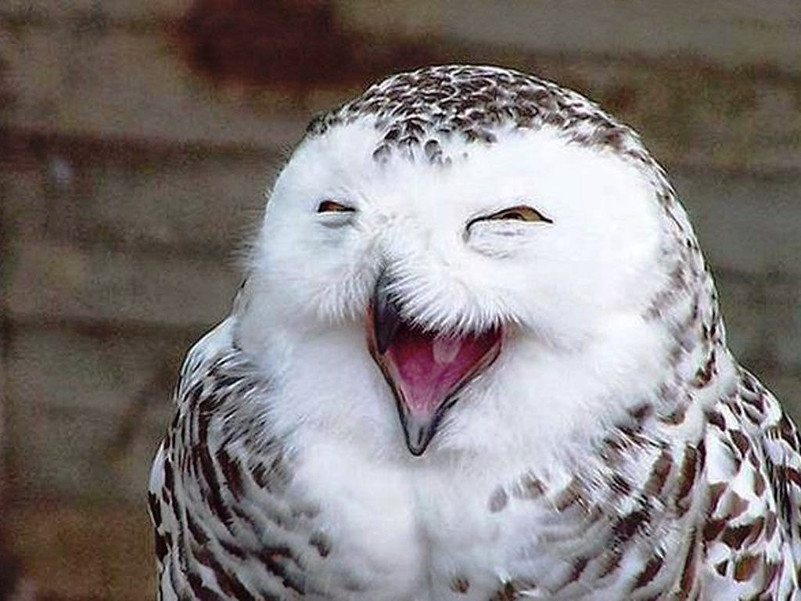](http://2.bp.blogspot.com/-KKXItTD4HXI/VM6nAPYhidI/AAAAAAAAADg/ajvONScwb_c/s1600/happy_owl_lachende_vogel_uil_animals_birds_hd-wallpaper-1534624.jpg)

The following game information is for typical owls of both the orders **Strigiformes (true owls)**and**Tytonidae (barn owls);**other species of owls have differences noted below.  
  
**AC:** 5  
**AT (Dam.):** 2 talons (used as a single attack; 1d3+1 [1d4]), beak (1d2)  
**Beginning HP**: 6   
**Habitat:** Any   
**MV:** 5; fly 8  
**SZ:** Tiny  
    
**Species Traits:** 

* **Excellent Vision**: Owls get a +4 bonus on all Scout lore checks to spot hidden objects
* **Flyby Attack**ability
* **Low Light Vision**
* **Natural Camouflage**: When in their home habitat, owls have a +4 bonus on Trickster lore checks to hide or remain unseen.
* **Nocturnal**: Most owls are active at night
* **Sharp Hearing**:  Owls get a +4 bonus on Scout lore checks to hear noise
* **Sneaky Bird**:  Owls gain a +3 bonus on Trickster lore checks to move silently; the bonus is +6 when they are airborne
* **Swoop**maneuver ability
* **Suitable Niches**:  Herbalist, Runner, Scout, Seer, Storyteller, Trickster

Some varieties of owl deviate from the above template, depending on species.  The differences are noted below.  
  
**Burrowing owl**  
This species of owl prefers underground nests, and often takes over abandoned ground squirrel or rabbit  burrows.  They prefer to line their nests with mammalian dung, which helps regulate the temperature within, and unlike most owls, they prefer insects as prey.

**[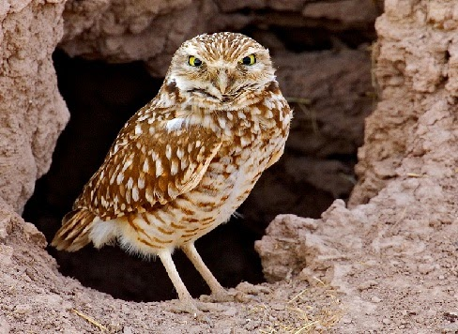](http://2.bp.blogspot.com/-ZempV596ktU/VM6oHRIUeXI/AAAAAAAAADo/ixRAgzEt3QY/s1600/b_owl6345.jpg)**

* **Mimicry**:  Burrowing owls can successfully mimic the hissing and rattling sounds of rattelsnakes with an Average Trickster lore check. A Challenging Deception save reveals the ruse.
* **MV**: 4 on the ground; burrowing owls have longer legs than their kin, and can thus move faster on the ground.

**Northern hawk owl**  
 Hawl owls have many hawk-like features, hence their name.  From a distance (especially during flight), they are often mistaken for hawks.

* **Diurnal:**Hawk owls are active during daylight hours
* **Habitat**: sub-Arctic
* **SZ**: Small

**Rabbit**

NOTE: These stats have been edited to conform to the [rules revisions](https://drive.google.com/file/d/0B-T2-uWej8Y3VExaeVNSOGtRUnc/view?usp=sharing) posted on 9/8/15.  
    
For convenience, I'm making the species found in the Quick Start rules available here, as well.  First up, the species that started it all, focus of the classic *Watership Down* and the original animal fantasy RPG, *Bunnies & Burrows*.  
  
Rabbits have the unfortunate fate of being delicious to nearly every kind of predator. They make up for it by being quick, smart, and crafty. Also, rabbits are believed to be the inventors of herbalism, and are certainly its masters.

[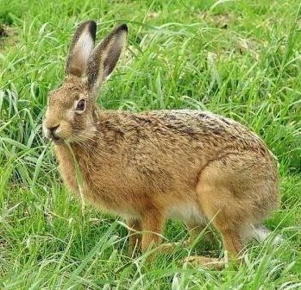](http://3.bp.blogspot.com/-ElgTZ7D5W8c/VN0MEbgRfnI/AAAAAAAAAFw/oodOz-ZG07U/s1600/rabbit_-_european_hare_-_wiki_commons_public_domain_1.jpg)

     **AC:** 6  
**AT (Dam.):**bite (1d3), rear kick (1 hp [1d2])  
**Beginning HP:**3 [4]  
**Habitat:** Temperate (desert, forest, plains/scrub)  
**MV:** 8

**SZ:** Tiny

**Species Traits:**

* **Leap**: Rabbits use their Trickster level rather than their Warrior level when making jump checks.  Further, they get a +4 bonus on such checks.  On a successful lore check, they can jump up to 3 feet in the air, or cover a distance of up to 9 feet without crossing the ground in between.
* **Low-Light Vision**
* **Scent**
* **Tunnel Sense**: Rabbits do not have a substantial burrowing speed, but are still familiar with underground environments.  They get a +1 bonus on all lore checks to notice unusual earthenworks, such as traps, recent burrowing, unsafe tunnels, and so forth.
* +2 bonus on lore checks to hide and move silently
* –3 penalty on all Warrior lore checks related to feats of strength
* **Suitable Niches:** Healer, Herbalist, Runner, Seer, Storyteller, Trickster.

**Rats!**

Rats are living paradoxes: individually fastidious, but notorious as plague-carriers; brave when facing bigger opponents, but always willing to run and hide when not being watched; adorable, yet feared by many species.  
  
Rats exploit their reputations for skullduggery and deceit for maximum effect, and some even embrace the role of thugs towards smaller rodents like mice.  Nonetheless, they are exceedingly loyal to those who see past this veneer to their true selves, and will think nothing of rushing into battle in defense of their friends, no matter how fearsome the opponent.  
  
They typically live in large communities, and are experts in the geography of longpaw settlements.  
  
     **AC**: 9  
     **AT (Dam)**: 1 bite (1d6 + disease)  
     **Beginning HP**: 3 [4]  
     **Habitat**: Any  
     **MV**: 4 (3 climbing, 2 swimming)  
     **SZ**: Tiny  
  
**Species Traits:**

* **Courageous**: Rats are notoriously brave (some would say foolhardy) when facing foes larger than themselves.  They get a +2 bonus on all Fear saves.
* **Disease Carrier**:  Though not individually unclean, rats are widely known as disease carriers by other species.  When a rat character is first created, the BM should make a secret core dice roll (2d10); on a result of 2 (or 1, if using the classic 1d20), the rat character carries a disease of the BM's choice that does not affect the rat herself, but can infect other animals.  Anyone bitten by such a rat must make a Poison save against the disease's listed Threat Level, or become infected.  Diseases commonly carried by rats include leprosy, plague, and rabies.  Note that a rat PC does not necessarily know that she is a disease carrier; if and when she finds out, she can take any actions she chooses to be healed of the affliction.
* **Iron Stomach**: Consummate omnivores, rats are highly resistant to the effects of spoiled food, and can often eat things that are totally inedible to other species.  Rats get a +2 bonus on all Poison or other saves against the effects of spoiled foods, and with a successful Healer check, can eat an object or substance that other species find impossible to digest.
* **Low-Light Vision**
* **Natural Climber**: +1 bonus on all climbing checks.
* **Primitive Hands**
* **Scent**
* **Sneaky**: Rats get a +2 bonus on all Scout or Trickster checks that involve hiding or moving silently.
* **Suitable Niches**: Herbalist, Scout, Seer, Trickster

**Raven**

[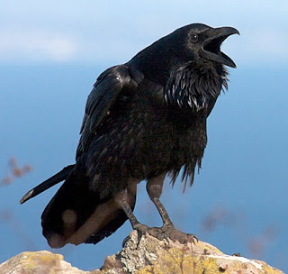](http://1.bp.blogspot.com/-0MwvL4ddCM0/Vdfe7JNJTSI/AAAAAAAAAQs/SwU9iRhZl8A/s1600/common_raven_2.jpg)

Ravens feed on carrion and gather in isolated, abandoned places.  For this reason, they are often seen as dreary or spooky by other beings, despite their great aptitude for play.  They also have a reputation for pointless thievery, often taking great risks to collect meaningless shiny objects from the places they visit. Nonetheless, ravens are highly intelligent and social beings, and the best tool-users among all of bird-kind.  
  
A raven's favorite food is the eyes of the dead.   They feel it honors the fallen by passing their dying sight onto another, becoming the basis of stories that will perpetuate memories of the dead long after they are gone.  Many ravens claim to experience visions or prophetic dreams after eating the eyes of the dead, though whether these visions are genuine or just mad rantings is any non-raven's guess.  
  
**AC**7  
**AT (Dam):** Bite (1d3); talons (1d2; this is a single attack with both feet at once)  
**Beginning HP:**3  
**Habitat:** Temperate   
**MV:** 3; 20 flying  
**SZ:** Tiny   
  
**Species Traits:**

* **Bauble-Snatcher's Curse:** All ravens carry their mythical hero's curse, and find shiny trinkets of any or no value almost irresistible.  Whenever you encounter such a trinket -- be it well-guarded or not -- you must succeed at a Challenging Charm save, or be compelled to try and steal the object from whoever possesses it.  Luckily, you  get a +2 bonus on your Trickster lore check when attempting this larceny. This bonus does not apply in circumstances where you succeeded on your saving throw.
* **Eye Peck:**On any unmodified attack roll of 19 or 20, you can pluck out or otherwise damage one of your enemy's eyes (provided the enemy has eyes, that is).  This attack blinds her in that eye, imposing a -2 penalty on all further attack rolls, or lore checks that rely on paw-eye coordination.  If you manage a second such attack against the same opponent, she is permanently blinded, a condition that can only be healed through magical means.
* **Flyby Attack**
* **Low-Light Vision**
* **Tool-Use:** You gain a +2 bonus on all Scout lore checks to use tools or decipher the function of simple longpaw devices.
* [**Ultravision**](http://greatandsmallrpg.blogspot.com/2015/02/on-beyond-purple-taking-back-ultravision.html)
* -4 penalty on all lore checks involving feats of strength.
* +3 bonus on Runner or Trickster lore checks that involve flying stunts
* **Suitable Niches**: Familiar, [Guardian](http://greatandsmallrpg.blogspot.com/2015/04/new-niche-guardian.html), Herbalist, [Magic-User](http://greatandsmallrpg.blogspot.com/2015/08/the-magic-user-niche.html), Runner, Scout, Seer, Trickster.

**Reindeer**

[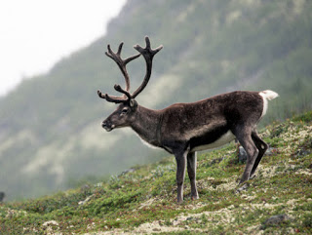](http://3.bp.blogspot.com/-WII1e6FG-5k/Vn27G3fBooI/AAAAAAAAAbc/UzhixjNR-2Y/s1600/reindeer-disappearing-climate-change-2-537x405.jpg)

Also known as caribou, reindeer are among the hardiest animals in the world, thriving in climes that would end lesser herd beasts.  They grow and shed their famous antlers seasonally on both sexes (another unique feature of the species), and have been symbols of strength and wisdom among longpaws for millennia.    
  
In classic fantasy settings, reindeer often serve powerful fairy lords or even deities as mounts or sleigh-pullers.  The greatest of these reindeer have been granted natural flight abilities, and possibly even other magical powers.  Young bucks and does aspiring to such heights have excellent motivations for adventuring.  
  
     **AC**: 7  
     **AT (Dam)**: antlers (1d7 [1d8]), bite (1d2 [1d3]), hooves (1d5 [1d6])  
     **Beginning HP**: 7 [8]  
     **Habitat**: Arctic & subarctic land  
     **MV**: 10  
     **SZ**: Medium  
  
**Species Traits**: 

* **Low Light Vision**
* **Scent**
* [**Ultravision**](http://greatandsmallrpg.blogspot.com/2015/02/on-beyond-purple-taking-back-ultravision.html)
* **Unique Diet**: Reindeer are the only mammals naturally capable of eating lichens, their favorite being reindeer moss.  They get a +2 bonus on all Herbalist lore checks involving the use of lichens, and with a successful Challenging Healer lore check, can boost their natural healing capability by 50% per day by eating a dose of reindeer moss.
* +2 on all lore checks to detect hidden or hear noise
* +2 on all saves to resist cold, either magical or natural
* +2 bonus on Warrior lore checks to push, pull, drag, break, or otherwise use their raw muscle power on heavy objects.
* **Suitable Niches**: Any

**Skunk**

NOTE: These stats have been edited to conform to the [rules revisions](https://drive.google.com/file/d/0B-T2-uWej8Y3VExaeVNSOGtRUnc/view?usp=sharing) posted on 9/8/15.  
    
Skunks are a sub-species of badger, but you wouldn’t know it from their demeanor.  Where badgers are ornery and often vicious, skunks are quiet and meek.  They will usually avoid confrontations (unless hunting for food) until their musk attack is their only option.  Because of their smelly musk, however, it is difficult for skunks to make non-skunk friends;  if they finally do, their new friends will find them gentle and loyal unto death.

[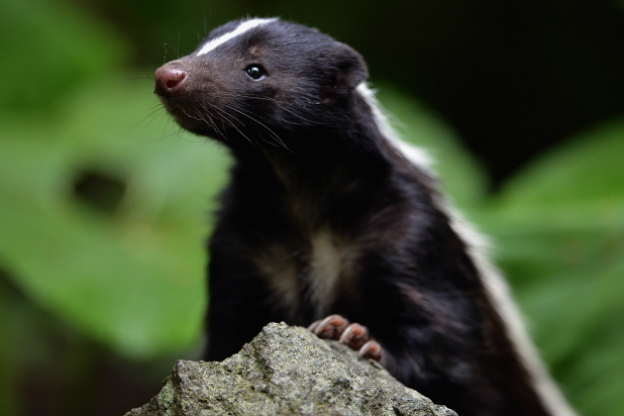](http://4.bp.blogspot.com/-eaVbnmt0Hos/VOJdfWRVwaI/AAAAAAAAAGc/dHhgtSdDpWk/s1600/Skunk.png)

**AC:** 7  
**AT (Dam.):** bite (1d3), 2 claws (1d2)   
**Beginning HP:** 4   
**Habitat:** Temperate (forests, urban, woodlands)  
**MV:** 6; burrowing 1   
**SZ:** Tiny   
  
**Species Traits:**

* **Low Light Vision**
* **Musk Attack**
* **Scent**
* **Tunnel Sense:**Skunks get a +1 bonus on all lore checks to notice unusual earthenworks, such as traps, recent burrowing, unsafe tunnels, and so forth**.**
* +2 bonus on Scout lore checks to follow trails left by other animals.
* +2 bonus on Trickster lore checks to escape traps and avoid danger
* **Suitable Niches:**Healer, Scout, Trickster, Seer, Warrior

**Snake (Constrictor)**

[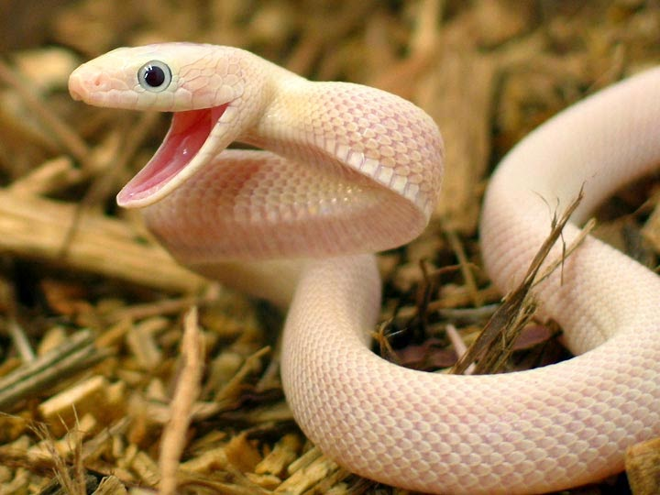](http://4.bp.blogspot.com/-1wla5sd2C4I/VOJgyMaFSEI/AAAAAAAAAGs/gBonC4J_WXI/s1600/lucy_TX_Rat_Male_0904-5.jpg)

NOTE: These stats have been edited to conform to the [rules revisions](https://drive.google.com/file/d/0B-T2-uWej8Y3VExaeVNSOGtRUnc/view?usp=sharing) posted on 9/8/15.  
    
Constrictor snakes are often deliberative and slow to act, and thus considered wise by many animals, even those who fear them as mighty hunters.  They are consummate planners who rarely act rashly, and pride themselves on being great strategists.  Of course, as predators, they are generally feared by many other animals, and with good reason.  A constrictor’s wrath is swift and terrible when it finally befalls her target.  
  
**AC:** 6  
**AT (Dam.):** bite (1d3)   
**Beginning HP:** 7 [8]  
**Habitat:** Temperate to Tropical (any)  
**MV:** 4; crawling, climbing, swimming  
**SZ:** Small   
  
**Species Traits:**

* **Constriction Attack:**(1d2 + Warrior niche die result, if any).  The damage caused by this attack bumps up if the snake increases in SZ.  At SZ Medium, this attack does 1d3 (+ Warrior niche die result, if any) damage; at Large Size, it does 1d5 [1d6] (+ Warrior niche die result, if any).
* **Diminished Profile:**Snakes can fit through openings and tunnels that are two SZ categories smaller than their actual SZ.
* **Great Strength**:  At 1st Total Level, snakes gain a +1 bonus on Warrior lore checks involving feats of strength.  This increases to +2 at 3rd Total Levels, and up to +3 at 6th Total Levels.
* **Growth Spurts**: Constrictors have the option of increasing their SZ by one category at 3 Total Levels, and then once more at 6 Total Levels.
* **Low Light Vision**
* **Natural Armor**: Improve AC by 1 point at 1st, 3rd, and 5th Total Levels.
* **Niche Restriction**:  Because they lack limbs, snakes cannot choose Herbalist as their niche.
* **Special Maneuvers**:  Wrestle
* **Stealthy**:  +1 bonus on Trickster lore checks to hide in shadows and move silently.
* **Suitable Niches**: Healer, Runner, Scout, Seer, Trickster, Warrior

**Snake (Venomous)**

Venomous snakes are far more dynamic than their constrictor kin, and often greatly more feared by others, as well.  For while constrictors are a lethal threat only to animals smaller than them, venomous snakes have the potential to kill opponents much larger than themselves. This gives them a much eviler reputation among non-snakes, and some venomous varieties embrace this perception and lead lives devoted to cruelty and terror.

Nonetheless, like constrictors, they are also regarded as symbols of change and wisdom, and tend to deliberate for as much time as they can before committing to an action.

**AC**: 6

**AT (Dam.)**: bite (1d3)

**Beginning HP**: 7 [8]

**Habitat**: Temperate to Tropical (any)

**MV**: 4; crawling, climbing, swimming

**SZ**: Tiny

**Species Traits:**

All venomous snakes share the following abilities in common**.**

* **Diminished Profile**
* **Low-Light Vision**
* **Natural Armor**: Improve AC by 1 point at 1st, 3rd, and 5th Total Levels.
* **Niche Restriction**:  Because they lack limbs, snakes cannot choose Herbalist as their niche.
* **Spit Venom**: Some venomous snakes have an additional use for their poison attack. Instead of delivering their poison through a bite, they can choose to spit their venom as a ranged attack.  On a successful hit, the target must make an Average Poison save or become blinded.  The blindness lasts for 1d5 [1d6] turns, but only if it gets cleaned out within 1d5 [1d6] minutes.  Otherwise, the blindness is permanent.
* **Steady Growth**: Venomous snakes can increase in SZ once per level, but can never grow larger than Large SZ without the aid of magic or other exceptional means. They cannot skip a level of growth and resume it later, however; once they stop at a particular SZ, it remains their natural length until death.
* **Stealthy**:  +1 bonus on Trickster lore checks to hide in shadows and move silently.
* **Threat Display**: Some of the most famous venomous snakes (cobras, rattlers) have some natural method of making themselves seem more menacing or threatening, especially towards those larger than them.  This gives these snakes a +2 bonus on all lore checks to frighten or intimidate foes.
* **Venom Attack**: Venomous snakes can make an envenomed Bite attack a number of times per day equal to 3x their Healer lore level, to a minimum of three times per day. Victims of a SZ category two larger than the snake or smaller must succeed on a Challenging Poison save or die within 1d10 turns. For creatures one SZ category larger, the save is Tough; for two categories larger, the save is Average; and at three or more categories larger, the save is Easy.
* **Suitable Niches**: Healer, Runner, Scout, Seer, Trickster, Warrior.

**Squirrel**

[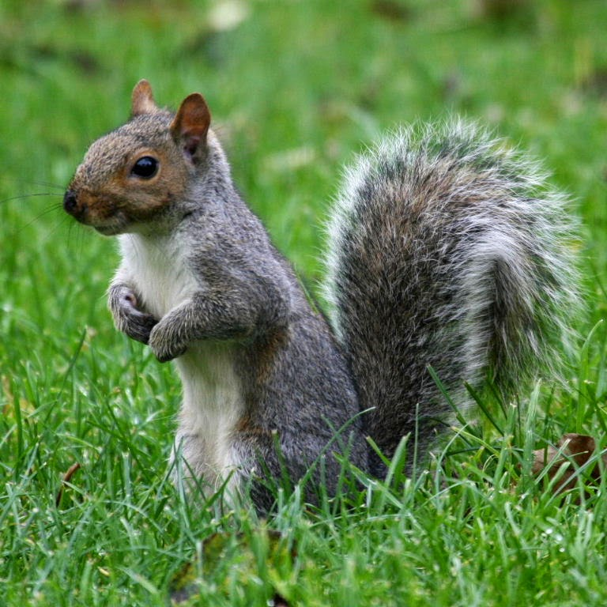](http://3.bp.blogspot.com/-7LUuABXcM3M/VOJjy37v4_I/AAAAAAAAAG0/7tjXLV-uAjE/s1600/squirrel2.jpg)NOTE: These stats have been edited to conform to the [rules revisions](https://drive.google.com/file/d/0B-T2-uWej8Y3VExaeVNSOGtRUnc/view?usp=sharing) posted on 9/8/15.  
    
Squirrels are frivolous, alert, and seemingly perpetually happy. They delight in all manner of dances, jokes, and riddles, and are among the craftiest of animals when it comes to living among longpaws. In classic fantasy worlds, squirrels may revel in the company of fairies like brownies or pixies, joyfully taking part in their schemes and tricks.  
  
**AC:** 6  
**AT (Dam.):** bite (1d3)  
**Beginning HP:** 2 [3]  
**Habitat:** Temperate (forest, plains, urban, woodland)  
**MV:** 4; climbing  
**SZ:** Diminutive   
  
**Species Traits** :

* **Brachiation**
* **Low Light Vision**
* **Glide (Flying Squirrels only):**Flying squirrels can use their “wings” to glide a distance of 2 feet vertically for every 1 foot horizontally.
* **Scent**
* **Scamper**: Squirrels can move at their full run speed while climbing, provided they are moving in a straight line.
* [**Ultravision**](http://greatandsmallrpg.blogspot.com/2015/02/on-beyond-purple-taking-back-ultravision.html)
* **Primitive Hands**
* -3 penalty on all Warrior lore checks involving feats of strength.
* +2 bonus on Trickster lore checks to hide and move silently
* +4 bonus on lore checks involving climbing or balancing; squirrels use their Trickster lore instead of their Warrior lore for climb checks.
* **Suitable Niches**: Healer, Herbalist, Runner, Seer, Storyteller, Trickster

**Tortoise (Gopher)**

[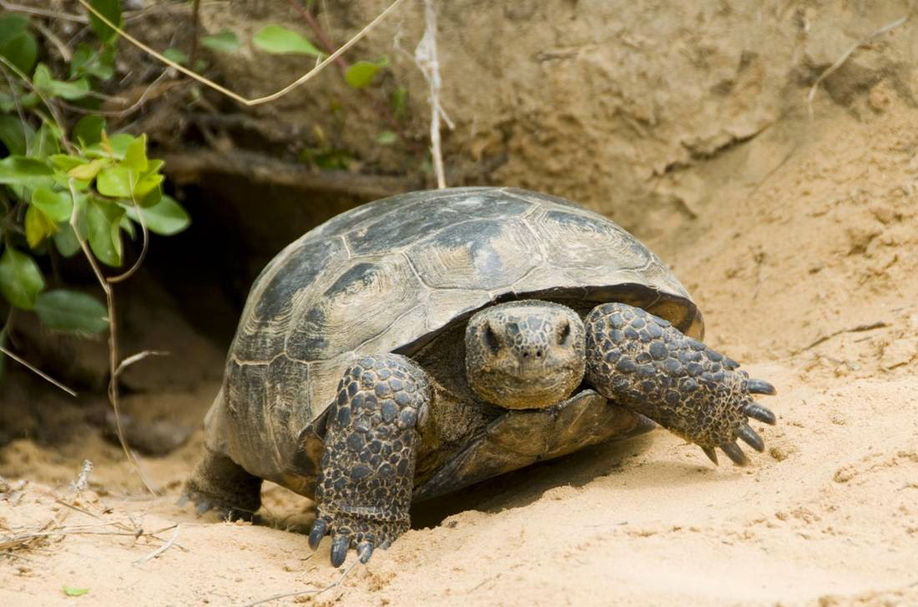](http://4.bp.blogspot.com/-LeBSalhqSpE/VOJmVgMVp8I/AAAAAAAAAHA/EOK6bTw41jU/s1600/gopher-tortoisejpg-dfbff410058cd2e02.jpg)

NOTE: These stats have been edited to conform to the [rules revisions](https://drive.google.com/file/d/0B-T2-uWej8Y3VExaeVNSOGtRUnc/view?usp=sharing) posted on 9/8/15.  
    
Tortoises and turtles are among the slowest animals on land, but also among the toughest. Blessed with the best natural armor, their approach to danger is normally to wait it out by withdrawing into their powerful shells. Known for long lifespans and gentle wisdom, aged gopher tortoises in particular are often sought out for advice by other Tiny and Small animals in their habitat, and even enjoy the respect of larger animals and predators. In classic fantasy worlds, they sometimes take up the practice of magic.   
  
     **AC:** 3  
**AT (Dam.):** bite (1d3)  
**Beginning HP**: 4  
**Habitat**: Temperate (plains, savannah, woodland)   
**MV**: 1  
**SZ**: Tiny   
  
**Species Traits:**

* **Improving Armor**: A gopher tortoise’s shell becomes thicker and sturdier as she ages. Her natural AC improves by 1 point each at 2, 5, and 8 Total Levels. Thus, at 2nd level, she has AC 2; at 5th level, she has AC 1; and at 8th level, she has AC 0
* **Low Light Vision**
* **Protective Shell**: When a 0-level gopher tortoise retreats into her shell, her AC becomes –1 . At 2nd Total Level, her pulled-in AC is –2; at 5th level, her pulled-in AC is –3; and at 8th level, her pulled-in AC is –4.
* **Niche Restriction**: Gopher tortoises lack the speed to be effective Runners.
* **Tunnel Sense:** Gopher tortoises do not have a substantial burrowing speed, but are still familiar with underground environments. They get a +1 bonus on all lore checks to notice unusual earthenworks, such as traps, recent burrowing, unsafe tunnels, and so forth.
* +2 bonus on all Herbalist lore checks to identify edible plants and fresh water
* –5 on all Runner lore checks; this becomes –3 at 5 Total Levels
* –3 on all Trickster lore checks; this becomes –1 at 5 Total Levels
* **Suitable Niches**: Healer, Herbalist, Scout, Seer, Storyteller, Warrior

**Wolf**

[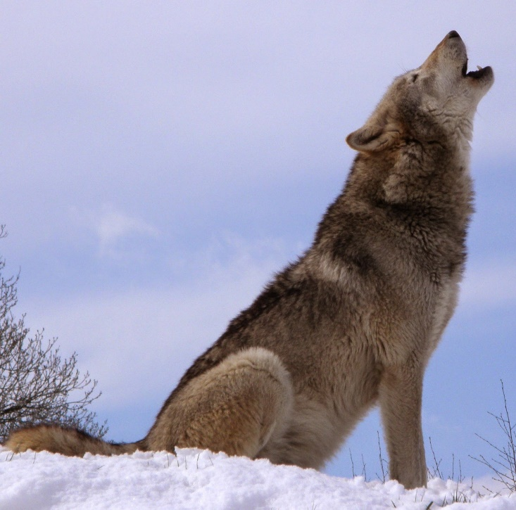](http://1.bp.blogspot.com/-Qt4hUxvBsM8/VRMyXMP1k0I/AAAAAAAAAJk/Z_0Au05mCBE/s1600/Howlsnow.jpg)

NOTE: These stats have been edited to conform to the [rules revisions](https://drive.google.com/file/d/0B-T2-uWej8Y3VExaeVNSOGtRUnc/view?usp=sharing) posted on 9/8/15.  
    
In ancient times, wolves challenged longpaws for mastery of the world.  The contest waged for generations, with each species learning from the other, until one day, those who would become dogs adopted some longpaw tribes and taught them the secrets of the hunt.  The results, from the wolves' point of view, were disastrous, and to this day, there is a deep well of distrust between wolves and dogs, despite their many commonalities.  
  
Contrary to many human conceptions, most wolf packs are not ruled by a dictatorial "alpha wolf."  Instead, they are typically a family group composed of a mated pair and their (usually adult) children; some larger wolf communities are composed of multiple families, each governed by a mated pair. In such large packs, the mated pairs form a sort of governing council that makes decisions by consensus.  
  
Adult children typically leave their family after 1 to 5 years to seek mates.  New mated pairs seek lands of their own in which to establish a new pack, or seek to join an existing group of wolf families, before having any of their own offspring.  
     **AC:** 7  
**AT (Dam.):** bite 1d5 [1d6]  
**Beginning HP**: 9 [10]  
**MV:** 12  
**SZ:** Small  
  
**Species Traits:**

* **Growth Spurt:** At 2nd Total Level, wolves grow in Size from Small to Medium.
* **Howl**: Wolves have a secret language of howls with which they can communicate over long distances. All wolves are taught this language from birth, and it is never taught to other species, under pain of death.  Wolves communicating by howl can count on their messages almost never being intercepted by non-wolf enemies.  Even dogs no longer know this language.
* **Low-Light Vision**
* **Scent**
* **Trip Maneuver**
* [**Ultravision**](http://greatandsmallrpg.blogspot.com/2015/02/on-beyond-purple-taking-back-ultravision.html)
* +2 bonus on lore checks to track by sense of smell
* **Suitable Niches:** Healer, Runner, Scout, Seer, Trickster, Warrior