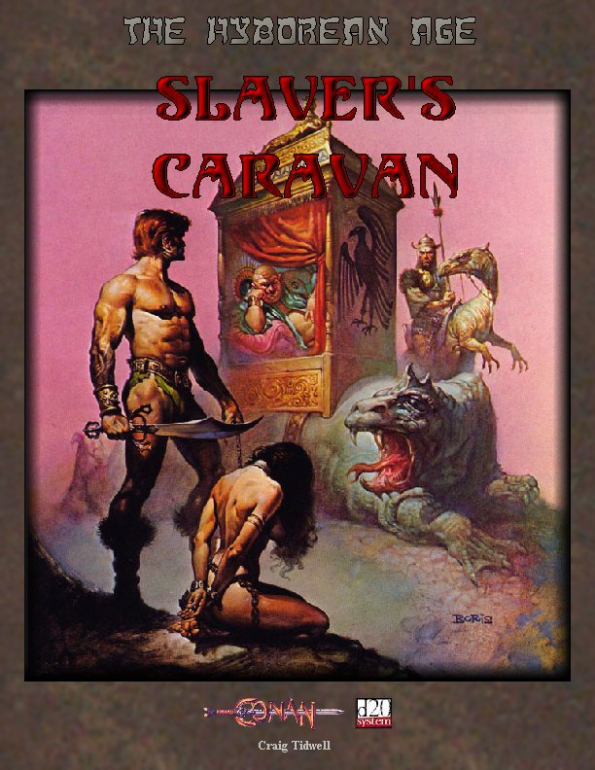

Slaver’s Caravan

A Hyborean Age adventure

By Craig Tidwell

Feedback welcome o_s_u_k_a@hotmail.com
Partial Concept by Steve Woodward

Special Thanks To:
thulsa@xoth.net for his extensive work on Conan d20
Jamis Buck for his NPC Generator
Wizards of the Coast for the d20 system
Frank Frazetta, Boris Vallejo, and unknown artists for their artwork (used without permission)

“Slaver’s Caravan” is a Hyborean Age adventure suitable for a party of four 1st or 2nd- level characters. PCs who survive the adventure should earn enough experience points (XP) to advance one or two levels.
Note: Anyone familiar with the novels of John Norman will notice that I have made use of the slave trading system presented in his Gor novels. This is not shameless pilfering, but a system I see fitting well into the Hyborean world.

You, the Dungeon Master (DM), need a copy of the Player’s Handbook, the Dungeon Master’s Guide, the Monster Manual, and the Hyborean Age (setting information available at hyboria.xoth.net ) to use this adventure.
Text that appears in shaded areas is player information, which you may read aloud or paraphrase where appropriate. Unshaded areas contain important information for you, including special instructions.
All important NPC’s can be found in the appendix of this adventure as well as an excerpt from the d20 Book of Sex.

Background

This adventure is designed to bring a disparate group of characters together into an adventuring band, and features the introduction of a possible recurring villain and a few combat encounters. The PC’s are assumed to be total strangers from one another. With this in mind, only one character hook is designed with the PC’s meeting for the first time in a tavern. This adventure is somewhat linear before and after The Beggar's Feast festival, with the main focus on familiarizing the players to the Hyborean Age setting with its new rules, but allows for some creative roleplaying during the festival.
Hamadras is an Aquilonian merchant living in Shadizar who has been trading ivory, spices, exotic woods, and occasionally slaves in Zamora between the cities of Shadizar and the Arenjun for nearly thirty years. On occasion he has been known to hire mercenaries for extra security—especially when trafficking slaves. For some odd reason, however, his mercenaries always disappear during the trip back to Shadizar. Being free mercenaries, no one really pays much attention to the fact that Hamadras hires new mercenaries each time he takes slaves to or from Arenjun. The PC’s are about to discover why Hamadras has a constant need for new recruits, but they are sure to be upset with what they find.

Summary
The PC's are traveling together as part of a merchant caravan that originates in Shadizar, makes its way to Arenjun,

and circles back around to Shadizar by way of a small town North of Arenjun, along the base of the Kezankian Mountains called Zintar. Once in Arenjun, however, they will have a week long layover while the city celebrates a holiday known as The Beggar’s Feast. On the way back to Shadizar, the party discovers that the Aquilonian merchant who hired them intends to double cross all of his hirelings, selling them into slavery to ruthless salt miners. This fateful discovery is to take place while camped a few days after they start the return trip from Arenjun. Only together can the PC's escape this situation, living to explore the many mysteries of Hyboria.

For the Players
 For whatever reason, all of the PC's are in Shadizar.
A young boy, perhaps 11 years old finds PC’s one by one. He approaches the PC and explains that a trader had instructed him to tell anyone carrying weapons that entered the town to meet him at the Ram's Tail at dusk and that he was buying drinks for everyone. The boy gets 1 cp for every person that shows up.
Once the PC’s arrive at the tavern it is easy to locate the trader. Robust men and dangerous-looking women holding frothy beer mugs and carrying weapons that look well used surround him as he stands on a short stool and motions for silence. He is a paunch, older man with a shaven head, fair skin, and bright eyes. He wears robes of yellow silk, and a blue sash tied about his waist. As the bartender brings each of the PC’s a foamy mug of beer the man begins to speak.
“My name is Hadramas, and I am looking for mercenaries as extra security to accompany me and a small caravan of goods to Arenjun in time for the yearly festival called The Beggar’s Feast. The road between here and there is a bit dangerous, but five or six of you should suffice. Those chosen will be paid 10 gold pieces upon signing, and an additional 20 gold pieces upon safe arrival in Arenjun—approximately a week long trip. Once we make it back to Shadizar, you will be given the remaining 40 gold pieces of your contract. Any treasure we recover from bandits we may encounter along the way will be split up evenly between yourselves and my personal guards.”
Some of the gathered mercenaries let out snorts of disgust and leave. Other than the PC’s, the only people remaining are a female fighter, a male cleric, and two young rogues who look like they have barely left home. Hadramas promptly tells the young rogues that they should wait a few years before taking on jobs like these. That leaves Unegen (YOO-nuh-gun) a Hyrkanian female Fighter (Ftr1) and Cillian (KEEL-yan) a Brythunian Cleric (Clr2) (see Appendix C for their stats), who sign on immediately, and the PC’s. The merchant is willing to haggle a little bit on the hiring price, but the PC’s must succeed a Diplomacy check (DC 18). He will pay them 5 extra gold pieces at the end of the trip for every point above the DC that the check succeeds. Each PC that haggles makes his/her own check.
Assuming the PC’s accept the job, they will be instructed to meet the merchant at the edge of the city at sunrise. They are given their signing bonus and cut loose for the evening.
If anyone asks details, Hadramas’ business usually consists of trading spices, ivory, and exotic wood—along with the occasional cargo of female slaves (as is the case with this caravan). Outbound from Arenjun he carries simple manufactured goods and ale. He makes the trip twice a
month or so, spending a week or two at either end
securing new purchases for the return trip.
[If the PC’s want to look for carnal encounters, decide whether or not they are able to find anyone to attempt to seduce, or a prostitute (either in a tavern or on the street). Useful excerpts from the d20 Book of Sex can be found in Appendix A of this adventure.]
The next day the PC’s get their first look at the merchandise they will be guarding.
At first light, you head to the edge of town where the caravan is organizing to head out. You weave through the narrow streets, bumping shoulders with rough soldiers, hurrying merchants, various diplomats, and sleepy prostitutes. The press makes you feel uneasy, and you unconsciously check your belongings by feel, expecting something to
disappear. The smell of unwashed bodies is strong, but you hardly notice. As you walk
past the merchant stalls containing various
junk, trinkets, baked goods, and weapons nothing really catches your eye. You smell the aroma of cooking meat, most likely rat or rabbit, as you come into a slight opening, passing through one of the town gates.
As you exit through the city gates you notice several caravans preparing to leave. According to your directions, the merchant’s caravan is the one just ahead. You see naked male slaves loading barrels of water, foodstuffs, ivory, and exotic woods into a set of four wagons with sheets of heavy brown canvas thrown across them to protect the cargo from the elements. Two other wagons have yellow and blue striped canvas covers and appear to be designed for passengers. Hadramas sits in a large intricately carved wooden carriage with red curtains strapped to the back of a large lizard-like beast. Unegen and Cillian are already here helping load cargo onto the wagons while several guards ring the caravan enjoying a last drink before they head out.
Hadramas waves the PC’s over and instructs them to put their gear in the lead wagon and then go see the guard foreman for their work assignment. He points out an olive-skinned man astride an upright lizard mount watching the other men load and secure the canvas on the wagons. In a harsh voice, the foreman orders the PC’s to make sure the cargo in the wagons is secure.
Two cargo wagons and a guard are at the front and back of the procession. Next are the covered wagons, with Hadramas’ carriage safely in the middle of the caravan flanked by a guard on either side.
The covered wagon behind Hadramas' carriage is empty right now, but soon the two male slaves climb aboard and one of the caravan guards fastens them together with a chain hooked to their steel collars.
Upon checking the covered wagon in front of Hadramas' carriage, the PC’s discover that it is full of naked women. Closer inspection reveals that there are six women, each wearing a steel collar. They are connected together—collar-to-collar—by a long chain running through rings attached to their collars. When a PC checks the wagon, women raise their eyes to meet him/her and plead, “Buy me, master!” (or mistress if the PC is a female).
Hadramas quickly yells at the women, “Shut up sluts! It is not time for you to be bought yet. That is to take place upon the public slave block in Arenjun during the festival.”
Hadramas turns to the PC’s, spreads his hands in mock innocence and explains, “In addition to being a standard merchant, I am also a slaver. The women slaves are to be sold in Arenjun. The men slaves, however, are my workers.” Almost as an
afterthought, he says, “You know, a perk of working for a slaver is that you get to use
any of the girls for free, unless she is a white silk virgin. Fortunately for you, I have no white silk girls.” He grins, sips wine from a silver goblet, and closes the curtains around his carriage.
Once all wagons have been checked, the PC’s are instructed to ride two in each slave wagon for the trip. Both Unegen and Cillian climb onto the last cargo wagon as the foreman yells the order and the caravan begins to move out.
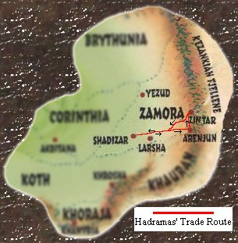

The Trip To Arenjun
Day 1:
Temperature Wind Sky
High 82 Low 64 South 4 mph Partly Cloudy
Precipitation/Special Weather/Notes No precipitation
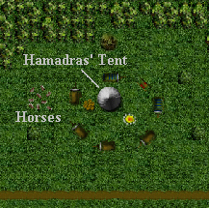
The caravan pulls away from Shadizar in a slowly rolling procession while two guards on horseback race about a mile ahead of the wagons to scout for the group. It's a well-protected operation. Hadramas has 6 regular guards riding horses and the caravan foreman on a lizard mount in addition to the 6 hired hands (the PC’s and the other two mercenaries) protecting the convoy (See Appendix C for caravan guard and foreman stats). No one takes this for granted, however, as raiders have been known to strike even larger convoys given the right circumstances. The group makes good time for the first few hours on the road just
outside of Shadizar. Before long
though, the road is a set of ruts,
slowing your progress. When you
stop for the night, the wagons are
pulled off to the side of the road and
circled up. The male slaves erect
Hamadras’ tent, and a large fire is
built in the center of the camp. The
PC’s along with the other guards set
up bedrolls on the ground around the
fire.
During the day, the PC’s are required to watch for trouble from the wagons. While camped they are required to take a guard shift—two at a time—with two of Hamadras’ regular guards. When the caravan is at rest, the female slaves will be released from their coffle in the wagon so that they may perform menial duties such as gathering wood, building the fire, cooking, etc. Usually three slaves are chained together and escorted by one guard whenever they leave the safety of the wagon ring to perform their duties. At night, the slaves are once again chained in their wagons with a guard at either end.

Day 2:
Temperature Wind Sky
High 87 Low 59 West 9 mph Cloudy
Precipitation/Special Weather/Notes No precipitation
(Daytime) EL 6 –
As the caravan tops a small hill, 5 men of average height and one man of huge proportions (about 7 feet tall) can be seen approximately 300 feet away crouching over a small body. It appears that they are looting it, but you are too far away to tell whether or not the victim is still alive.
Check to see if the bandits spot the PC’s (DC 20 due to their interest in the victim). The victim is a short man in ragged clothes. Vegetables and the torn remains of two large baskets are scattered around the general vicinity. It appears that he was a farmer on his way to sell his vegetables. The bandits will attempt to fight the PC’s and the caravan guards until one of a few things happen:
- Their leader (the large man) is killed.
- Four of the other bandits are killed.
- 4 rounds pass, at which time the two caravan scouts return to protect the wagons.
Once one of these criteria are met, the remaining bandits attempt to flee into the nearby forest (about 500 feet away from the edge of the road).
- Bandits (Medium-Size Humanoid) (Ftr2) (4):
hp 17, 16, 12, 9; Init: +1; AC 14; Fort +4 Ref +1 Will +0; Attack: Longsword +3 melee, +2 dmg.
- Bandit Leader ( Medium-Size Humanoid) (Bbn 4):
hp 42; Init: +4; AC 18; Fort +6 Ref +3 Will +1
Attack: Scimitar +7 melee, +3 dmg.
- Treasure: Normal bandit- 2gp, 4 cp each,
Leader- 4 gp, 2 sp, 1 cp, carved ivory dragon comb with red garnet eye (1,295 gp)

Day 3:
Temperature Wind Sky
High 83 Low 60 SW 16 mph Cloudy
Precipitation/Special Weather/Notes Rainstorm (light), 9 am ~ 6 pm; temperature drops to 60; Tracking DC +1 for every hour of rain;
(Early evening, during camp) EL 9 (if combat erupts)– A male Stygian sorcerer, Pediamun the Red, and a male Turanian barbarian, Baksh, approach the camp. They are simply hoping to buy a female slave, but depending on how the PC’s roleplay the situation, it could turn into a combat scenario. If the initial encounter with the PC guard(s) goes well, Baksh stands outside of Hamadras’ tent while Pediamun haggles inside on a price for one of the slaves. After about ten minutes of bargaining, the sorcerer emerges with Hamadras and follows him to one of the slave wagons where he climbs inside. Soon Pediamun emerges from the wagon with a female slave in tow (her throat collar has been fastened to a short silk rope). [If any of the PC’s have shown a special interest in one of the slave girls, this is the one bought by Pediamun—possibly causing hostilities between the wandering pair and the PC’s.] (See Appendix C for stats).
Day 4:
Temperature Wind Sky
High 81 Low 59 NE 54 mph Cloudy Precipitation/Special Weather/Notes Severe Storm; rain 2 in/hour; 3am ~ 11:30 am; movement ¼; vision ½; Tracking DC +10; +1 for every hour of rain; every hour, cumulative 10% chance of 1d4+2 points of subdual damage to exposed creatures.
(Early Morning) EL 4 – About 5 am, the PC’s are woken up (Listen DC 22) by a noise (not to mention the heavy rain at 3 am). They hear (Listen DC 15) a voice coming a short ways from their location, in the direction of a gully that runs parallel to the road for several miles (if any PC’s are on guard duty, the Listen DC 22 to wake up is irrelevant, since they are already awake). The voice sounds as if it is female, and is possibly crying for help. If they investigate and successfully make 3 more Listen checks at DC 14, 12, and 10 respectively, followed by a Spot check at DC 12, they see the following.
You see a woman lying at the bottom of a gulley trapped under a large branch that has been ripped off of a tree in the storm. The branch is lying across her legs and lower abdomen, and has her pinned to the ground. Rainfall has quickly collected in the gully, and is beginning to get deep. It is obvious that if she is not freed soon she will drown (only 5 rounds until a flash flood causes her to hold her breath or drown, not to mention causing the PC’s to make Balance checks DC 20 or be swept downstream). She has a longsword out, and has apparently been trying to chop the log off of herself, but because of the angle she is not able to get a good swing at it.
The log is quite large and heavy, requiring a total Strength of 45 to lift (a total of four people can try to lift at once). The PC’s may opt to chop the log in half rather than lift it. If this is the case, they must do 30 points of damage (hardness 5) to the log. Due to the wind and slippery conditions in the gully, the log has an effective AC 5 (once the flash flood hits, the effective AC raises to 8 due to the increasingly difficult conditions). Any miss on the log has a 30% chance of hitting the woman (Shadrya) for normal damage. Once the log has been dealt with, the PC’s must get the woman out of the gully (she is too tired to walk). She weighs a total of 157 pounds with equipment, and up to four people can try to lift and carry her (add the weight of the equipment carried by the PC’s attempting to lift her, and then add her weight. Compare this total to the combined Strength of the PC’s, and refer to the table on pg. 142 in the PHB to determine whether or not they can lift her.).
Once she has been hoisted, the carrying PC’s must make a Balance check (DC 16) to climb up out of the muddy gully. If any of the PC’s slip, their Strength score must be deducted from the total Strength score used to haul the woman out of the gully. If they fail their Balance check by more than 10, the PC falls into the water and is washed downstream. If the PC’s drop the woman, she is washed downstream as well.
Once in the strong current, victims travel 50 feet per round, taking 1d3 points of subdual damage from debris and exposure until they can succeed at a Swim check (DC 18), or until someone throws them a rope, branch, etc. and pulls them out (requiring a Reflex save DC 14 to grab and a Strength check DC 12 to pull the victim out). Don’t forget to apply a -1 penalty to the Swim check for every 5 pounds of equipment a character is carrying (Shadrya is carrying ** pounds). See the appendix for complete statistics on Shadrya.
If Shadrya is freed, award XP equivalent to a level 4 encounter. She will give the PC’s all the money she has right now (8 gp) as thanks. She is too exhausted to walk without help until she has rested for at least 4 hours, but her only real wounds were caused when the branch hit her causing her to lose 10 hp. She is on her way to her home village in Cimmeria, and will not travel with the PC’s, but they may attempt to seduce her during her night's stay with the group. Once she finds out that the PC’s are helping a slaver, however, she is disgusted—raising the DC to seduce her by 8. If the PC’s try to enslave her, she will fight until she is unconscious or until she gets a chance to flee (if she can walk, that is)—and will not be an obedient slave.

Day 5:
Temperature Wind Sky
High 75 Low 48 SW 18 mph Partly Cloudy
Precipitation/Special Weather/Notes No precipitation
The day passes without incident and the caravan makes good time.

Day 6:
Temperature Wind Sky
High 90 Low 63 SW 12 mph Clear
Precipitation/Special Weather/Notes No precipitation
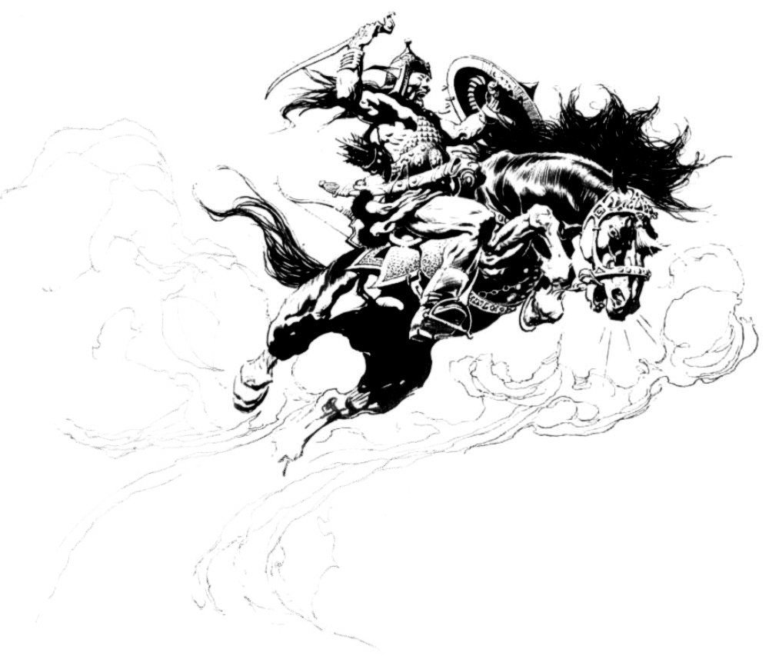
(Late Morning) EL 5—The caravan is raided by a sizeable bandit group. The bandits are all on horseback and have longswords and daggers.
9 of the bandits
(Fighters) use their
Rideby Attack feats to
stay mobile while
they fight.
The other 6 of the
bandits (Rogues)
will ride the
perimeter of the
caravan firing
arrows with
shortbows (they
have Mounted Combat, so the penalty to hit is only -2). They each have 8 arrows, and when they run out they draw swords and close to melee.
As soon as 10 or more of the bandits are killed or disabled, the remaining ones flee. None of the bandits are carrying treasure, but their weapons could be sold for ½ normal price once the PC’s reach Arenjun.
- Bandits (Medium-Size Humanoid) (Ftr2) (9):
hp 12, 10, 9, 9, 8, 8, 8, 8, 7; Init: +2; AC 13; Fort +4
Ref +2 Will +0; Attack: Longsword or dagger +4 melee,
+2 dmg.
- Bandits (Medium-Size Humanoid) (Rog1) (6):
hp 7, 6, 5, 5, 4, 3; Init: +3; AC 15; Fort +0 Ref +5 Will +0; Attack: Shortbow +3; Shortsword or dagger +2 melee,
+1 dmg.
In addition to the PC's and Unegen and Cillian, there are 4 caravan guards and the caravan foreman here to defend the wagons. The foreman stays next to Hamadras' carriage and only engages enemies that stray close enough to it to be a threat. The four caravan guards attempt to engage the Rogue bandits to stop the rain of arrows on the caravan, leaving the PC's and Unegen and Cillian to fight the streaking Fighter bandits. Once the Rogue bandits have been dealt with, however, they will attack the Fighter bandits.

Day 7:
Temperature Wind Sky
High 87 Low 63 West 1 mph Clear
Precipitation/Special Weather/Notes No precipitation
At approximately 6 pm, the group pulls into the Northern Caravan Grounds of Arenjun. The merchant caravan has made good time in spite of the fierce storm earlier. Hadramas pays the PC’s the 20 gold pieces for getting to Arenjun. He then explains that he wants them to enjoy the festival, but not to get arrested or killed. He wants them to meet him here at the Northern Caravan Grounds again at first light the morning of seven days hence. If they are late, they lose the contract altogether and their share of the loot from both bandit encounters. A map of Arenjun can be found here.

The Beggar’s Feast
This week long festival ushers in the new trading season when the ice and snow has melted off the Kezankian Mountain passes, allowing traders from those areas to vend their goods in the streets of Arenjun. As a result of the variety of men that attend the festival, the variety of goods to be found is equally diverse. During this festival, all commerce moves to the North and South Bazaars. A few of the more wary merchants stay in their shops, but all of the exotic wares are to be found at the Bazaars. Also during the festival, all taverns offer free drinks to everyone—beggar and noble alike (hence the name of the festival). One would think that the tavern owners would go bankrupt with such generosity, but the city requires all merchants who take part in the Bazaar to pay a percentage of their earnings to the Tavern Guild in an effort to offset the costs incurred to the tavern owners.
Slavers also use this time to sell a large number of slaves. Traditionally, the last day of the festival is set aside for the slave auctions that take place at the Slave Market. Long tents are erected and sectioned off for the different slavers to display their goods. Slaves are chained in a coffle in their owner’s tent until the auction begins, at which time they are led up onto a raised platform approximately 5 feet high. On this platform, they are instructed to walk, dance, or just about anything else the auctioneer feels will bring a high price. Since slavers often save their best and most beautiful slaves for this festival, it is no wonder that this is one of the most popular events, rivaled only by the gladiator events held in the Arena on the 5th day.
Arenjun is not necessarily known for being a clean city during normal times, and the presence of so many visitors just compounds the problem. Every day the PC's spend within the city walls, they have a 5 % chance of being exposed to one of the following diseases (d4): 1) Blinding Sickness 2) Cackle Fever 3) Mindfire 4) Shakes
If exposed, the PC must make a Fortitude save against the DC for the indicated disease, or contract it.
Note that this is a flat percentage chance. Just because they stay within the city walls for several days at a time does not make them any more susceptible to catching a disease.
If the PC's buy (or consider buying) any food (particularly meats from street vendors), the DM decides—either at random or by dice roll—what foods are dirty, spoiled, infested, etc., and then allows a skill check in Wilderness Lore, Profession: Cook, Profession: Butcher, or something similar (DC 10) to determine the dangerous quality of the food. If they eat the food anyway (or unwittingly), they must make a Fortitude save or contract a parasite.

Disease DC Incubation Damage
Ingested Parasite 14 1d3 days 1d2 Con
The only way to get rid of a parasite is to be healed by magic—Cure Light Wounds or higher—or a successful Heal check (DC14). The Constitution damage caused by the parasite persists until the character is cured. Additional parasites cause additional Constitution damage (but will not reduce a character's Constitution to below 1), and each parasite must be healed separately.

Any extra-curricular activity with the opposite sex also poses a risk of becoming infected with a disease. See the excerpts from the d20 Book of Sex in the appendix for details on sexually transmitted diseases.
Allow the PC’s freedom to roam the city during the celebration. Insert various random encounters from the table in the appendix, or create your own as you see fit.

Day 8: Beggar's Feast
Temperature Wind Sky
High 61 Low 43 SW 4 mph Clear Precipitation/Special Weather/Notes Light Fog, 5am~noon; movement ½; vision ¼; Track +3 DC
To herald the beginning of the Beggar’s Feast, a huge banquet is provided free of charge among the tents of the Bazaar.

Day 9:
Temperature Wind Sky
High 58 Low 44 South 7 mph Cloudy
Precipitation/Special Weather/Notes Light Fog, 5am~10am; movement ½; vision ¼; Track +3 DC

Day 10: Open Arena Tournament
Temperature Wind Sky
High 97 Low 75 West 17 mph Partly Cloudy
Precipitation/Special Weather/Notes No precipitation
The Open Arena Tournament is a combat tournament fought in the gladiator arena, but is open to the general public. It is divided into Beginner, Intermediate, and Advanced levels. There are 8 combatants per level, with one champion for each level. These fights are done either unarmed or with blunt swords (damage equal to a club). Fights are only until one combatant gives up or is unconscious. Deaths rarely occur here since healers are on standby. The champion in each level is awarded the following:
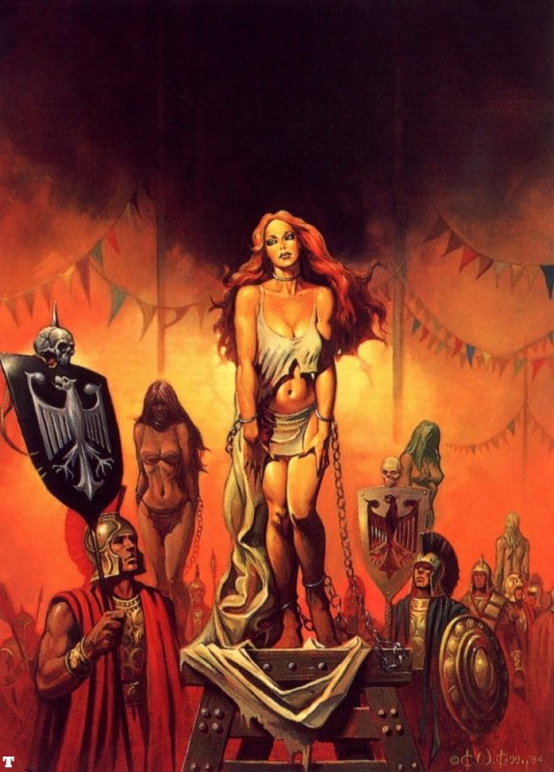
Beginner- 500 gp, Intermediate- 700 gp, Advanced- 1000 gp. Entering the tournament costs only 5 gp per person, and PC’s are welcome to sign up. Betting is not usually done on the Open Arena combatants, but the PC’s might persuade someone to wager some coin with a successful Diplomacy check (base DC 14 with modifiers as the DM sees fit). Contestants are absolutely forbidden from wagering, however. If discovered doing this, the violator is imprisoned until the end of the festival—at which time all minor crimes committed during the festival are forgiven.

Day 11:
Temperature Wind Sky
High 92 Low 79 East 14 mph Cloudy
Precipitation/Special Weather/Notes Rainstorm (light);
11 am ~ 4 pm; temperature drops to 82; Tracking DC +1 for every hour of rain;
(Early Afternoon) EL 2—A black bear transported by a wealthy merchant to display at his tent (and thereby attract customers) has escaped its chains and is now rampaging through the street where the PC's are.
A large black bear with a steel collar and a short length of broken chain stands before you on its hind legs. It is furious and is in the process of mauling one of the caravan guards that traveled with you from Shadizar. Hamadras is also nearby and yells, "Don't just stand there! Help him! I'll give you 10 gold pieces, now hurry!"
 Black Bear (Medium-Sized Animal) (1); hp 19;
see Monster Manual pg. 193 for complete statistics.
True to his word, if the PC's save the guard, Hamadras gives them 10 gp (to the group—not each). The guard does not die (no matter how much damage he takes from the bear), but roll damage each round for suspense until the PC's kill the bear. He is, however, close to death by the time the bear is dead.

Day 12: Gladiator Tournament
Temperature Wind Sky
High 88 Low 71 East 6 mph Cloudy
Precipitation/Special Weather/Notes No precipitation
Next to Slaver’s Day, the gladiator tournament is the biggest
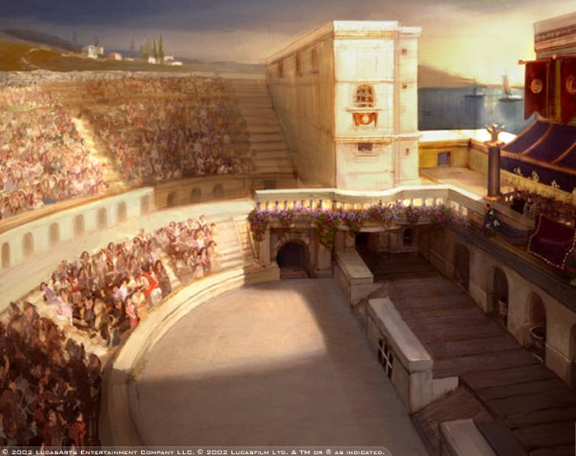
event during the
Beggar’s Feast
celebration. Bets
are made on
everything from
who will win the
tournament, to how many strikes
it will take a
certain gladiator to fell his opponent.
Players are free to place bets of their own (anyone in the crowd will oblige them).
The gladiators, along with the tournament roster, can be found in the appendix. You may want to allow the players to control the gladiators to better teach them the d20 combat system.

Day 13:
Temperature Wind Sky
High 97 Low 80 SE 2 mph Partly Cloudy
Precipitation/Special Weather/Notes No precipitation

Day 14: Slaver’s Day
Temperature Wind Sky
High 94 Low 75 SE 4 mph Clear
Precipitation/Special Weather/Notes No precipitation
The highlight of the festival is the final day. On this day the
major slavers gather their best slaves in the large tent erected just outside the North Gate and display them on the public block. The specimens displayed on the public block are true beauties and bring a high price (anywhere from 2,000 to 15,000 gp depending on her beauty and training). The more common slave girls sold in the individual slaver’s tents before Slaver’s Day usually sell for 100 to 500 gold pieces (the slaver’s always haggle with a Diplomacy skill bonus of between +5 to +20 — DM’s discretion).
Anyone is free to attend the public slave blocks, but not many men have the money it takes to purchase one of these exquisite women. Most people simply attend to view the women on display. The high quality of these women means that there are usually only 10-15 slaves displayed each year.
Those who own women slaves—usually common slaves—often brag about how “…this little wench of mine is far prettier than those sluts on the block today.”

Day 15:
Temperature Wind Sky
High 82 Low 65 S 24 mph Cloudy
Precipitation/Special Weather/Notes Thunderstorm; 10:30 am ~
1:30 pm; 2 in. rain; movement ¾; vision ¾; Track+4 DC; Lightning strikes occur once every 10 mins.; 1% chance on each strike party member will be hit (10% if sheltering under trees). First determine if party member is hit, then determine which member (don't roll 1% for each member). 3d6 damage, Ref save for ½.
The morning finds the caravan assembled and waiting for the PC's to arrive. If not dead thus far, Unegen and Cillian arrive shortly after the PC's and take their place on the last wagon. Hamadras did well during the festival, and as a result one of the slave wagons is now empty of women. Now it carries a few barrels of water and various wines and cheeses. Two of the PC's are ordered to ride in it while the other two are ordered to ride in the male slave wagon behind Hamadras' caravan—along with his three new acquisitions. Two of the women appear to be new to slavery, but the third is one of the gorgeous women from the Slaver's Day event. Hamadras informs the PC's riding there that the two new slaves are white silk virgins, and the beauty cost him 11,000 gp. That means that all the women are off limits.
At about 3 pm, the caravan is approached from the rear by a lone rider wearing an elaborate breastplate and carrying a lance and shield. The lance is upright and the rider does not appear to be aggressive.
As he gets closer, he hails the caravan, "Halt! You must pull your wagons aside and allow for my lord to pass."
Hearing the commotion, Hamadras opens the curtain to his carriage and peers out at the rider. Upon spying the black dragon crest on his shield, Hamadras immediately orders the caravan to come to a stop.
Within minutes, a caravan comes bumping along the road. Twenty men on horses lead the procession, followed by an obviously expensive coach wagon and a cage wagon, with twenty more mounted men bringing up the rear. As the cage wagon draws near, you can see that there are seven women riding inside. (If the PC's attended the Slaver's Day event, read the following) [You recognize three of the women as beauties that were displayed on the slave block during the last day of the festival.]
With a spray of filthy water and mud the convoy passes you by and Hamadras orders the caravan to start moving again.

Day 16:
Temperature Wind Sky
High 87 Low 71 SW 4 mph Cloudy
Precipitation/Special Weather/Notes No precipitation
When the caravan stops for lunch, a guard finds at least one of the PC's away from the eyes and ears of the other guards.
The guard that was mauled by the bear in Arenjun approaches you and sits facing the caravan. He speaks in a low voice, "I thank you for saving me from the bear. What I am about to tell you I do because you saved my life. Do not think me a traitor to Hamadras or Dinak. You must tell your companions that Hamadras plans on selling the lot of you into slavery when we reach Zintar tomorrow. You will all be surprised in your sleep late tonight and thrown into chains. Now that I have given you this information, you must do as you see fit. I have repaid my life debt to you and my honor is intact.
I will tell you this—it is not wise to try to escape during the light hours. Hamadras and Dinak know the area too well. You should try to make your way back to Arenjun. That is the
best place for you to disappear and avoid Hamadras. I will not tell anyone of your escape or of your destination, but if I am ordered to search for you, I will."
With that, he stands and returns to the caravan.
The PC's have about 15 minutes to converse together before the caravan begins moving again. Again, two PC's must ride in the wagon in front of Hamadras, and two must ride in the slave wagon behind him.

The Great Escape
Assuming the PC's take the advice of the guard and try to escape during the night, use the information as presented below. Otherwise, use this information to improvise.

Rain begins to fall—sometimes heavily—about an hour before the caravan stops for the night, and the clouds make for a dark and moonless night. Two of Hamadras' guards pace the compound, two stand watch over the horses, and the rest sleep lightly. The foreman and two guards are also awake, but rest uneasily in Hamadras' tent. Just after dark, four men arrive on horses and are ushered into Hamadras' tent. They are guards sent from the miner that plans on purchasing the PC's (use Cuty Watchman stats in Appendix C). They plan on striking the PC's at about 2 am. Unless the PC's are somehow able to take out all of the guards, plus the foreman, someone sees them stealing away in the night and raises the alarm.
The advantage in the chase that follows should go to the PC's. Have them run into a few guards, but allow them to avoid the others (if they are not defeated by the guards they run into, that is).
Unable to track due to the rain, the guards give up chase after only a couple of hours and return to the camp to make ready to leave. They head out just before dawn—leaving nothing behind to be scavenged.

Concluding the Adventure
There are two possible ways to end this adventure.
Escape. If the PC's escape Hamadras' clutches, they are free to do what they want. If they are still alive, Unegen and Cillian take their leave of the PC's and head back to Arenjun to 'disappear'.
Will the PC’s return to Arenjun or Shadizar, or will they set out to seek their fortune in a different part of Hyborea? If they return to Arenjun, The Elephant Tower could be a good follow-up adventure.
No matter what they decide, the PC's have a potent enemy in Hamadras. He may even send bounty hunters after them.
Enslaved. Although the ideal situation is for the PC's to escape, it is entirely possible that they may not act in time to flee, or they may be subdued in the attempt. If this happens, they are sold to a short, dirty man with long, black, unkempt hair once they reach Zintar. This man runs a mine in the mountains near Zintar and has an agreement with Hamadras to buy slaves from him. The PC's are stripped of everything and chained together. They are taken to the mine where they must dig for 12 hours a day.
Female PC's are collared and chained in the slave wagon. They are transported to Hamadras' compound where they are to be trained to serve as slaves.
The next adventure could include the male PC's escape from the mines, and their search for the female PC's in Shadizar, or the female PC's escaping and helping the male PC's escape the depths of the mine.

Appendix A: Excerpts From the d20 Book of Sex

This is a small excerpt from the d20 Book of Sex. Since wenching is a common practice in the Hyborean Age, I felt that some guidelines would be helpful, while adding depth to the game. The full document can be found at ***.***.com, and is a d20 conversion of the original AD&D Complete Guide to Unlawful Carnal Knowledge. There are some slight discrepancies from the full d20 guide, however, as this excerpt has been customized for the Hyborean Age setting.

SEDUCTION: MORE THAN REACTION ROLLS
This is a simple yet effective way to handle seduction. It is far more fun than making endless reaction checks and it certainly keeps players on their feet.
The following are the steps for seducing:
* When the character first comes in contact with someone he/she wants to seduce, a normal reaction roll is made. If the reaction of the victim is friendly, then a seduction may take place.
* The preliminary moves are made (i.e. role playing) and attribute checks are made. The seducer makes a check using his Diplomacy skill and the modifiers from Table 2 (depending on the manner he makes his move), or simply his Charisma modifier if he does not have Diplomacy. This becomes the DC for the victim to resist the seduction. The unwilling victim then makes an ability check, adding the Intelligence modifier, and any Sense Motive skill bonuses (to see if she is dumb enough to fall for it). If the victim fails to beat the seducer’s DC, the seducer is doing well and may continue. Otherwise, the victim realizes what’s going on. Willing participants need not make checks to resist a seduction attempt, but simply give in to their aggressor's advances.
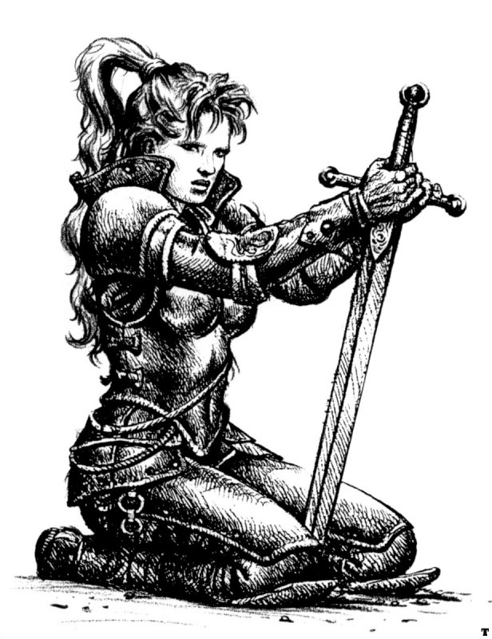
* The DM decides how many more checks should be made with suitable pluses or minuses to the DC (take into account how well the player is role-playing). Usually no more than two or three more successful checks are necessary. If the victim’s roll succeeds, it means that she realizes what is going on and has lost interest.
The seducer can try again, but must subtract 2 from Table 2: Seduction Modifiers
the DC each time the victim beats his DC (this penalty is Moves Made Seducer DC
cumulative, with a duration of 24 hours). Drunkenly -2
Sleazy/Raunchy -1

Table3: Seducer’s Clothing Modifier (optional) Aggressive +1
Heavily clothes, thick robes -2 Gentleman/Lady-like +2
Armor, adventuring gear -1
Normal clothing 0
Scantily/Provocatively clad +1 Table 3 should be used loosely. For example, Lirona’s
Nude +2 adventuring gear in this picture may be considered sexy
(Nude is not practical in most cases enough to not impose the –1 penalty. Some adventurers
and may lead to arrest of the individual (often mages) may even normally dress in adventuring outfits
for indecent exposure if in public.) that could be considered downright revealing and sexy.

CHANCE OF CONTRACTING A DISEASE
To contract a sexual disease, the character must be having sex with somebody who already is infected with a disease, or as a result of a malicious magical effect. The Fortitude save DC for resisting a sexual disease is 1 per minute of sexual activity.
For example, Rath (Fort save +3) becomes intimate with a person that has a sexual disease. He participates in 16 minutes of sex, making his DC for resisting the disease 16. He makes a Fortitude save roll of 12, adds 3, for a total of 15, resulting in our hero being infected with a sexual disease. A lesson to be learned. Note that a natural 1 always fails, no matter what the end Fortitude save result is with modifiers.
The use of protection from disease is of course very useful for preventing disease, but is difficult to acquire due to the low magic nature of Hyborea.

RANDOM DETERMINATION OF WHO IS DISEASED

The DM should decide if the person a character has sex with is infested with a disease before sexual activities begin, but if he wants to decide randomly, this system is provided. Using this system to determine if a prostitute is diseased, add the base chance by population to the social class modifier of Lower Lower Class. Even if taken care of, the best prostitutes are still only Upper Lower
The base percent chance of having a disease is dependant on the size of the settlement (the theory is that more diseases are found in bigger settlements where more people interrelate):

Table 4: Base Percent Chance of Disease by Population
Thorp 5 Large Town 25
Hamlet 10 Small City 30
Village 15 Large City 35
Small Town 20 Metropolis 40
Modifiers to the base chance are by social level (the theory is that more diseases are transmitted amongst the lower classes, because there are dirtier and less careful):

Table 5: Social Class Modifier to Disease
Lower Lower Class +20 Lower Middle Class +5 Lower Upper Class -10
Middle Lower Class +15 Middle Middle Class 0 Middle Upper Class -15
Upper Lower Class +10 Upper Middle Class -5 Upper Upper Class -20

Thus, a lower lower class citizen of a metropolis would have a 60% chance of having a disease—maybe because she lives on the street, is raped every so often, and sleeps around to get extra food money. In a nearby hamlet, an upper upper class citizen would have only a 1% chance (due to a negative score) maybe because he has a private mistress to engage in sexual activity when he is up to it. While in a large city, a citizen of equal status has a 20% chance, maybe because he parties a lot and he screws just as much.
There is always a minimum of 1% chance no matter how large the settlement, or the social class, unless the person is a virgin.
At first glance of this system, a person might assume that in a city of 9,000, roughly 40% (3,600) of the population have a sexually transmitted disease. The first item to note is that this system includes only those that engage in sexual activity. This eliminates a large amount of the city including children, elderly, etc. As a result, the actual numbers are not quite as high.
Let’s say that half of the city engages in sexual activity (which is actually a lot). Social level is another important aspect that must be included. Thus in this example, let us assume that all social levels except slaves exist and their population is equal:

Total Sexual Chance Total Of
Social Level Pop. Active Of Dis. Diseased
Lower Lower Class 1,000 500 x 50% = 250 Thus, only 1,350 of 4,500 people who have sex
Middle Lower Class 1,000 500 x 45% = 225 (out of 9,000 people living in the city) are infected
Upper Lower Class 1,000 500 x 40% = 200 with a sexual disease. This is perhaps a lot, but
Lower Middle Class 1,000 500 x 35% = 175 we're assuming that those that participate in sexual
Middle Middle Class 1,000 500 x 30% = 150 activity do this with more than one person. The
Upper Middle Class 1,000 500 x 25% = 125 thing to keep in mind is that this system is to
Lower Upper Class 1,000 500 x 20% = 100 calculate individual persons, not mass population.
Middle Upper Class 1,000 500 x 15% = 75 When the dice start rolling, the results usually don't
Upper Upper Class 1,000 500 x 10% = 50 go with the odds.
_____ ____
9000 1350

Diseases
Sexual diseases are definitely not fun (not for the players, anyway). After choosing a disease on Table 6, the DM should roll 1d8 to decide occurrence and 1d8 to decide the severity of the disease. Diseases can either be left to run their course, or a Heal check may be made to cure it outright. Note that chronic diseases do not naturally go away for good, making it much more difficult to heal them.

Table 6: Diseases
Occurrence Severity
Name Acute Heal DC Chronic Heal DC Mild Severe Terminal
E.S.S. 1-4 14 5-8 22 1-3 4-5 6-8
Gonorrhea 1-6 12 7-8 18 1-5 6-7 8
Prurire 1-7 12 8 16 1-6 7-8 x
Segmen Neus 1-4 16 5-8 26 1-3 4-5 6-8
Syphilis x x 1-8 24 1-5 6-7 8
Yeast Infection 1 14 2-8 20 1-8 x x

Occurrence determines whether the disease is a single (acute) attack or whether the disease will recur periodically once contracted (chronic). Chronic maladies will affect the character periodically. Once the disease has 'run its course', it goes into remission. Each month it is in this dormant state, the victim must make a roll to see if there is a relapse. If a relapse is indicated, the disease simply 'runs its course' once more before returning to its dormant state.
Severity refers to the seriousness of the disease and determines any additional effects of the malady.
MILD: During the period of affliction the character has a 50% chance of being fatigued each day (see DMG pg. 83 for descriptions of conditions).
SEVERE: A severe malady causes a character to constantly be fatigued. Roll once on Table 7 for additional effects.
TERMINAL: The malady causes the victim to be fatigued all the time, with a 50% chance each day of being exhausted instead. Roll twice on Table 7 for additional effects, ignoring duplicate results.

Table 7: Additional Disease Effects
d8 Effect d8 Effect
1 Burning during urination 6 Uncontrollable vomiting; -1 Constitution
2 Constant pain; -1d4 to attack rolls (determine daily) per week (minimum of 1)
Gradual brain rot; -1 Intelligence and Wisdom per 7 Sluggishness; ¾ movement rate, -2 initiative
week (minimum of 1) 8 10 % chance every 6 hours of a spasm, causing
- Hyperactivity; movement doubled, +2 initiative held items to be dropped, and rendering victim
5 Loss of voice; no verbal spells, singing, etc. nauseated for 1d3 rounds (move-equivalent actions only).

Description
Enlarged Scrotum Syndrome (E.S.S.) - This disease is only contracted in males. The effect is that the male's testicles become extremely enlarged (max. of 8 inches in diameter each). Due to excruciating pain, the victim's movement is reduced to ¼, and attacks and AC suffer a -4 penalty. This condition lasts for 1d3 weeks, and there is a 15% chance each month that chronic victims experience the disease again.
Gonorrhea - An infectious disease caused by bacteria that can infect the genital tract, the mouth, and the rectum. It causes pain when urinating, and in Severe or worse cases causes bloody feces and vomiting (randomly check once/day for vomiting)—causing a -2 to Constitution until cured or in remission. It lasts 2-4 weeks, and there is a 50% chance each month that chronic victims experience the disease again.
Prurire - "The Itch", as it is better known, is quite an uncomfortable—but not lethal experience. The period of affliction is 1d4 weeks. There is a 50% chance during each month of remission that chronic victims experience the disease again. While active, it causes a -2 to any skill checks that require concentration.
Segmen Neus - This disease is named after a disgusting perverse man who raped hundreds of women. The effects of the disease are as follows:
* -1 temporary Charisma penalty each day (gradual disfigurement—minimum of 1)
* Right or left leg goes bad decreasing movement by ½
* Develops an aversion to sexual activity
This affliction lasts 1d2 weeks, and there is a 75% chance during each month of remission that chronic victims experience the disease again. Lost ability points are recovered over time, as normal.
Syphilis - A chronic infectious venereal disease that causes sores on the genitals, anus, or lips. After 3 weeks, the infected develops a rash that does not itch. This rash goes away on its own, but the victim is infected from the time he acquires the disease from an infected partner. 8 weeks after catching the disease, it begins to do damage in the form of -1 to all abilities each week until the victim is disabled (all abilities decreased to 1), or the disease is cured. Lost ability points are recovered as normal.
Yeast Infection - This disease only manifests itself in female characters. It causes the victim’s genitals to produce a disgusting stench. Going unnoticed is nearly impossible, giving a -2 penalty to Hide checks. Further, creatures with the Scent ability have a +2 to find the character by smell. There is a 50% chance during each month of remission that chronic victims experience the disease again.

GETTING TO KNOW A PROSTITUTE (RANDOM GENERATOR)

Prostitutes in General
Before getting to know a specific prostitute, the prostitute pool should be known. It is a good idea to have a number of prostitutes crated before an adventure begins, giving you a list of potential harlots to choose from. The DM may make adjustments to any part of this generating system as deemed necessary.
To decide the number of prostitutes in a given settlement, use Table 8. Most DM's feel that the number of prostitutes should never
exceed 10% of the total population unless the settlements primary function is prostitution. Therefore, adjustments should be made accordingly.

Table 8: Number of Prostitutes

Settlement Population # Of Prostitutes
Thorp 20-80 1d4
Hamlet 81-400 3d4 + 5
Village 401-900 3d4 + 10
Small Town 901-2,000 3d20 + 5
Large Town 2,001-5,000 4d20 + 20
Small City 5,001-12,000 5d20 + 40
Large City 12,001-25,000 5d20 + 60
Metropolis 25,000+ 5d20 + 100

Information on prostitutes working under management can be found in the Filling The House Of Ill Repute section.

Getting a Feel for the Prostitute
Not all prostitutes are alike. Below are the steps necessary to make a very unique and exciting female prostitute.
1) Choose a country of origin in respects to the area, or roll on Table 14.
2) Generate ability scores as describe in the PHB.
3) Height and weight can be generated randomly using the tables on page 93 of the PHB.
4) Age should be generated by rolling 1d4+12. This table allows individuals to begin prostitution at a younger age than adventuring.
5) Roll on Table 9 three times to get hair color, eye color, and complexion; or choose.
6) The various measurements of a woman can be randomly generated as followed:
- Roll on Table 10 to get the Vital Measurement Base, and add the Constitution modifier from Table 11.
- To find bust size, add the Vital Measurement Base to the proper Bust modifier (Table 12).
- To find waist size, add the Vital Measurement Base to the proper Waist modifier (Table 12).
- To find hip size, add the Bust to the proper Hips adjustment (Table 12).
- If the woman's height is less than 5 feet, subtract 2 from the generated bust and hip size.
7) With prostitutes can come bad things. Using tables 4 & 5, determine if the prostitute is diseased.
8) The average base cost to hire a prostitute is 1000 sp / number of prostitutes available. Thus, the average cost for a prostitute in a town with 10 prostitutes is 100 sp each.
Additional costs can manifest itself when patronizing a courtesan. A customer might have to spend money on a meal (they got to eat too), alcoholic beverages (no doubt), a room (unless you like doing it in an alley), and medical expenses (you give them a disease—you pay for it).
There—now a nice versatile prostitute has been created, but there still is room for improvement. Keep in mind that some prostitutes are Rogues (possibly even high level) and should have such abilities. Some rare prostitutes could even be another class that has fallen on hard times and just needs some way to make extra money. There could even be Cleric prostitutes who worship some deity of lust, and prostitution is just one of their forms of worship.
The thing to remember is that a DM can use a prostitute as a very important NPC. Prostitutes usually have dirt on everybody who passes through their beds; not to mention pillow talk information that shouldn't have been told. A prostitute is more interesting than the old fat tavern keeper with old boring stories. Keep this in mind, before throwing out such an encounter.

Table 9: Color Specifics Table 10: Vital Table 11: Constitution Modifier to
d% Hair Color Eye Color Complexion Measurement Base Vital Measurement Base
01-13 Crimson Lt. Blue Dusky Olive d% Vital Base Constitution Modifier
14-30 Lt. Blond Dk. Green Bronze 01-20 22" 1-4 -3"
31-40 Auburn Hazel Milky White 21-40 23" 5-9 -2"
41-52 Sable Lt. Brown Ebony 41-55 24" 10-14 0
53-65 Lt. Brown Crimson Lt. Red 56-69 25" 15-17 +1"
66-72 Silver Silver Yellow 70-82 26" 18-20 +2"
73-80 White Lt. Green Brown 83-85 27" 21+ +3"
81-83 Med. Brown Dk. Blue Golden 86-90 28"
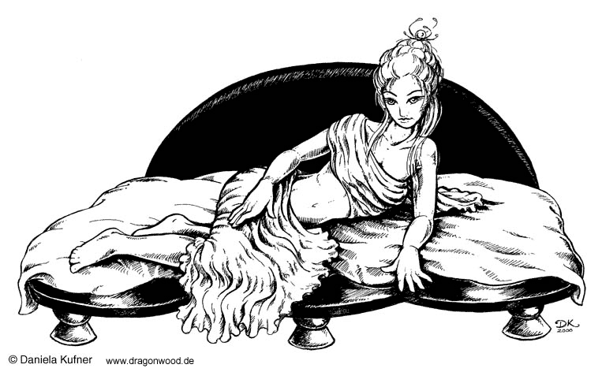
84-85 Dk.Brown Pink Fair 86-90 28"
86-88 Dk. Blonde Dk. Brown Lightly Tanned 91-94 29"
92-99 Black DMs choice DMs choice 95-97 30"
00 Bald Each eye DMs choice 98-99 31"
different color 00 32"

Table 12: The Measurements

Charisma Bust Waist Hips
1-4 0 5-30" +6d6"
5-7 5-8" 2-12" +2d6"
8-10 6-9" 1-4" 0
11-13 7-10" 1-2" 0
14-16 8-11" 0 -1"
17-19 9-12" 0 -2"
20-21 10-12" 0 -2"
22+ 10-13" 0 -3"

FILLING THE HOUSE OF ILL REPUTE

A brothel (whorehouse, relaxation emporium, or whatever the name) is a place where a person may go for physical refreshment.
A brothel comes in three basic sizes: Small (4d4 employees), Medium (6d6 employees), and Large (8d8 employees).
In addition to the regular employees listed above, there will be a number of amateurs who use the house as a base. They will usually average 30% of the regular staff of that house. There will usually be a small number of young virgin girls in training, frequently working as maids for the top regulars. These girls do not yet work with the customers, and there is often an auction to determine who takes her virginity.
As Table 13 shows, there are four classes of brothels. The DM can roll randomly or choose.

House amateurs usually receive about ½ the going rate; one does not find amateurs in a
Table 13: Brothel Class slave house. The racial mix in the average house of its class is given on Table 14; the DM
d% Class may either specify the race of the girls working here or roll dice (d%) for each girl to see
01-03 Fine who's available.
04-12 Normal Houses tend to be run by women, although some are managed by men (occasionally chosen
13-16 Low by the girls, frequently simply the "pimp" who has hired them). If run by a woman, she is
17-20 Slave usually (80%) a high rank courtesan herself and will occasionally be available to preferred,
politically influential, or extremely wealthy customers.
There are usually some additional costs involved in patronizing
a courtesan in such an establishment. Although entertainment is Table 14: Races Found In Different Brothel Classes (d%)
usually provided at no extra cost in the major houses, normally Race Fine Normal Low Slave
a character should expect to spend the price of the girl's meal and Afghuli 01-03 01-03 01-05 01-06
alcoholic beverages. If a character should wish to spend the entire Aquilonian 04-08 04-07 - 07-08
night with the lady of his choice, the total cost multiplied by 2. Argossean 09-13 08-11 06-10 09-11
This does, of course, provide one with a room for the night in Aesir 14-18 12-16 11-15 12-15
addition to the cuddly bed companion. If a man is dealing with Brythunian 19-22 17-21 16-20 16-19
a girl who works on the street, there is a 25% surcharge to her price Cimmerian 23-24 22-24 21-23 20-25
if she is to provide a room. This will always be the case unless the Corinthian 25-29 25-27 24-25 26-27
customer has nearby lodgings (within 2 to 3 blocks at the furthest). Darfar 30-33 28-30 26-30 28-30
Time spent in a whorehouse may range up to 4 or 5 hours (if Hyperborean 34-35 31-33 31-34 31-35
not overnight). With a street girl, an interlude should occupy Hyrkanian 36-46 34-42 35-43 36-42
about 1-1/2 to 2 hours. Iranistani 47-49 43-46 44-45 43-45
The chance of a brothel prostitute having a disease is less Kambujan 50-54 47-50 46-48 46-47
than that of a street girl based on the class of a house in which Keshani 55-58 51-53 49-51 48-51
the girl works. The higher the class of the house, the better health Khitani 59-64 54-57 52-55 52-55
care the girls receive, and the lower the chances of infection. Khorajian 65-69 58-61 56-60 56-59
In a Fine house there is a -10% chance, in a Normal house there
is a -5% in a Low house there is a -5% chance, and in a Slave Race Fine Normal Low Slave
house there is a -15% chance of the girl being infected. The Slave Kothian 70-73 62-66 61-64 60-61
house modifier is high because most slavers consider losing Kushite 74-76 67-68 65 62-64
income or valuable property to disease uneconomical. With the Meru 77 69-70 66-69 65-66
girls on the street, there is no modifier to the chance of the Nemedian 78-79 71-76 70-77 67-69
girl being infected. Ophirian 80-83 77-81 78-81 70-72
Pictish -- 82-83 82-85 73-79
Shemitish 84-85 84-85 86 80-81
Stygian 86-90 86-89 87 82-83
Turanian 91-93 90-92 88-90 84-86
Vanir 94 93-94 91-92 87-89
Vendhyan 95-96 95-96 - 90-91
Zamoran 97 97-98 93-96 92-93
Zembabwei -- 99 97-98 94-98
Zingara 98-00 00 99-00 99-00

Appendix B: Random City Encounters (d8)

1. A fugitive rogue slips a tiny package of black lotus into one of the PC’s pockets/clothing (make a Pickpocket check against the PC's Spot check to see if the PC notices). A bounty hunter looking for the rogue sees the transfer and assumes the PC is working with the thief and attempts to shadow the PC until he/she can get a good shot at capturing the unwitting PC. The bounty hunter wants information on the thief, but after a short interrogation will realize that the PC is innocent. (This may even lead into a mini-adventure within the city—find the rogue for the bounty hunter for a reward).
 Bounty Hunter
Dulcea Quintin, female human (Nemedian) Ftr4/Rog3:
CR 7; Size M (5 ft., 4 in. tall); hp 65; Init +6 (+2 Dex,
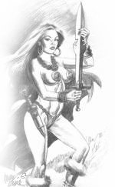
+4 Improved Initiative); Spd 30 ft.; AC 16 (+2 Dex, +3 armor, +1 buckler); Attack +9/+4 melee, or +8/+3 ranged; SV
Fort +8, Ref +8, Will +2; Str 17,
Dex 15, Con 16, Int 12, Wis 10,
Cha 17
Languages Spoken: Nemedian
Skills: Bluff +5, Climb +9,
Concentration +6, Decipher
Script +5, Forgery +3,
Gather Information +8,
Hide +6, Jump +8, Listen +7,
Move Silently +4, Open
Lock +7, Pick Pocket +4,
Search +7, Spot +4,
Tumble +8, Use Rope +5,
Wilderness Lore +3
Feats: Dodge, Improved
Initiative, Improved
Unarmed Strike, Lightning
Reflexes, Power Attack,
Weapon Focus (longsword),
Weapon Specialization
(longsword)
Possessions: Studded leather armor, buckler, longsword, dagger, 50' silk rope, 40 gp

2. 2 guards from another merchant caravan are wandering the streets drunk. They run into the PC's (literally), and decide that the PC's owe them an apology. Even if the PC's apologize, they decide to teach the PC's a lesson and attack. (Use the stats in Appendix C for Hamadras' caravan guards, but apply a -4 penalty to attack and AC, and a +2 to damage and hit points due to their extreme drunken state).

3. A prostitute looking for some quick coin approaches on of the PCs, offering his/her/it's services. She has a trashy room with nothing but a filthy, thin bedroll and a partially collapsed wall in the alley behind where she is standing. If the PC accepts, the prostitute’s pimp arrives just before the PC is finished and demands double the fee 'or else'. If the PC refuses, the pimp draws a tulwar (use falchion stats) and makes ready for combat. Since he is somewhat of a coward, he would like to avoid having to fight. Before attacking he gives the PC a few chances to make good on the increased fee with statements like, "It's not too late, you can still settle things without getting hurt." and "C'mon, you don't want me to gut you for a few coins, do you?" If fighting actually breaks out and the pimp is injured, or not able to seriously wound the PC after 2 rounds, he flees.
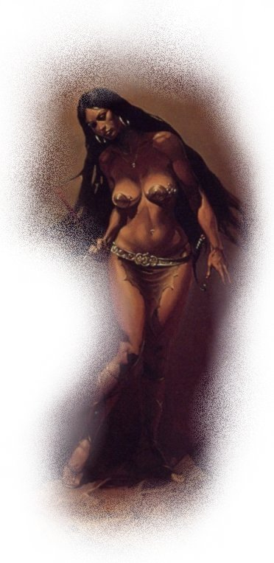
 Prostitute
Mandughai, female human (Hyrkanian) Com1: CR 1;
Size M (5 ft., 7 in. tall); hp 6; Init +2
(+2 Dex); Spd 30 ft.; AC 12
(+2 Dex); Attack +2 melee, or
+2 ranged; SV Fort -1, Ref +2,
Will +1; Str 15, Dex 14, Con 8,
Int 11, Wis 13, Cha 15
Languages Spoken: Hyrkanian,
broken bits of Zamoran
Skills: Hide +2, Listen +3, Move
Silently +2, Spot +5, Swim +6,
Use Rope +6
Feats: Skill Focus (Use Rope),
Toughness.
Possessions: Dagger

 Pimp
Behrouz, male human (Zamoran) Com3: CR 2; Size M
(6 ft., 2 in. tall); hp 10; Init +0; Spd 30 ft.; AC 11 (+1 armor); Attack +3 melee, or +1 ranged; SV Fort +0, Ref +1,
Will +4; Str 15, Dex 11, Con 9, Int 13, Wis 12, Cha 7
Languages Spoken: Zamoran, Hyrkanian
Skills: Appraise +4, Climb +9, Escape Artist +2, Jump +6, Listen +1, Spot +7
Feats: Iron Will, Power Attack, Skill Focus (Climb).
Possessions: Padded armor, tulwar, dagger, 4 sp, 8 cp

4. 5 city watchmen threaten to take the PC's in if a little money (2 gp) isn’t forthcoming. If the PC's fight, they have a 20% chance of being spotted and reported (making them fugitives). If they lose the fight, or simply refuse to pay without fighting, the city watch arrest them and throw them in prison overnight. Once released, the PC's may discover (upon inspection of their items) that the money asked for is gone anyway. If they are imprisoned for fighting city watchman, Hamadras bails them out at the end of the festival. (See Appendix C for city watchmen stats)

5. EL 1 Four thugs and their leader see the PC's as an easy mark. They immediately attack the PC's in the street. The PC's are not bothered by the city watchmen, who would rather have the PC's kill the street trash than have to deal with them day after day. (See Appendix C for stats on the thugs)

6. A mother is frantically looking for her missing daughter. She will ask the PC's if they have seen her ["Short brown hair, brown eyes, about 'so' tall, wearing a red tunic and leather breeches. Her name is Houri."]. If the PC's offer to help find her, they are able to track her down by making 3 Spot or Gather Information checks (DC 12). The checks do not have to be consecutive, and the PC's may keep trying to make their skill checks until they find the girl, or they give up, but each check requires the PC to search for 30 minutes whether the check succeeds or fails. The party rolls one skill check for everyone—unless they split up, at which time everyone rolls for themselves. If found and returned to her mother, award the party XP equivalent to an EL1 encounter.

7. EL 2 The party walks past an alley in time to see a man dressed in expensive looking black clothes shoot a green robed man standing with his arms raised in surrender in the forehead with a shortbow. Even if the party does not interfere, the man sees the party and turns his bow on them. He is stealing the Green Fire-Stone of Xuchotl that the now dead man had in his robes. (see http://hyboria.xoth.net/sorcery/magical_items.htm )
 Assassin
Hadrianus, male human (Kothian) Rog2: CR 2; Size M (6 ft., 2 in. tall); hp 14; Init +2 (+2 Dex); Spd 30 ft.; AC 14
(+2 Dex, +2 armor); Attack +2 melee, or +3 ranged; SV
Fort +1, Ref +5, Will +0; Str 12, Dex 15, Con 13, Int 12, Wis 11, Cha 10
Languages Spoken: Kothian, Zamoran
Skills: Appraise +6, Climb +6, Disguise +3, Gather Information +5, Hide +6, Intimidate +5, Listen +2, Move Silently +2, Perform +4, Search +6, Sense Motive +5,
Spot +0, Swim +6
Feats: Dodge, Mobility
Possessions: Leather armor, short sword, dagger, composite shortbow, 12 arrows, belt pouch, 9 gp, 2 sp

8. When the PC's enter a small store or merchant tent, they find its proprietor lying face down in a pool of his own blood; candles mark a rough geometric pattern around him and all of the money is still in his wooden treasure chest. Nothing seems to be missing from the store. After two rounds, a city watchman walks in on the PC's and assumes the worst. He calls for aid in apprehending the PC's.
If the PC's fight, they cause for even more guards to be summoned until they are captured or killed. If they submit to the guards at the merchant tent, however, they are interrogated for two days, and released with an apology when the real killer is in custody. If captured after fighting, they cannot convince their judges of their innocence, and they are sentenced to the dungeons for 10 years. The guards are quite corrupt, however, and make no secret of the fact that one can 'escape' from the dungeons for a mere 10 gp. If the PC's are unable—or unwilling—to make such a contribution to the guards, Hamadras arranges for their 'escape' the night before his caravan departs (he stands to lose money if he doesn't have slaves to sell to the miners on the trip back).

Appendix C: NPC Roster

Feats with an asterisk (*) denote those unique to the Hyborean Age setting.

■ Merchant/Slaver
Hamadras, male human (Aquilonian) Rog1/Nob8: CR 6; Size M (6 ft., 2 in. tall); 51 years old; hp 42; Init +3; Spd 30 ft.; AC 17 (+3 Dex, +4 armor); Attack +7/+2 melee, or +9/+4 ranged; SV Fort +0, Ref +7, Will +8; Str 13, Dex 16,
Con 10, Int 16, Wis 15, Cha 16
Languages Spoken: Aquilonian, Argossean, Ophirian, Zamoran.
Skills: Disguise +14, Diplomacy +12, Escape Artist +7,
Hide +5, Innuendo +13, Intimidate +10, Intuit Direction +6, Listen +14, Move Silently +5, Open Lock +7, Perform +15, Ride +5, Search +7 , Spot +4, Swim +12, Wilderness
Lore +12
Feats: Alertness, Combat Reflexes, Dodge, Leadership, Skill Focus (Perform).
Possessions: Light chain shirt, masterwork dagger, masterwork hand crossbow, 12 bolts, platinum ring inlaid with rubies (550 gp), gold chain necklace with deep blue spinel amulet (825 gp), thin 3' steel chain with locking clasp.

Hamadras is a shrewd merchant, who always seems to get the better end of a business transaction. When selling slaves, he uses his Perform skill to put on a great show and oration in an attempt to convince the buyer of the incredible worth of the individual(s) being shown. When selling wares of a more mundane nature, he uses his Diplomacy skill to squeeze a few more coins out of the buyer. Now that he is no longer a petty thug, Hamadras avoids combat if at all possible. He will flee at the first chance he gets, and prefers to leave the ‘dirty work’ to his guards.
Hamadras owns a large estate in Shadizar where, along with his stockpiles of goods traded between Shadizar and Arenjun, he trains slaves and brews his own style of beer. He is one of many rich men in Shadizar, and as such has some influence among the aristocracy and leadership of Zamora.

■ Caravan Foreman
Dinak, male human (Zamoran) Bbn1/Ftr4: CR 5;
Size M (5 ft., 9 in. tall); 35 years old; hp 46; Init +6; Spd 40 ft.; AC 20 (+2 Dex, +1 natural, +5 armor, +2 shield); Attack +7 melee, or +7 ranged; SV Fort +8, Ref +3, Will +1; Str 15, Dex 15, Con 15, Int 11, Wis 11, Cha 14
Languages Spoken: Zamoran, Corinthian
Skills: Climb +6, Hide +2, Intuit Direction +4, Listen +2, Move Silently +4, Spot +3, Swim +8
Feats: Cleave, Expert Shield Use*, Improved Initiative, Iron Skin*, Power Attack, Weapon Focus (scimitar)
Possessions: Breastplate, large steel shield, scimitar, dagger, light lance; (lizard mount—use stats for light warhorse) military saddle, bit and bridle

After a short career as an outlaw raiding caravans in the wilderness of Zamora, Dinak traveled to the capital city of Shadizar and underwent formal combat training. He used his experience raiding caravans to land him a job protecting caravans for Hamadras, and quickly rose among the ranks to become foreman of Hamadras’ personal caravan. He trusts few people, other than Hamadras—to whom he is completely loyal, and usually kills anyone who annoys him rather than argues with them.
Although he now guards caravans, Dinak never completely cut his ties with his bandit friends. They have a fairly solid agreement in which they won’t attack any of Hamadras’ caravans in return for cargo and travel information from Dinak about other caravans—usually Hamadras’ competitors.

■ Caravan Guards
Male human (Zamoran) Ftr4 (6): CR 4; hp 31; Init +1
(+1 Dex); Spd 30 ft.; AC 16 (+1 Dex, +3 armor, +2 shield); Attack +6 melee, or +5 ranged; SV Fort +4, Ref +2, Will +1; Str 13, Dex 12, Con 11, Int 8, Wis 10, Cha 14
Languages Spoken: Zamoran, Corinthian
Skills: Climb +6, Hide +3, Listen +5, Move Silently +5,
Spot +2, Swim +4
Feats: Alertness, Blind-Fight, Combat Reflexes, Power Attack, Cleave
Possessions: Studded leather armor, large wooden shield, longsword, dagger; (light horse) military saddle, bit and bridle

These six men were companions of Dinak during his career as a bandit. Once he gained limited status among Hamadras’ troops, he offered his friends jobs. They are fairly loyal to Dinak, but are not above minor insubordination if it will make them some extra money—and there is little chance of their getting caught. They are not afraid of combat, and will fight to the death as a matter of honor.

■ Unegen
Female human (Hyrkanian) Ftr1: CR 1; Size M (5 ft., 8 in. tall); hp 13; 17 years old; Init +2 (+2 Dex); Spd 30 ft.; AC 17 (+2 Dex, +5 armor); Attack +4 melee, or +3 ranged; SV Fort +5, Ref +2, Will +2; Str 16 (+3), Dex 15 (+2), Con 16 (+3), Int 12 (+1), Wis 15 (+2), Cha 13 (+1).
Languages Spoken: Hyrkanian, Turanian, Aquilonian
Skills: Climb +5, Hide +4, Knowledge (Religion) +3,
Listen +2, Move Silently +2, Ride +6, Spot +2, Swim +5
Feats: Exotic Weapon Proficiency (chakram), Mounted Combat, Power Attack.
Possessions: Lamellar armor, scimitar, chakram

Unegen is the daughter of a Hyrkanian soldier. About a year ago she stole her father's armor and scimitar and ran away from home rather than becoming an army slut—those women that are hauled around with troops to warm the beds of officers on cold nights.

■ Cillian
Male human (Brythunian) Rgr1: CR 1; Size M (6 ft., 0 in. tall); hp 11; 16 years old; Init +3 (+3 Dex); Spd 30 ft.; AC 16 (+3 Dex, +3 armor); Attack +2 melee, or +4 ranged;
SV Fort +3, Ref +3, Will +1; Str 13, Dex 17, Con 13, Int 13, Wis 12, Cha 6
Languages Spoken: Brythunian, Zamoran
Skills: Hide +3, Knowledge (nature) +3, Listen +1, Move Silently +7, Profession +3, Ride +7, Search +5, Spot +5, Use Rope +5, Wilderness Lore +3
Feats: Dodge, Mounted Combat, [Track].
Possessions: Studded leather armor, large wooden shield, battleaxe, dagger, sling, 24 stones, 4 gp, 8 sp

Cillian grew up in the forests of Brythunia. He hunted from the time he was a small boy, and that love of nature led to his profession as a fighter and tracker-for-hire.

(Use these generic templates for any thugs the PC’s might encounter on the streets of Arenjun)
■ Thug Leader
Male human War1: CR 1; hp 9; Init +5 Spd 30 ft.; AC 12; Attack +4 melee, or +3 ranged; SV Fort +3, Ref +2, Will -2; Str 16, Dex 14, Con 13, Int 10, Wis 6, Cha 7
Skills: Hide +1, Intimidate +2, Jump +7, Listen -2, Move Silently +2, Ride +6, Spot -2
Feats: Improved Initiative, Improved Unarmed Strike
Possessions: Short sword or club, dagger, 1d2 gp

■ Common Thug
Male human Com1: CR 1; hp 3; Init +1; Spd 30 ft.; AC 11; Attack +1 melee, or +1 ranged; SV Fort -2, Ref +1, Will +0; Str 12, Dex 12, Con 7, Int 8, Wis 11, Cha 6
Skills: Hide +1, Listen +4, Move Silently +1, Swim +5
Feats: Endurance, Run
Possessions: Club or dagger, 1d4 sp

■ City Watchman
Male human (Zamoran) War2: CR 1; hp 13; Init +0;
Spd 30 ft.; AC 13 (+3 armor); Attack +3 melee, or +2 ranged;
SV Fort +5, Ref +0, Will +0; Str 13, Dex 11, Con 14, Int 12, Wis 11, Cha 10
Languages Spoken: Zamoran
Skills: Climb +3, Concentration +4, Gather Information, +2, Intimidate +7, Listen +2, Spot +2
Feats: Skill Focus (Intimidate), Weapon Focus (short sword).
Possessions: Hide armor, halberd, short sword

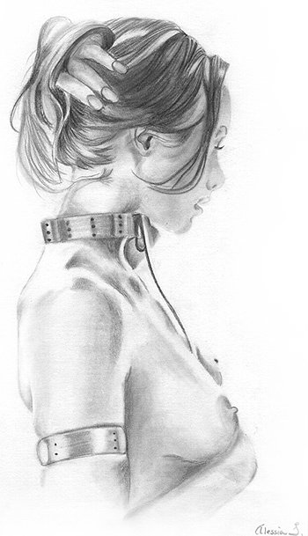

■ Hamadras' Slaves (Created with guidelines from the d20 Book of Sex in Appendix A)
Female (to be sold in Arenjun) (none are diseased)
1) Khitani; waist-length, black hair; slanted lt.brown eyes; yellow complexion; 5'5"; 115 lbs;
20 years old; Bust 32 Waist 29 Hips 32; hp 3; Str 16, Dex 12, Con 13, Int 13, Wis 14, Cha 10
2) Khorajian; shoulder-length, dk. blonde hair; hazel eyes; fair complexion; 5'3"; 105 lbs;
17 years old; Bust 39 Waist 33 Hips 39; hp 3; Str 16, Dex 11, Con 11, Int 8, Wis 15, Cha 13
3) Darfar; shoulder-length, med.brown hair; blue eyes; milky white complexion; 5'7"; 135 lbs;
23 years old; Bust 30 Waist 24 Hips 30; hp 3; Str 14, Dex 13, Con 16, Int 12, Wis 10, Cha 11.
4) Hyperborean; shoulder-length blonde hair; green eyes; fair complexion; 5'11"; 135 lbs;
25 years old; Bust 33 Waist 23 Hips 32; hp 5; Str 15, Dex 13, Con 10, Int 13, Wis 9, Cha 18
5) Ophirian; short, dk. brown hair; light green eyes; tan complexion; 4'11"; 90 lbs.
18 years old; Bust 35 Waist 27 Hips 34; hp 4; Str 17, Dex 12, Con 14, Int 11, Wis 9, Cha 17
6) Afghuli; shoulder blade length, dk. brown hair; dk. brown eyes; bronze complexion; 5'6"; 135 lbs;
24 years old; Bust 42 Waist 31 Hips 40; hp 5; Str 15, Dex 11, Con 11, Int 8, Wis 9, Cha 15
Male (work slaves)
Pictish hp 8; Str 15, Dex 13, Con 13, Int 14, Wis 12, Cha 14
Zimbabwei hp 10; Str 16, Dex 12, Con 16, Int 10, Wis 16, Cha 13

Appendix D: Gladiator & Tournament Roster
All gladiators are nude save for sandals, a loincloth, and any armor they wear. They are slave/gladiators, and only know the arena.

#1, male human Bbn5: Size M (5 ft., 11 in. tall); hp 45;
Init +1 (+1 Dex); Spd 40 ft.; AC 12 (+1 Dex, +1 buckler); Attack +8 melee, or +6 ranged; SV Fort +5, Ref +4, Will +1; Str 16, Dex 12, Con 13, Int 8, Wis 10, Cha 12
Skills: Climb +9, Craft +7, Hide +1, Jump +11, Listen +8, Move Silently +1, Spot +2, Tumble +3
Feats: Alertness, Endurance, Lightning Reflexes.
Possessions: Buckler, light flail

#2, male human Rog6: Size M (5 ft., 1 in. tall); hp 26;
Init +7 (+3 Dex, +4 Improved initiative); Spd 30 ft.; AC 17 (+3 Dex, +4 armor); Attack +4 melee, or +7 ranged;
SV Fort +2, Ref +8, Will +4; Str 11, Dex 16, Con 11, Int 12, Wis 15, Cha 15
Skills: Balance +9, Bluff +11, Craft +9, Disable Device +10, Gather Information +5, Hide +3, Intimidate +11, Intuit Direction +10, Listen +11, Move Silently +12, Open Lock +7, Spot +2, Swim +8, Tumble +12
Feats: Ambidexterity, Improved Initiative, Two Weapon Fighting, Quick Draw
Possessions: Chain shirt, 2 daggers
#3, female human Ftr5: Size M (5 ft., 7 in. tall); hp 47;
Init +4 (+4 Improved initiative); Spd 30 ft.; AC 15 (+5 armor); Attack +8 melee, or +5 ranged; SV Fort +6,
Ref +1,Will +0; Str 16, Dex 10, Con 14, Int 16, Wis 8,
Cha 14
Skills: Balance +1, Climb +11, Craft +8, Handle Animal +6, Jump +11, Listen +3, Move Silently +4, Search +7, Spot +3, Swim +8
Feats: Alertness, Blind-fight, Exotic Weapon Proficiency (net), Improved Initiative, Power Attack, Weapon Focus (trident).
Possessions: Breastplate, trident, net.

#4, male human Ftr5: Size M (5 ft., 11 in. tall); hp 44;
Init -1 (-1 Dex); Spd 30 ft.; AC 11 (-1 Dex,+2 shield);
Attack +6 melee, or +4 ranged; SV Fort +7, Ref +0, Will -1; Str 12, Dex 9, Con 12, Int 15, Wis 7, Cha 9
Skills: Craft +8, Diplomacy +2, Forgery +3, Handle
Animal +5, Hide +1, Intuit Direction +0, Listen +3, Move Silently -1, Spot -2, Swim +7
Feats: Blind-Fight, Combat Reflexes, Great Fortitude, Toughness, Weapon Focus (mace, heavy), Weapon Focus (short sword).
Possessions: Large wooden shield, short sword

The roster is simple: in round 1 gladiators #1 and #2 fight, and #3 and #4 fight. Round 2 is between the winners of the round 1 matches. You may wish to enhance the matches by letting wild animals loose in the ring (a la Rome)—animals that attack whoever is closest to them. Another possible option is to blindfold both opponents, thus making them rely on Move Silently and Listen checks to get close enough to attack without having their location perceived by their opponent. If you use your imagination, gladiator matches can be made quite entertaining both to watch and participate in.

